

**Dear parents, pupils and members of the community, welcome to our June newsletter.**

With less than 3 weeks to go, we’re hoping the sun comes out as we’ve got lots of exciting events to enjoy before we break up! We hope you will be able to join us for some or all of them. Communications Evening this Thursday will be a really good opportunity to hear about school development, address points raised in the questionnaires and meet new staff; it would be great to see as many people there as possible. As well as Sports Day, our Key Stage 2 production of Moon Bear, our new ‘in-school’ version of Film Night and our Leavers Service are all excellent opportunities to celebrate the brilliant work of our pupils. On that note, I’d like to mention two acknowledgments of the superb writing that the children have been doing. The school has just undergone a highly successful moderation of Year 6 writing by the Local Authority, where all judgments by staff were verified and the examples of work were noted as amongst the best seen in the county. Our Year 2 pupils have just received the exciting news that all their diary entries about food that comes alive will all be included in the Young Writers Book for Leicestershire! Finally, I would like to thank you for the level of engagement with the school you have shown through the recent questionnaires. There were so many brilliant ideas for development alongside an overwhelming positive overall response to the school and its work. As always, please do not hesitate to get in touch if there is anything we can help you with or you wish to discuss further. ***Mr Lee***

*‘Nurture Inspire Discover Create’*

[www.stathern.leics.sch.uk](http://www.stathern.leics.sch.uk)

01949 860316

Stathern Primary School

**Newsletter**

June 2019

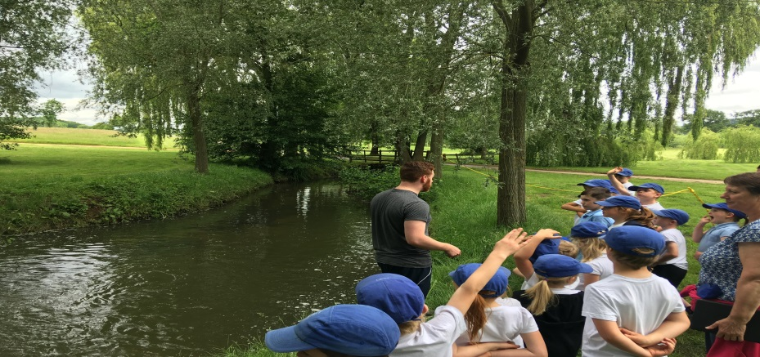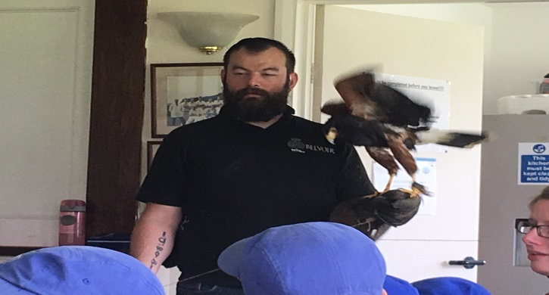..

**Cricket and Countryside Day**

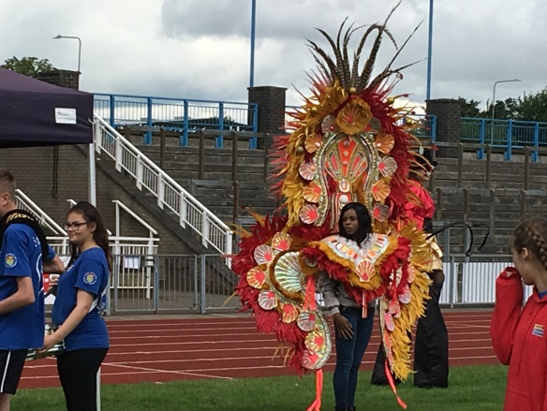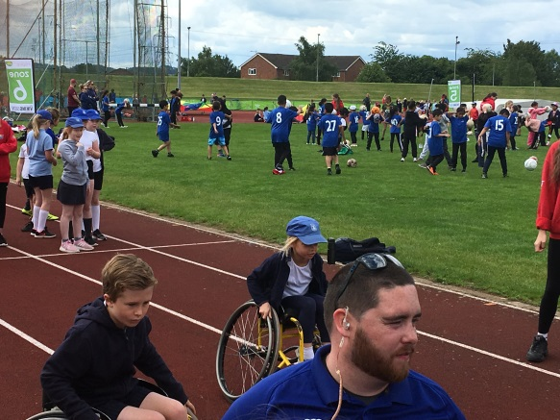.

**Year 3 & 4 Mini Olympics**

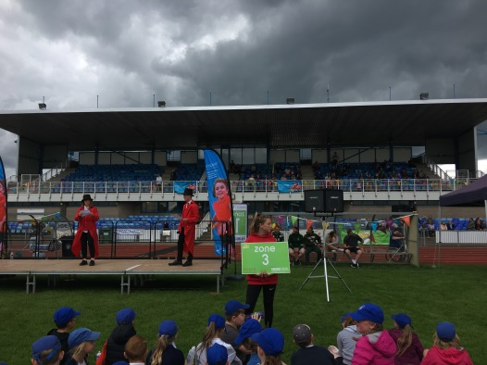

**Sports, Health and Well Being Update**

We really enjoyed the Year 3 &4 Mini Olympics in Grantham. Children had the opportunity to represent and explore different countries and cultures alongside experiencing a range of Olympic and Para-Olympic sports.

Well done to our Cycling and Quad Kids teams for their excellent performances .Our Netball team performed brilliantly, narrowly losing 1-0 in the final of the competition and finishing a fantastic second.

**Dates and Things to Remember:**

* Sports Day – Wed 26th June – 1:15-3pm*
* New Starters Transition – Thurs 27th June 1:30 -3pm
* Communications Evening – Thurs 27th June – 5:30pm*
* Summer Fair – Fri 28th June – 3:15-5:15pm*
* 5/6 Girls Football Tournament – Sun 30th June*
* KS2 Production – Wed 3rd July – 1:45pm & 6:45pm*
* Move up half day – Thurs 4th July (inc. new starters 9:30-11:30am)
* Year 6 Leavers Trip – Fri 5th July
* Leavers Disco - Fri 5th July – 7-8pm @WMI*
* Film Night – Mon 8th July*
* Year 6 Leavers Service and Last Day – Fri 12th July – 9:15am @ St Guthlac’s Church *

*\*Parents welcome*

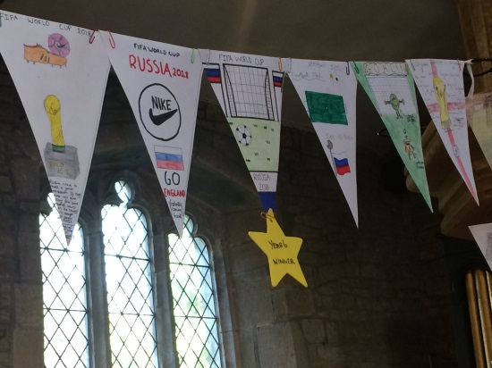

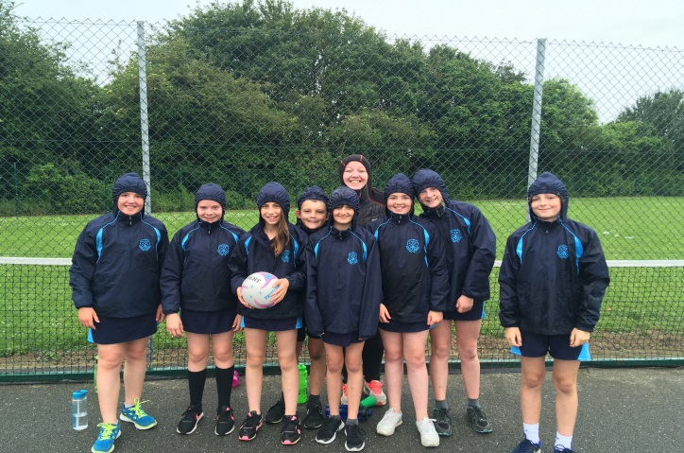

**Communications Evening- Thurs 27th June**

We would be delighted if you were able to attend our Communications Evening which will be on Thursday 27th June at 5:30pm. There will be a short presentation followed by a chance to offer your thoughts and opinions on a range of matters relating to future development and school in general. There will also be an opportunity to meet new staff.

If you would like to attend then please e-mail the school office at: [theoffice@stathern.leics.sch.uk](mailto:theoffice@stathern.leics.sch.uk) or telephone on: 01949 860316. If you have any items you would like including on the agenda then please let us know.

**Key Stage 2 Production – Wed 3rd July**

Tickets are now available for our performance of ‘Moon Bear’. We kindly request that children in Key Stage 2 are available for two performances: 1:45pm-3pm & 6:45pm-8pm on Wednesday 3rd July. If your child is unavailable for the evening performance then please let us know as soon as possible.

The performances will take place in the school playground and if you would like to request tickets then please contact the school office. In the event of bad weather performances may have to be rescheduled.

**Film Night – Mon 8th July**

We hope you can join us for our annual celebration of children’s writing, performing and film making skills. The event will be held in school this year but with the same red carpet theme and children having the opportunity to ‘dress to impress’!

Parents of children in classes 1 & 2 are invited between 5pm and 5:45pm whilst parents of children in classes 3 & 4 are invited between 6pm and 6:45pm. Following refreshments in Class 1 and an opportunity to look at the children’s writing in Class 2, the films will be shown across Classes 3 and 4.

If you would like to request tickets (£3 each) then please contact the school office. Tickets will be more readily available due to the change of venue. Parents and carers with children in both sessions wishing to attend twice will be offered up to 2 free tickets for the second session.

**Summer Fair – Fri 28th June**

Come and join us between 3:15pm and 5:15pm this Friday for lots of games, stalls, refreshments and children’s performances.

Dance performances for the children will run as follows:

Class 1: 3:30pm, Class 2: 3:45pm, Class 3: 4pm, Class 4: 4:15pm

A huge thank you to FOSS for organising the event. Don’t forget our non-uniform day this Thursday where we’d be grateful to receive any tombola contributions. Our children will also be serving their home grown vegetables from our small space gardening vessels to feed everyone!