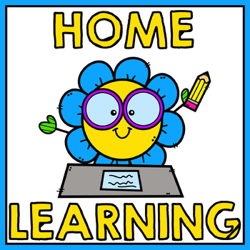
Welcome back Class 3!
Wow – where did that half term go? It has flown by and here we find ourselves at the start of a fresh, new half term! We hope that you had a well-deserved break over the last week away from the screen for home learning and managed pack in some quality family time!
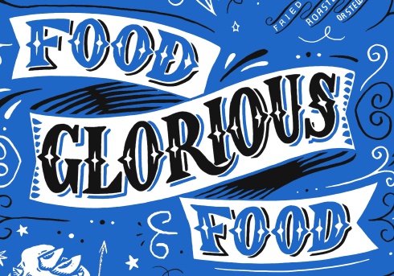
This half term, we move away from the Romans and their invasion of Britain and focus on a brand new topic for the next 5 weeks called: Food Glorious Food! We hope that you enjoy the activities that we have planned for you this half term and desperately hope that in a couple of weeks’ time, we will all be back together to continue this topic in school. However, for the time being, we need to continue learning at home and we know that you will continue to be the stars that you were last half term in showing determination and perseverance in completing the remote learning tasks planned for you.

This week, our main focus to introduce the topic will be based around ‘Healthy Lifestyles’ which is something very close to our hearts at Stathern Primary School. Throughout the week, you will investigate handling data in Maths where you will explore bar charts and take part in a live session on Friday. In English, your week’s learning will be based on the first 5 chapters of George’s Marvellous Medicine by Roald Dahl. Don’t worry if you do not have your own copy of the book as you will be provided with the relevant chapter for each lesson. Your other activities include poster making, exploring the work of Carl Warner and exploring macrophotography! We have introduced Well Being Wednesday and Family Friday too with activities focused for the whole family to take part in together.

Have a great first week back and see you TEAMS soon!

https://stathern.eschools.co.uk/website/class_3_pupils_-_remote_learning/521528
class3@stathern.leics.sch.uk Mrs Hill, Mrs Maxwell and Mrs Green

Weekly Theme: Healthy Lifestyles
Week 1 | Monday | Tuesday  Class 3 Weekly Planner | Wednesday | Thursday | Friday
English Activity | Finding descriptive words within a text  Chapter 1 George’s Marvellous Medicine  Complete activity sheet | Nouns and noun phrases  Chapter 2 George’s Marvellous Medicine  Replace nouns with you own nouns or noun phrases within a section of the chapter | Scanning a text  Chapter 3 George’s Marvellous Medicine  Complete activity sheet | Using organisational features to create a medicine bottle label  Chapter 4 George’s Marvellous Medicine  Find the missing information from the text to complete the sheet. | Present perfect tense of verbs  Chapter 5 George’s Marvellous Medicine  Rewrite 6 sentences into the present perfect tense.
Maths Activity | Pictograms | Drawing a bar chart | Reading Bar Charts | Interpreting a table | Live session: Taking a survey
Topic Activity  Afternoon Activity | PSHE  Life in Good Balance  Oak Lesson  Poster Making Activity | Art  Carl Warner  Create your own observational drawing of a fruit or vegetable | Well Being  Wednesday  Look on your assignments to choose your activity | Art  Macrophotography | Family Friday
TEAMS Drop In Session | Welcome Back Chat  1:00-1:30 | Lunchtime chat  12:30 -1:00 | Live story time  12:30-1:00 | Assembly with Mrs Lambert  1:00-1:30 | Live Maths session 11 – 11:30 (please watch the short video lesson first)

Things to prepare | Maths: You’ll need squared paper today  PSHE: You’ll need paper and pens for poster making.  English – Chapter 1 George’s Marvellous Medicine and worksheet | Maths: You’ll need squared paper, a ruler and a dice today  Maths: You’ll need squared paper and a ruler  English – Chapter 2 George’s Marvellous Medicine and worksheet | Maths: Printed problem sheet  English – Chapter 3 George’s Marvellous Medicine and worksheet | Art: You’ll need access to a camera (one on a phone or tablet is fine) We also recommend downloading the free app snap seed, but any photo editing app will be fine.  English – Chapter 4 George’s Marvellous Medicine and worksheet | Maths: Please watch the short video before the live lesson today. For the lesson you’ll need squared paper and a ruler.  English – Chapter 5 George’s Marvellous Medicine and lined paper

See you soon!
X

