

**Football Card**

We still have a few teams left, if all teams sell the winner will receive £50!!!!

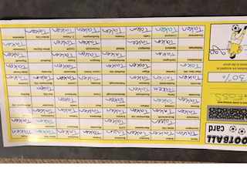

£2 a team – the more teams we sell the more you could win! Send your request to mswain@stathern.leic.sch.uk

£2 a team – email [mswain@stathern.leics.sch.ukwith](mailto:mswain@stathern.leics.sch.ukwith) your chosen team(all teams on a first come basis)

**Dear Parents, Pupils and members of the community,**

We hope this newsletter along with the other information on the website will help you find information about all the up-coming events that FOSS are organising and involved in. This year is even more of a challenge to raise funds as many of our fundraisers involve us all coming together for events, this isn’t possible at the minute with the current Covid-19 situation so we are having to try and raise the much needed funds in different ways. We have a new tab on the website that gives information about all our current fundraisers. This year FOSS is hoping to support the school in updating and increasing the technology within the school along with helping fund enriching experiences.

We are really hoping that lots of parents will come on board and get involved this year and help us support the school during these unpresented times.

Your support is very much needed from buying a Club100 number to being a member of our committee.

***FOSS***

*Friends of Stathern School*

[www.stathern.leics.sch.uk](http://www.stathern.leics.sch.uk)

01949 860316

FOSS

**Newsletter**

September 2020

**Bags2School**

Have you had a clear out recently?

We have a collection booked for the morning of Tuesday 29th September.

Please items in a black bag and place in the clearly labelled area by the front. Please adhere to social distancing whilst dropping bags off.

Here is a link to what they are able to accept <https://bag2school.com/what-we-collect>

Thank you for your support.

**Club 100**

Club 100 is back!

All details are under the Club100 section in the FOSS tab.

By helping us you could win yourself! The more numbers we sell the more you could win!!

**NEW MEMBERS!**

We are looking for new members to join FOSS – please contact Mary Swain or the school if you can help.