

**Dear parents, pupils and members of the community, welcome to our September newsletter.**

Welcome back and I hope you had an enjoyable summer break. I’ve included some photos of our new playground area which was finished on Sunday. The area has undergone quite a transformation and I feel the school has managed to improve the area in line with our two targets of having a larger play space that is useable all year round and new equipment that supports the physical development of the children. It will also provide better facilities for us to take our learning outdoors. A huge thank you to FOSS for supporting this project and on that note if you are able to join FOSS or just help out at certain events then please contact us. All of our children made contributions to what was a very successful Stathern Horticultural show. Each child from last year had made World Cup themed bunting and from this year had made an entry for the show on their first two days in school. It was a pleasure to be asked to present the awards at the show and we will be celebrating their achievements in school this week. We hope your child has settled well in school but please feel free to contact me if you wish to discuss anything. Further dates, photos and class updates can also be found on our website [www.stathern.leics.sch.uk](http://www.stathern.leics.sch.uk). We are looking forward to a fantastic term and one of our first jobs will be to further explore our vision and ethos for the school – something which I hope you will be able to get involved in and support us with. ***Mr Lee***

*“Achievement for all in a stimulating and caring environment”*

[www.stathern.leics.sch.uk](http://www.stathern.leics.sch.uk)

01949 860316

Stathern Primary School

**Newsletter**

September 2018

.

**Our New Playground Area!**

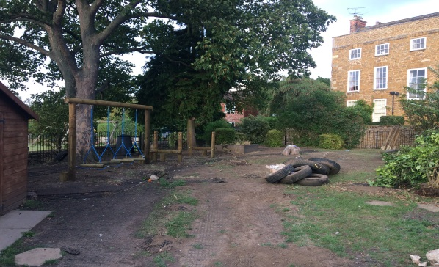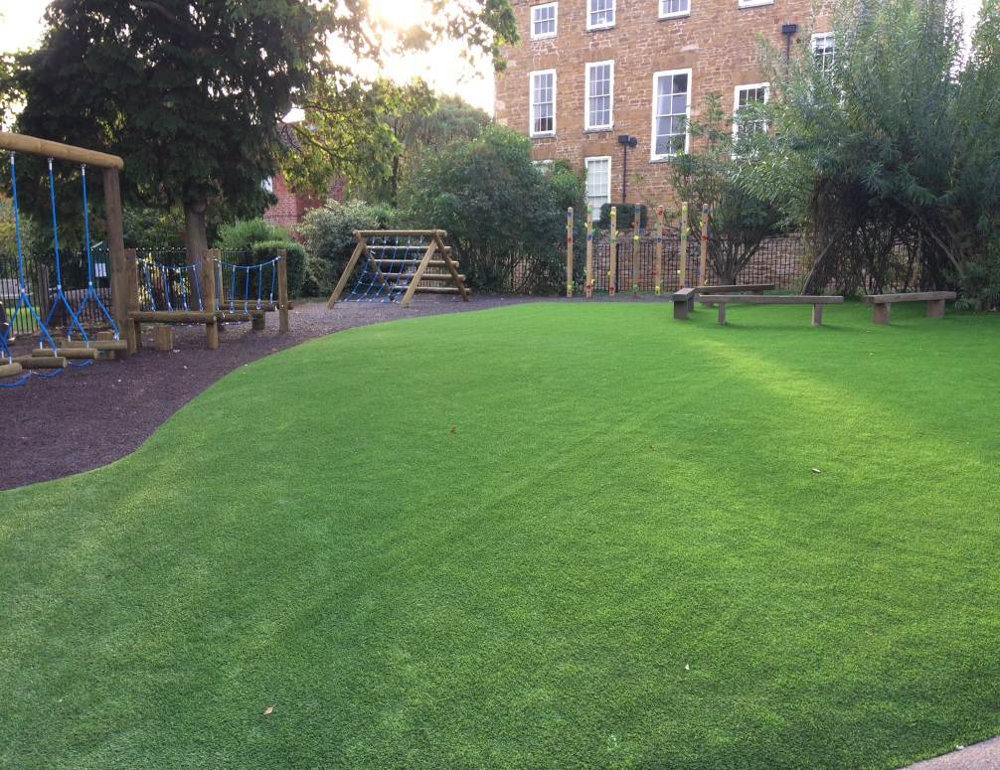

.

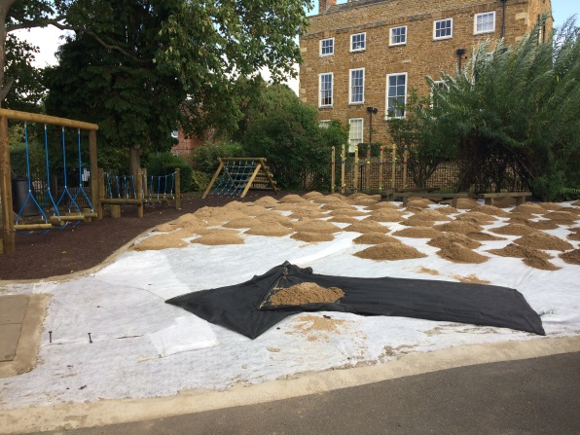

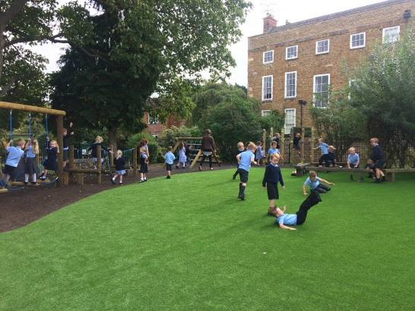

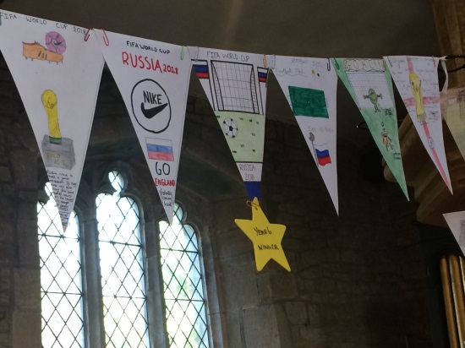

**Dates and Things to Remember:**

* Swimming Starts – Thurs 6th Sept – Yr3-5 (last session 20th Dec)
* Clubs Start Mon 10th Sept
* School Photos (Individuals) – Fri 14th Sept
* 2019/20 Prospective Parents Meeting – Thurs 4th Oct @ 6pm
* Harvest Festival – Fri 5th Oct 9:15am @ St Guthlacs – All children, parents invited.
* Parents Evening – Wed 10th & Thurs 11th
* Last Day before Half term – Fri 12th Oct
* Warning Zone – Mon 12th Nov – Yr5&6
* Great Fire of London Experience – Fri 16th Nov - Class 2
* Christmas Fair – Fri 30th Nov (provisional)
* Flu Immunisation – Tue 11th Dec YrR-6
* Christmas Dinner – Thurs 13th Dec
* Last Day before Christmas – Fri 21st Dec

**Sports and Clubs Update**

We are looking forward to another season of sporting opportunities and success.

This term we have festivals and competitions coming up in gymnastics, football, table tennis, dodgeball and cross country.

We hope your child will enjoy the PE and School Sport available in lessons, at lunchtimes and after school. Please sign up for clubs on the separate letter which your child will bring

home.

*Write* Now!

Creative writing after school club

**Fun new club for Y3 to Y6 children taster session Sept 11th.**

Do you love books, films or plays? Love poems or songs? Ever dreamt of writing your

own? Come and join our club and be inspired to write.

**Watch out for the FREE taster session on the first week of term.**

We’ll read amazing books, act out plays, play games, make story boards, write stories,

poems, reviews, scripts, lyrics for songs, perform our work, enter writing competitions,

author visits… Oh, and there’ll be biscuits! What are you waiting for?

*Write* Now!

**2019/20 Prospective Parents Meeting – Thurs 4th Oct – 6pm**

For those parents with children due to start in the academic year 2019/20, there will be a Prospective Parents Meeting on Thursday 4th October at 6pm. Parents are also invited to make individual appointments to look round the school should they wish to. Please pass on this information to any other parents who may be interested but do not receive this newsletter.

**Stathern Show** – Thank you to all who supported the show. Bunting winners are shown below!

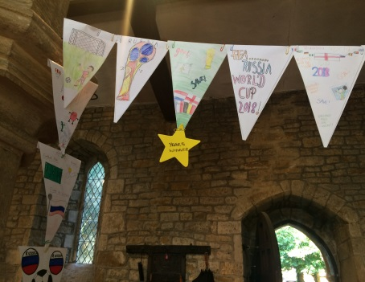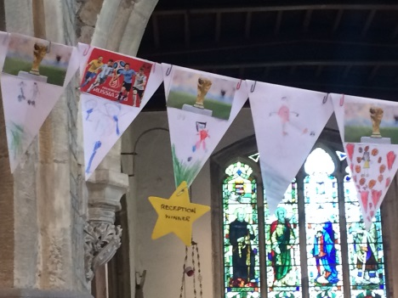

**FOSS**

FOSS are looking to recruit new members – please contact the school if you are interested in joining the team in raising money for exciting school projects.

**Midday Supervisor Position**

We are looking to recruit a new midday supervisor to work with us for any number of days up to 5 a week. If you are interested in the position or know someone who is then please contact the school or pass on our details.

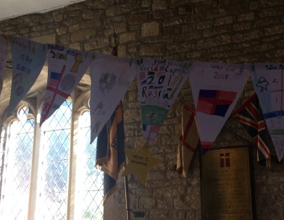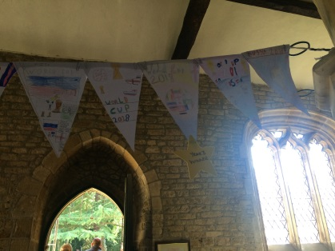

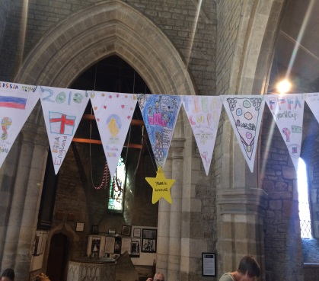

**School Photos – Fri 14th Sept**

Individual school photos will take place shortly and from 8:15am anyone who wants photos with siblings not of school age is invited to join us. The photographer will then photograph individuals during normal school hours along with joint pictures including brothers and sisters.