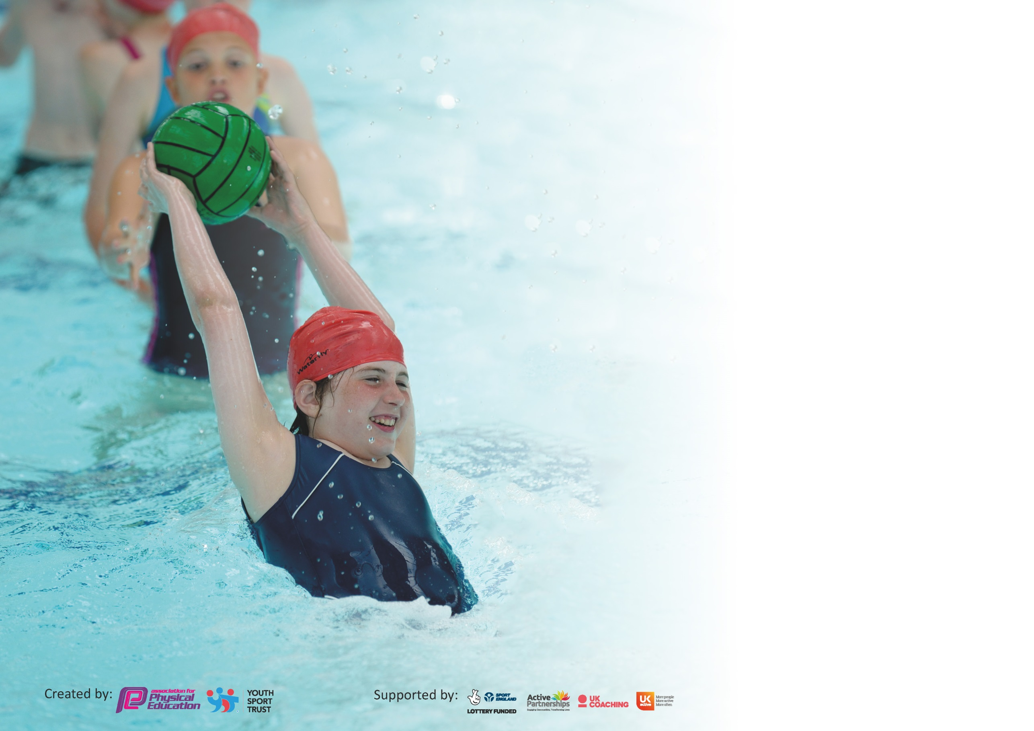

It is important that your grant is used effectively and based on school need. The Education Inspection Framework (Ofsted 2019 p64) makes clear there will be a focus on ‘whether leaders and those responsible for governors all understand their respective roles and perform these in a way that enhances the effectiveness of the school’.

Under the Quality of Education criteria (p41) inspectors consider the extent to which schools can articulate their curriculum (INTENT), construct their curriculum (IMPLEMENTATION) and demonstrate the outcomes which result (IMPACT).

To assist schools with common transferable language this template has been developed to utilise the same three headings which should make your plans easily transferable between working documents.

Schools must use the funding to make additional and sustainable improvements to the quality of Physical Education, School Sport and Physical Activity (PESSPA) they offer. This means that you should
use the Primary PE and Sport Premium to:

- Develop or add to the PESSPA activities that your school already offer
- Build capacity and capability within the school to ensure that improvements made now will benefit pupils joining the school in future years

Please visit gov.uk for the revised DfE guidance including the 5 key indicators across which schools should demonstrate an improvement. This document will help you to review your provision and to report your spend. DfE encourages schools to use this template as an effective way of meeting the reporting requirements of the Primary PE and Sport Premium.

We recommend you start by reflecting on the impact of current provision and reviewing the previous spend.

Schools are required to publish details of how they spend this funding as well as on the impact it has on pupils’ PE and sport participation and attainment by the end of the summer term or by 31st July 2020 at the latest.

We recommend regularly updating the table and publishing it on your website throughout the year. This evidences your ongoing self-evaluation of how you are using the funding to secure maximum, sustainable impact. Final copy must be posted on your website by the end of the academic year and no later than the 31st July 2020. To see an example of how to complete the table please click HERE.

Support for review and reflection - considering the 5 key indicators from DfE, what development needs are a priority for your setting and your pupils now and why? Use the space below to reflect on previous spend and key achievements and areas for development.

Key achievements to date until July 2020: | Areas for further improvement and baseline evidence of need:
Increase in the number of personal challenges and level 1 competitions, to ensure engagement of all pupils in at least 30 minutes’ physical activity a day.  Happy lunchtimes training completed and new ideas implemented to ensure pupils are happy and active at lunchtime.  Increase in the number and variety of activities offered as extra –curricular clubs to help more pupils engage in 60 minutes activity a day.  Increased number of blogging onto the school website and Stathern’s school games page.  Initial training conducted for increasing the level of activity in lessons throughout the school day and high staff and children engagement in this new school development. | Implementation of the Daily Mile to aid with the engagement of all pupils in regular physical activity.  Increase in the variety of physical activities offered at break and lunchtime to aid with the engagement of less active pupils in regular physical activity.  Active lessons to continue to be increased across the whole school and continue to be embedded into the whole school ethos and school development plan

Meeting national curriculum requirements for swimming and water safety.
What percentage of your current Year 6 cohort swim competently, confidently and proficiently over a distance of at least 25 metres?  N.B. Even though your pupils may swim in another year please report on their attainment on leaving  primary school at the end of the summer term 2020. | 100%
What percentage of your current Year 6 cohort use a range of strokes effectively [for example, front crawl, backstroke and breaststroke]? | 100%
What percentage of your current Year 6 cohort perform safe self-rescue in different water-based situations? | 100%
Schools can choose to use the Primary PE and Sport Premium to provide additional provision for swimming but this must be for activity over and above the national curriculum requirements. Have you used it in this way? | No

Action Plan and Budget Tracking
Capture your intended annual spend against the 5 key indicators. Clarify the success criteria and evidence of impact that you intend to measure to evaluate for pupils today and for the future.

Academic Year: 2018/19 | Total fund allocated: £ | Date Updated:
Key indicator 1: The engagement of all pupils in regular physical activity – Chief Medical Officer guidelines recommend that primary school pupils undertake at least 30 minutes of physical activity a day in school |  |  |  | Percentage of total allocation:
 |  |  |  | 20%
Intent | Implementation |  | Impact
Your school focus should be clear what you want the pupils to know and be able to do and about  what they need to learn and to  consolidate through practice: | Make sure your actions to achieve are linked to your intentions: | Funding allocated: | Evidence of impact: what do pupils know now and what can they do now? What has changed?: | Sustainability and suggested next steps:
- To implement the Daily mile to aid with the engagement of all pupils in regular physical activity.  - Increase in the variety of physical activities offered at break and lunchtime aid with the engagement of all pupils in regular physical activity.  - Increase activity level within the classroom using strategies such as brain breaks and ice breakers. | - CPD  - Purchase more equipment  - Change4life resources and training from Clare Marlow for Sports crew members  - Student voice – questionnaire on physical activity within their daily lessons. | £3402 | - Student’s feel their lessons have increased with activity and are happier because of it.  - Lunchtime activity/challenge class lists increased  - Daily boost data  - Behaviour records show less incidents at break times and lunch times.  - Attainment improvement across all classes | Maintain high level of activity across the school day.  Maintain a variety of KS1 and KS2 centred activities and break and lunchtimes and use local providers to keep children excited and interested in different activities.  Regular CPD across the whole school to embed the active learning ethos and continued implementation of the daily mile.
Key indicator 2: The profile of PESSPA being raised across the school as a tool for whole school improvement |  |  |  | Percentage of total allocation:
 |  |  |  | 20%
Intent | Implementation |  | Impact
Your school focus should be clear what you want the pupils to know and be able to do and about  what they need to learn and to  consolidate through practice: | Make sure your actions to achieve are linked to your intentions: | Funding allocated: | Evidence of impact: what do pupils now know and what can they now do? What has changed?: | Sustainability and suggested next steps:
- Certificates to be given out in assembly to celebrate school values through physical activity at lunchtimes.  - Sports crew activities and notice board to celebrate pupils sporting successes  - Inspire plus activities and challenges/competitions  - Whole school initiatives being implemented by all staff for example Daily Mile and Daily Boost to promote PESSPA | - Sports crew to organise and deliver termly competitions to help engage pupils in physical activity and sport  - Weekly assemblies that focus on the celebration of sporting achievements  - All pupils to engage in Daily Boost activities.  - Sports crew board to contain sports team photos, personal challenge scores and competition winners work | £3402 | - Increased knowledge of the benefits of being active and the benefits of taking part in sport and physical activity  - Increase in the enthusiasm and passion for sport and physical activity but overall being healthy both mentally and physically | Continue to evaluate new ideas and keep updating activities so children stay engaged and enthusiastic.  Regular CPD for staff with new ideas for daily boost and ideas to promote PESSPA across all subjects.

Key indicator 3: Increased confidence, knowledge and skills of all staff in teaching PE and sport |  |  |  | Percentage of total allocation:
 |  |  |  | 30%
Intent | Implementation |  | Impact
Your school focus should be clear | Make sure your actions to | Funding | Evidence of impact: what do | Sustainability and suggested
what you want the pupils to know | achieve are linked to your | allocated: | pupils now know and what | next steps:
and be able to do and about | intentions: |  | can they now do? What has
what they need to learn and to |  |  | changed?:
consolidate through practice:
- CR and SM to continue to support staff in the planning and delivery of 2 hours of high quality PE a week.  - Upskilling of new staff in areas of less confidence/knowledge or new PE initiatives.  - Staff audit to be completed to provide areas of improvement for all staff. | - CPD  - Upskilling of staff on new activities/resources  - Use of National Governing body websites to upskill staff on new skills/games/lesson structures. For example England Hockey Hub and England Netball | £5103 | - Pupils are being taught two hours of high quality PE a week  - Curriculum is being updated with new initiatives and to include a variety of inclusive sports | PE specialist and PE co-ordinator to work on ensuring the curriculum is clear and of high quality in terms of Intent, Implementation and Impact.  Use PE specialist to upskill staff only when necessary. For example; new staff or a new initiative.  Staff to be receive regular CPD so their confidence in delivering high quality PE is high.
Key indicator 4: Broader experience of a range of sports and activities offered to all pupils |  |  |  | Percentage of total allocation:
 |  |  |  | 20%
Intent | Implementation |  | Impact
Your school focus should be clear | Make sure your actions to | Funding | Evidence of impact: what do | Sustainability and suggested
what you want the pupils to know | achieve are linked to your | allocated: | pupils now know and what | next steps:
and be able to do and about | intentions: |  | can they now do? What has
what they need to learn and to |  |  | changed?:
consolidate through practice:
- Wider range of activities offered at lunchtimes and extra-curricular clubs to increase the engagement of pupils being active for at least 60 minutes a day.  - Wider range of activities being taught to pupils during their PE lessons to engage all pupils in two hours of high quality physical activity | - Student voice to be used to help with what activities to deliver.  - Purchase of new equipment  - Sports crew members to attend training with Clare Marlow to develop their skills in designing new games and activities to deliver at break and lunchtimes.  - Smarty pilates and Yoga resources  - Orientreering  - Melton and Belvoir partnership funding – work it weekly and rugby clubs | £3402 | - Pupils have experienced a wide range of physical activities and we have seen an increased engagement in lunchtime and extra-curricular clubs  - Feedback form student voice is very positive from pupils about the variety of activities being delivered during their PE lessons. | Continual review of activities available to children and purchase any new equipment when necessary.  PE co-ordinator to engage staff with new CPD on offer and take advantage of different buy in schemes available.

Key indicator 5: Increased participation in competitive sport |  |  |  | Percentage of total allocation:
 |  |  |  | 10%
Intent | Implementation |  | Impact
Your school focus should be clear | Make sure your actions to | Funding | Evidence of impact: what do | Sustainability and suggested
what you want the pupils to know | achieve are linked to your | allocated: | pupils now know and what | next steps:
and be able to do and about | intentions: |  | can they now do? What has
what they need to learn and to |  |  | changed?:
consolidate through practice:
- To attend at least 50% of the School games competitions on offer this year.  - To take B teams to as many competitions as possible to increase participation in competitive sport for a wider range of children.  - To offer more competitive sport opportunities at lunchtimes and after school. | - Sports crew training  - CR to deliver half termly house tournaments in a range of different sports  - CR and sports crew to deliver half termly Melton Sports challenges run by Clare Marlow.  - Link the curriculum to the School Games calendar to give a larger amount of children the opportunity to compete at level 2. | £1701 | - Increase in the number of pupils engaged in competitive sport at lunchtimes and in school games competitions  - Positive feedback from pupils via student voice on the number and variety of competitive sporting opportunities that are available to all pupils on a weekly basis. | Review children’s participation in competitive sport throughout the year and engage children who have not participated in competitive sport.  CPD for lunch time staff so they are confident at organising competitive sporting opportunities for children during lunchtimes.

Signed off by
Head Teacher: | Matthew Lee
Date: | 27/7/20
Subject Leader: | Sarah Minnaar
Date: | 3/7/20
Governor:
Date:

