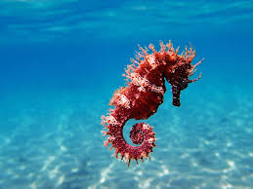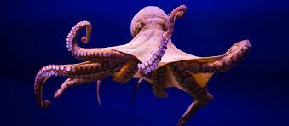 **Lesson 2 – Under the Sea Warm up – Andy’s wild workout – Under the Sea (BBC i-player and CBeebies)**

**Main activity** – Hold each pose for between 30 seconds to 1 minute and repeat the poses as many times as you want!

**Octopus** - Lay on your back and wiggle arms and legs from side to side – remember to squeeze your tummy muscles!

**Crab** - Sit on your bottom with your legs crossed and make snappy claws with your hands. Twist your body from side to side.

**Starfish** – Option 1: Lay on your back in a starfish shape. Option 2: lay on your tummy in a starfish shape. Option 3: stand up tall in a starfish shape. Make sure you stretch your arms and legs and try and hold the different poses for 20 seconds each.

**Shark** – Lay on your tummy and make your hand into a fin shape. Wiggle your body and move around the room like a shark.

**Jellyfish** – Stand up tall and straight. Wiggle your arms, legs and body whilst keeping your feet glued to the floor.

**Dolphin** - Move around the room jumping up and down as if jumping out of the water like a dolphin! Remember to bend your knees when taking off and landing your jumps.

**Extension activity** – Have a think about what other creatures live under the sea and create your own pilates poses/moves!