

**Challenge 5 50m Shuttle Run**

***How quickly can you complete 5 lengths of a 10metre course?***

**What you’ll need:** - Cones, pegs, tape, tins or clothes to use as markers

- Measuring tape/ruler

- Stopwatch to record your time

**How to play:** - Set up a 10m running lane with markers at either end

- The aim is to run the 10m distance a total of 5 times to complete 50m as quick as you can

- Get help from someone at home to record your time with the stopwatch

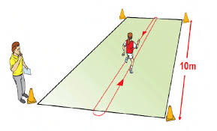



Working together can still motivate you to achieve your personal best, why not reach out to one of your friends to show some support?

**Challenge 6 Obstacle Course**

**S*et up a course using household objects outdoors and set your own rules for success.***

**What you’ll need:** - Lots of household objects

- Things to run around, jump over etc.

- A stopwatch?

**How to play:** - Set up a course and decide how you want your challenge to take place

**-** How many obstacles can you run around or jump over in 60 seconds?

**-** How many circuits can you complete in 5 minutes?

**-** How quick can you complete your course?

- Be creative! Place out objects; pillows, teddies around the space.

- Each time you jump over an object you could score a point.

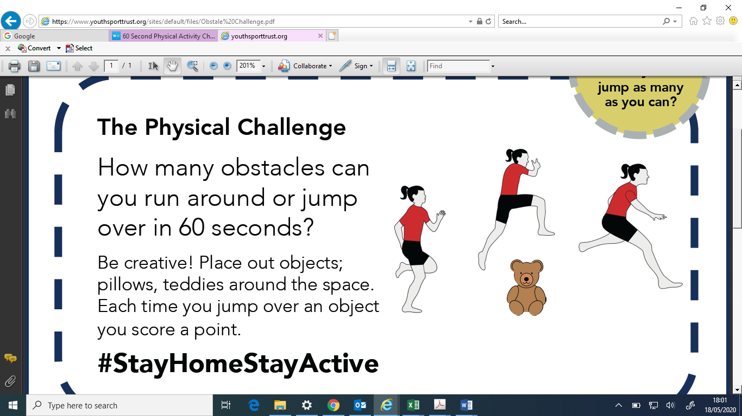

Design a flag or banner showing support for your School or Area ahead of next Week’s School Games Summer Championships

**Personal best score card  
Submit results by 4pm on Friday 19th June**

**Name:**

|  |  |  |
| --- | --- | --- |
|  | **Your best score/time** | **How many attempts did you have throughout the week?** |
| **Challenge 5** |  |  |
| **Challenge 6** |  |  |

**We’d love to see you in action so why not tweet us a clip of you taking part** [**@MeltonBelvoir**](https://twitter.com/meltonbelvoir?lang=en)[**@SouthCharnwood**](https://twitter.com/SouthCharnwood?ref_src=twsrc%5Egoogle%7Ctwcamp%5Eserp%7Ctwgr%5Eauthor)

**Next week will see the whole of the County invited to take part in the School Games Summer Championships, don’t miss out on taking part.**