**Hi there Class 3 – you’ve made it to week 5!**

**Only two weeks to go until half term!**

As we begin our 5th week apart, we hope that you are all still smiling those amazing smiles of yours. They really do brighten up our day when we see you on TEAMS. We know that some of you will be finding the news difficult that we still have more weeks ahead until we can fully reunite. However, we are immensely proud of your focus and dedication to joining our live sessions as well as completing the assignments that you have been able to have a go at. Keep looking after yourselves and your grownups at home – we miss seeing you all!

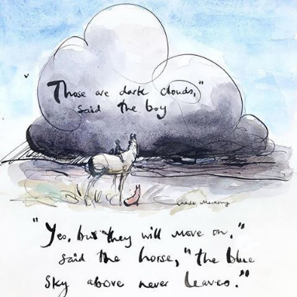The main focus as we continue our Roman topic this week is: ‘How did the Romans change Britain?’ You will discover why the Romans built roads, have a go at building your own edible Roman road, understand how the Romans kept towns and cities clean as well as how they governed their towns and cities. In Geography, you will further explore the United Kingdom and practise using the 8 points of a compass. As a little heads up, in our last week of term, we’d like to celebrate all of your fantastic learning this term with an optional virtual Roman Banquet (cheese, fruit and bedsheet togas...). You may also like to join in with an optional bread baking activity in that final week for which you will need dried yeast and bread flour.

Don’t forget to complete your EdShed and Reading Eggs assignments that we are setting for you as well as practising your quick recall of times table facts on 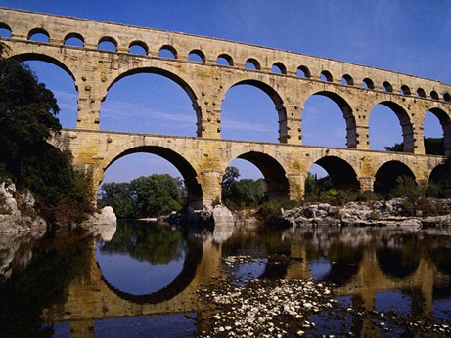TT Rockstars. We know some of you are finding these tricky to fit in and we think you are all doing brilliantly! I know some of you prefer to do these a few each day, or you may like to spend some time on Friday taking a look at these assignments. We do recommend that spellings and number facts are best practised a little each day. Don’t forget to take a look at the times fables activities as well if you haven’t already. Repeat these until you know them off by heart!

We wonder who has started their ‘2021’ Activity Challenge! Don’t forget to record your activity each day once you have completed your 20 minutes of physical activity. Which challenges did you manage to have a go at or are you going to start this week?

<https://stathern.eschools.co.uk/website/class_3_pupils__remote_learning/521528>

[class3@stathern.leics.sch.uk](mailto:class3@stathern.leics.sch.uk)

Mrs Hill, Mrs Maxwell and Mrs Green

**Class 3 Weekly Planner**

|  |  |  |  |  |  |
| --- | --- | --- | --- | --- | --- |
| Wk 5 | Monday | Tuesday | Wednesday | Thursday | Friday |
| English Activity | Journalistic Vocabulary  [Oak National Academy Lesson](https://classroom.thenational.academy/lessons/to-generate-formal-journalistic-vocabulary-6tj64r) | Planning the opening and recount paragraphs  [Oak National Academy Lesson](https://classroom.thenational.academy/lessons/to-plan-the-opening-and-chronological-recount-paragraph-of-a-newspaper-report-60r38d) | Writing the opening paragraph to a newspaper report  [Oak National Academy Lesson](https://classroom.thenational.academy/lessons/to-write-the-opening-of-a-newspaper-report-cnhp2e) | Writing the recount paragraph to a newspaper report  [Oak National Academy Lesson](https://classroom.thenational.academy/lessons/to-write-the-chronological-recount-paragraph-of-a-newspaper-report-69gp2t) | Past, present and future tense  [Oak National Academy Lesson](https://classroom.thenational.academy/lessons/to-practise-using-simple-past-present-and-future-tense-c5hp2c) |
| Maths Activity | Perimeters on a grid | Calculating Perimeter | Perimeter of squares and rectangles: a special case | Perimeter with missing values | Perimeter of rectilinear shapes |
| Topic Activity  Afternoon Activity | **Mindfulness**  Rest and Routine | **History**  [**How did the Romans change Britain?**](https://classroom.thenational.academy/lessons/how-did-the-romans-change-britain-60r3gt)  Oak Academy Lesson | **History/DT**  Romans: The Dawn of Plumbing  Aqueducts | **Geography**  Compass Directionsand Roman Roads | **PE**  Roman Dance lesson |
| TEAMS Drop In Session | Mrs Hill’s Drop In Session  1:30-2:00 | Quick Draw  **Can you draw a picture from a description?**  1:30 Live session | Show and Tell  12:30-1:00 | Assembly with Mrs Lambert  1:00-1:30 | Maths Drop In Session  1:30-2:00 |
| Things you might need to prepare | Maths: Squared paper (see resources if you don’t have any)  Mindfulness: coloured wool or string, paper plate (or card circle) and something to colour with. You may also like to add beads, stickers or feathers if you have any. | Quick draw activity: paper and a pencil/pen | Build your own aqueduct activity:  Water tank (or something to hold water), cardboard, plastic sheeting or plastic bags, clear tubing, sharp knife (adult to use this), scissors, large plastic bottle filled with water, measuring tape, strong duct tape or something similar. | Geog: printed map and compass worksheet sheet  Optional edible Roman Roads Activity: Maltesers, plain biscuits, ready made custard, custard cream biscuits, smarties, a clear container. | Maths: printed copy of today’s worksheet |

|  |  |
| --- | --- |
| English Monday | <https://classroom.thenational.academy/lessons/to-generate-formal-journalistic-vocabulary-6tj64r> |
| English Tuesday | <https://classroom.thenational.academy/lessons/to-plan-the-opening-and-chronological-recount-paragraph-of-a-newspaper-report-60r38d> |
| English Wednesday | <https://classroom.thenational.academy/lessons/to-write-the-opening-of-a-newspaper-report-cnhp2e> |
| English Thursday | <https://classroom.thenational.academy/lessons/to-write-the-chronological-recount-paragraph-of-a-newspaper-report-69gp2t> |
| English Friday | <https://classroom.thenational.academy/lessons/to-practise-using-simple-past-present-and-future-tense-c5hp2c> |
| History Lesson | <https://classroom.thenational.academy/lessons/how-did-the-romans-change-britain-60r3gt> |
| History/DT Lesson | <https://www.youtube.com/watch?v=mR9TuOXCF7k> |

See you soon on TEAMS!

X