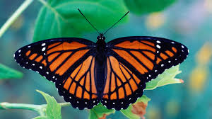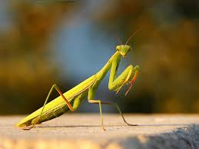 **Lesson 3 – Insects**

**Warm up – Andy’s wild workout – The undergrowth (BBC i-player and CBeebies)**

**Main activity** – Hold each pose for between 30 seconds to 1 minute and repeat the poses as many times as you want! (Optional music – Complete the poses to the Bare Necessities song from the Jungle Book).

**Ant** – Stand up tall with your arms by your side and your feet shoulder width apart. Match on the spot with high knees and swing your arms.

**Snail** – Lay on your tummy and bring your feet up to your bottom. Try and hold onto your feet with your hands and lift your head and chin up.

**Butterfly** – Sit on your bottom and make a diamond shape with your legs so that the soles of your feet are touching. Move your legs up and down like butterfly wings but make sure your feet stay touching and you keep your back straight.

**Praying mantis** - Stand up tall with your arms in the air and your feet shoulder width apart. Lift one foot off the floor and hold it still. Swap and lift the other foot. (Balance activity like Tree pose).

**Grasshopper** – Crouch down into a ball shape and then jump into the air like a grasshopper, making sure that you keep your knees bent when you land your grasshopper jump!

**Bee** – Tip toe around your space and flap your arms like you have wings! Swoop down to the ground and gather some pollen from a flower and then continue to move around your space on your tip toes.

**Monkey beetle** – move around your space on your hands and feet like a monkey beetle collecting food for its tribe.