

**Dear parents, pupils and members of the community, welcome to our July newsletter.**

Thank you for all your support this year. This last month we have seen the children put on some marvellous performances and show their wide range of skills and talents. Receiving our award for our work in connecting children to the roots and origins of food through our small space gardening and food events was a real honour. We will be working closely with The Soil Association next year to support out children’s physical and mental health through food and growing. Our Film Night event was a great celebration of our children’s fantastic writing which has been inspired by film making. Thank you to all those who nominated children for their ‘Courage’ and ‘Creativity’ – two of our important character words. A huge well done to our Key Stage 2 team led by Miss Widdowson for their wonderful open air performance of ‘Moon Bear’ – it was a real treat and showed children’s ability to act, sing and dance to a very high standard. It was also a fantastic Summer Fair; the sun came out and the food, performances and fun were delivered brilliantly by FOSS, pupils and school staff. Thank you to all who supported the school disco as well. A huge thank you and good luck to our brilliant year 6 pupils who are now moving on to secondary school. They have had a fantastic journey and have made us so proud during their time at Stathern Primary School. Miss Pearce will sadly be retiring after 16 years working in the school, I’m sure you will join me in thanking her and wishing her good luck in the future. Next term we are looking forward to welcoming two new Teaching Assistants to the school – Mrs Ali Dee and Mrs Melissa Green, who has already been working in school. I hope you have a great summer break and look forward to welcoming you back in the new academic year. ***Mr Lee***

*‘Nurture Inspire Discover Create’*

[www.stathern.leics.sch.uk](http://www.stathern.leics.sch.uk)

01949 860316

Stathern Primary School

**Newsletter**

July 2019

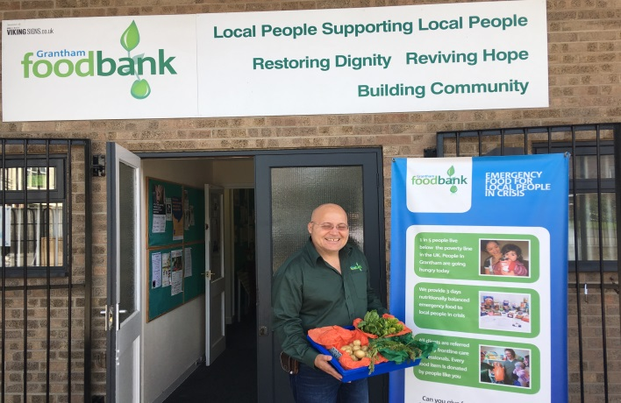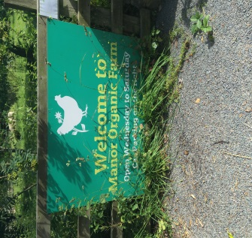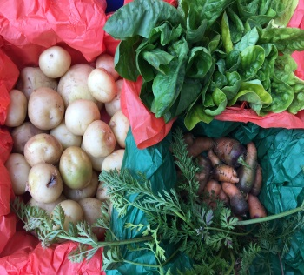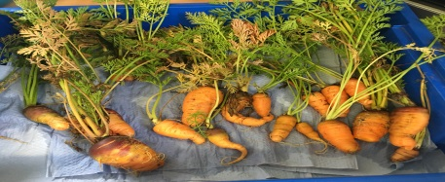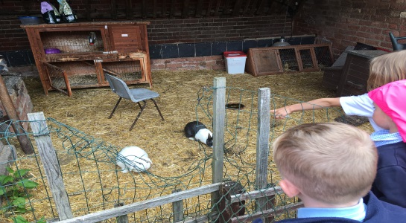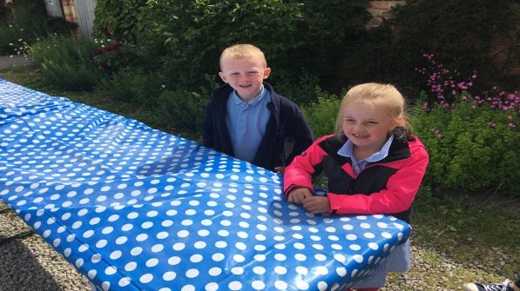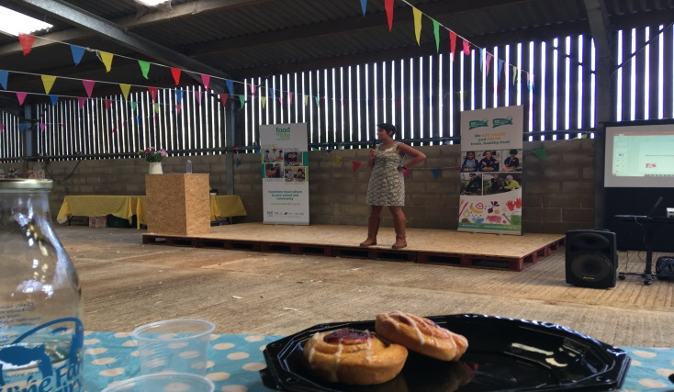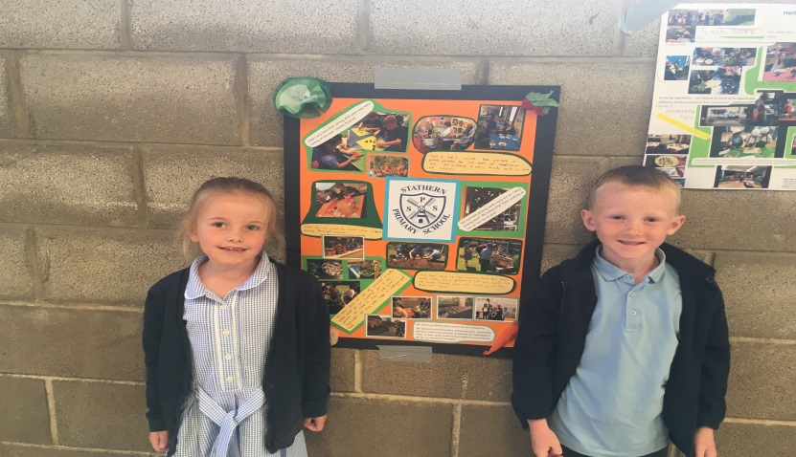..

**Food For Life – The Soil Association – *A Celebration of Our Award and The Journey of Our Small Space Gardening Produce!***

.

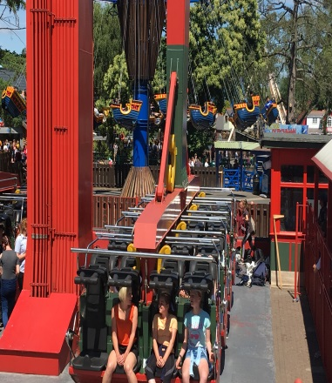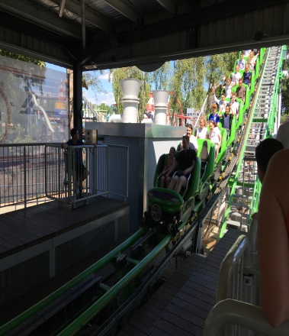

**Sports, Health and Well Being Update**

Well done to our Girls Football team for their brilliant win in the recent tournament at Asfordby. Many of the girls have been training and playing for 3 years and both the team on the day and the whole squad really deserved the win. Following a series of wins, the team managed to overcome their close rivals 1-0 in the final after drawing 2-2 with them in the group stages. It was a really special performance!

**Year 6 Leavers Trip – Drayton Manor**

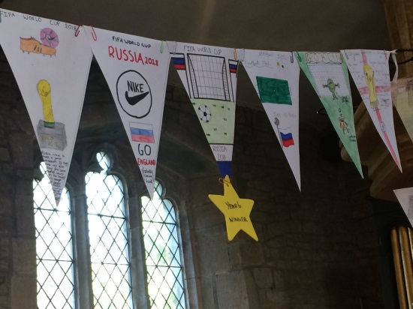

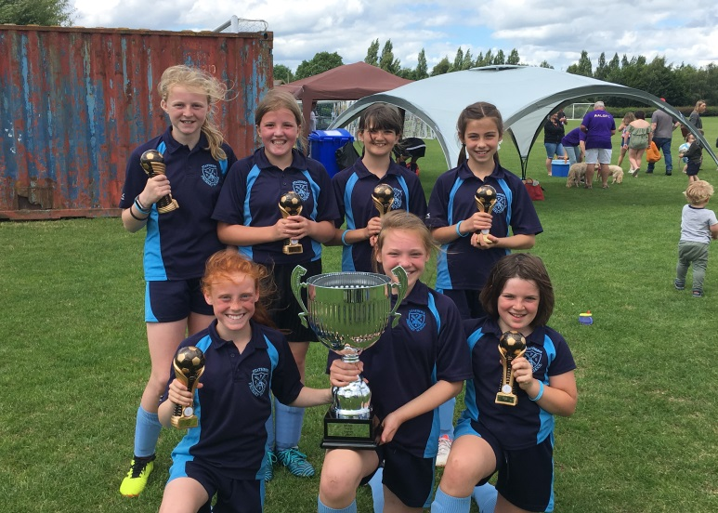

**Film Night – *Celebrating Writing and Film Making***

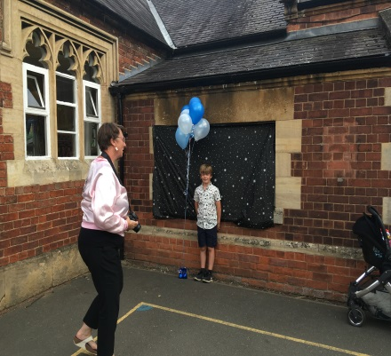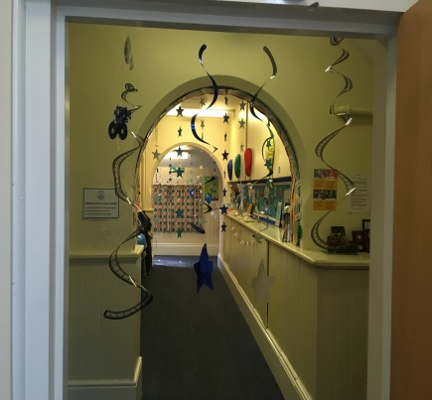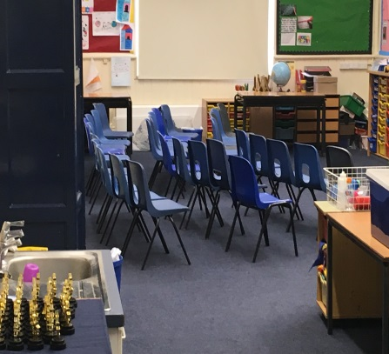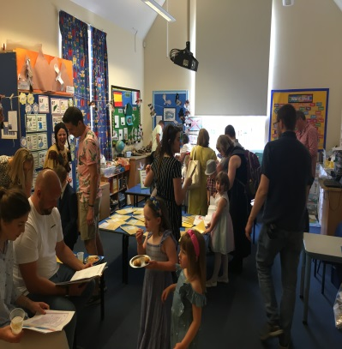

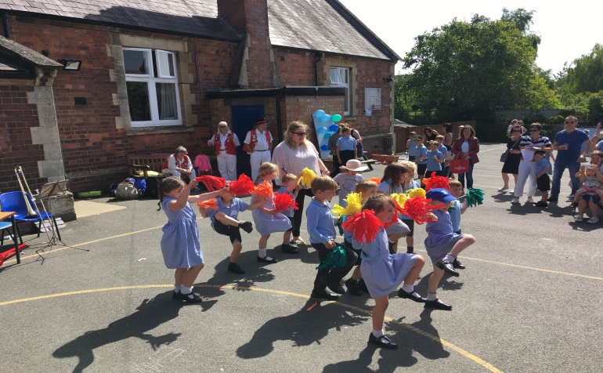

**Summer Fair**

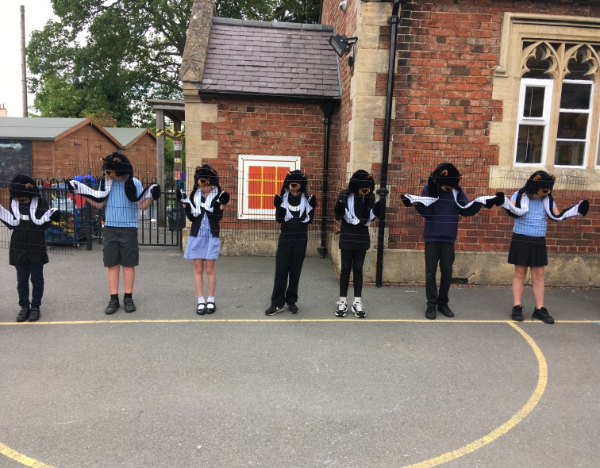

**Key Stage 2 Production – Moon Bear**

