

**Dear parents, pupils and members of the community, welcome to our February newsletter.**

I would like to start by announcing the date for our Ethos and Visions Family Event where we will be sharing our new Ethos, Vision and Values in full and asking parents, carers and family members to come and take part in a spot of ‘Small Space Gardening’. We will be asking you to work with your child/children to produce exciting designs that utilise plastic pop or milk bottles, old wellies and a range of other interesting and unusual vessels! During the event, we will show you how we are embedding our teaching of character whilst producing an outcome that will make a difference to the community. Our ‘Small Space Gardening’ products will be used to support healthy eating and well-being, both in school and around the community. If the designs are good enough, they may even be able to go out beyond the school gates! We hope you will be able to keep the date free and join us for one of the sessions – it will be a really good opportunity to explore the exciting direction that the school is heading in, following the much valued input from pupils, parents, staff and governors. In the meantime should you have anything you wish to discuss then please do not hesitate to contact me. ***Mr Lee***

*“Achievement for all in a stimulating and caring environment”*

[www.stathern.leics.sch.uk](http://www.stathern.leics.sch.uk)

01949 860316

Stathern Primary School

**Newsletter**

February 2019

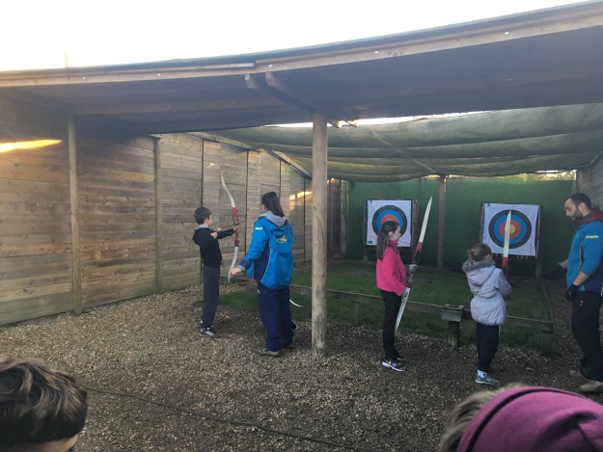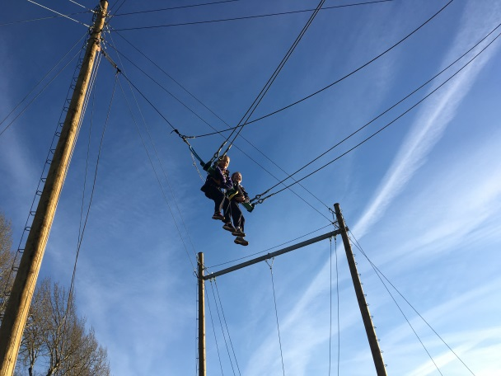..

**PGL Half Day – Year 4 –** Well done to all the children in Year 4 who took part in Giant Swing and Archery!

**Ethos and Visions Family Event - Wednesday 27th March 2pm – 5:30pm (3 x 1 hour sessions will be available)**

Can you donate any:

Seeds, Plug Plants, small

vegetable or flower

plants, wellies, milk

cartons, pop bottles

(2litre), old plant pots,

small wheelbarrows,

toy shopping trolleys or

other small unusual

plant growing vessels?!

.



**Dates and Things to Remember:**

* Y3-6 Sky Dance Challenge – Wed 13th Feb
* Y3/4 Hathersage Residential – 25th-27th Feb
* Class 2 Cross Country @ Longfield – 1st March
* Y6 Pre-residential Meeting – 4th March 3:15pm
* Rev. Jamie @St Guthlacs – Lent Assembly (parents welcome) - 4th March 9:15am
* World Book Day – Thurs 7th March
* Y2 Pre-residential Meeting – 11th March 3:15pm
* Y4 Vale Choir – Wed 13th March – 2pm rehearsal + 7pm evening performance (parents welcome)
* Y6 PGL Residential – 18th – 20th March
* Ethos & Vision Family Event – Wed 27th March 2pm-5:30pm (parents welcome)
* Parents Evening – 2nd & 3rd April 3:30pm-6pm
* Easter Service & Celebration Assembly @ St Guthlacs – Mon 8th April (parents welcome)
* Y2 Beaumanor Residential – 9th & 10th April
* Wear Your Hat Day (Last Day) -12th April

**Sports, Health and Well Being Update**

Thank you to all who have supported us with the first task on the Legacy Challenge where children had to complete a word search and try as many of the vegetables as they could! Class 1’s challenge will be available shortly.

Well done to our swimming team who managed to finish 4th overall and performed exceptionally well in the competition at Melton. Congratulations also to our team who finished 2nd at the recent Futsal event. They played brilliantly and I know they were disappointed not to win but what a superb team performance.

Ben Smith, who ran 401 marathons in 401 days, delivered an inspirational assembly in school. His story of how he turned his own experiences of bullying into such a positive force to raise money and awareness in support of

children today was

remarkable! Thanks Ben.



**World Book Day – Thurs 7th March**

Get ready to dress up as your favourite book character on World Book Day next month. We can’t wait to see who you’ll choose to be!





**Uniform Reminder**

Unfortunately, a small amount of trainers have started to be worn by children instead of shoes. Can we kindly ask that parents/carers use the half-term to make sure that children are in the correct uniform.

**Governor Corner – By Sarah Cross**

I became a governor last year and find it a great honour to be able to share with you a little of what I have seen so far.

The finance committee meet once a term with responsibility to understand the school’s budgets and question/challenge to ensure that money is being spent in the best way possible. I can honestly say that I have great confidence in the financial running of the school and decisions taken.

As Governor Safeguarding lead I visit the school every term to review policies/procedures, speak to staff/pupils to understand how the school operates should a safeguarding issue arise and also how pupils would react if they experienced or witnessed anything e.g. bullying. Safeguarding covers a wide topic, all centring on keeping our children safe. I am pleased that everything I have seen at the school so far has given me even more confidence in the ethos and the caring nature of our school. And more importantly, if issues arise, the school is equipped to handle them effectively.

**FOSS**

A huge thank you to all those who supported the school by attending Burns Night – we hope you enjoyed it. Significant funds were raised which are being put towards refreshing ICT equipment.

We hope you will be able to join us for the upcoming Children’s Disco and Curry and Music Quiz – more information to follow shortly.

**Recruitment at Stathern**

We are looking to add another member of staff to our Before and After School Care team – please contact the school office if you would like further information or know of someone who may be interested.

We are still looking to recruit a new midday supervisor to work with us for any number of days up to 4 a week. If you are interested in the position or know someone who is then please contact the school or pass on our details.