

Hi … Class 3!

We hope you all feel OK and that you are all well…

We are sorry we are not all together as we know some members of our class must isolate…

Please see the timetable below. There are resources, videos and activities on the school website for you to complete this week. Please use them in any order and at times that are convenient to you and your family in your routines.

Some of you may have looked already!

Mrs Hill, Mrs Maxwell and Miss Green

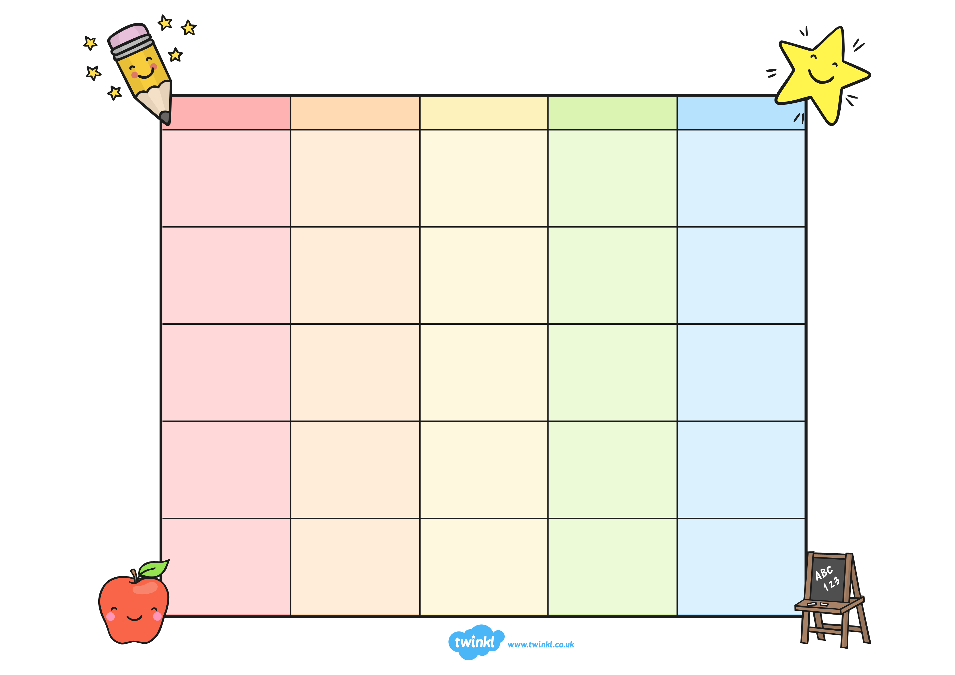

Maths work

Maths work

Maths work

Maths work

**Class 3 Weekly Planner**

**Monday**

**Friday****riday**

**Thursday**

**Wednesday**

**Tuesday**

Reading activities



Reading activities

Reading activities

Handwriting and spelling practice using the focus pattern for this week

Maths work





Times tables practice

Select a song and activity slide from the PPT.

Don’t forget TT rockstars!













Literacy work

PE

RE and Well being

PE

Computing

Geography

Science

Art

Get lots of fresh air in the garden, keep washing your hands and eating lots of healthy snacks!

We look forward to seeing your pictures and hearing from you.

Keep looking on the Stathern Primary School website…you will find extra ideas and other activities that you can do if you get bored!!!

The class email address is here for you to email us important questions and to send us photos.

See you soon!

X

[Class3@stathern.leics.sch.uk](mailto:Class3@stathern.leics.sch.uk)