

**Dear parents, pupils and members of the community, welcome to our April newsletter.**

Thank you so much to all who were able to be a part of our Ethos and Visions, Small Space Gardening Event, we really hope you enjoyed the evening. What a creative set of parents and carers we have! We are looking forward to looking after our plants as they grow and your contributions toward our vision, motto and values were really appreciated. The final version of these will be sent out this Easter. It has been a brilliant experience to develop a shared vision that represents what our school is all about and where it is heading. Over the coming months we will continue to communicate exciting changes to our curriculum in line with this vision. We have exciting news to announce; it has been quite a year for Mrs Bailey as she is expecting twins! Miss Rowe is also expecting a baby this summer! We hope you will join us in congratulating both ladies as we wish them the best of luck. Please be assured we will be making sure that these positions are covered from September with staff of the highest calibre until they re-join us. We look forward to seeing you next week at our Celebration Assembly/Easter Service and our Wear Your Hat Day on the last day of term to support Brain Tumour Research. Look out for hats coming home for you to grow into master pieces! I hope you have a fantastic Easter. ***Mr Lee***

*“Achievement for all in a stimulating and caring environment”*

[www.stathern.leics.sch.uk](http://www.stathern.leics.sch.uk)

01949 860316

Stathern Primary School

**Newsletter**

April 2019

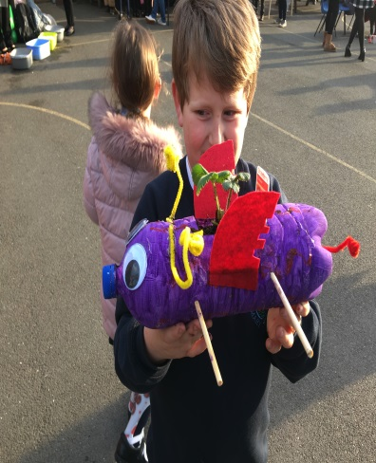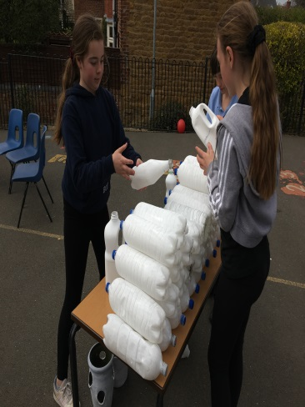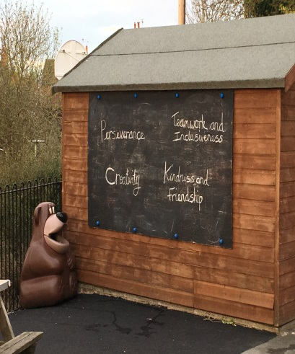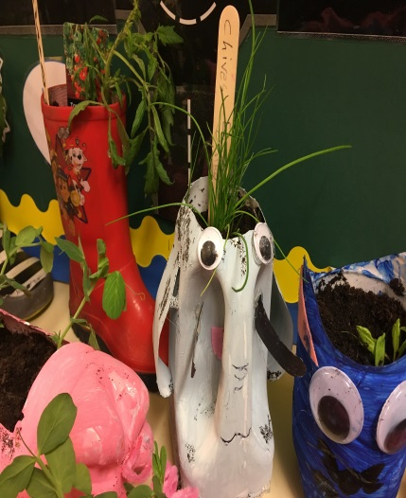..

**Ethos and Visions Family Event - Wed 27th March 4pm – 6pm**

.

**PGL Residential – Year 5&6 – more photos available at www.stathern.leics.sch.uk**

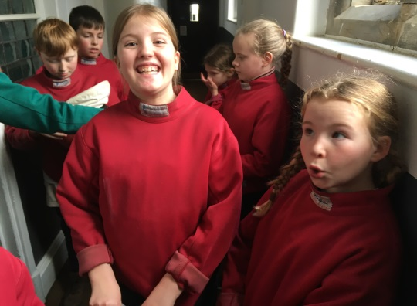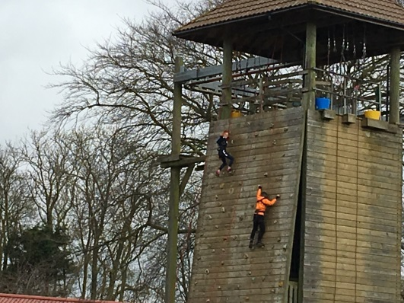

**Dates and Things to Remember:**

* Easter Service & Celebration Assembly @ St Guthlacs – Mon 8th April 9:15am (parents welcome)
* Y2 Beaumanor Residential – 9th & 10th April
* Wear Your Hat Day (Last Day) -12th April 2pm (parents welcome)
* First Day Back – 29th April
* Singing @ Dove Cottage – Sun 12th May 11am
* KS2 SATs Week Year 6 – 13th May – 16th May – *please make sure your child is in school

**Sports, Health and Well Being Update**

We were really proud to be presented with our Bronze Food for Life Award by Deborah Taylor from The Soil Association. All of our hard work to connect children to the origins of food and support others in the community has not only led to this award but we are now nearing completion of the silver criteria!

Congratulations to all our children who competed in the regional/national event at Prestwold Hall. The Melton and Belvoir Year 5 girls even won gold! Well done to our basketball team who represented Melton and Belvoir at the recent tournament – the team competed really well. Finally, our Year 6 children have completed their Cycle Safe training to help them keep safe on the roads – well done!

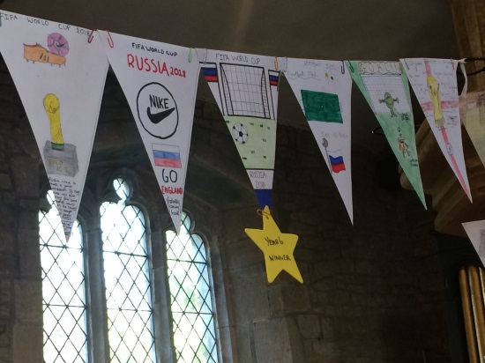

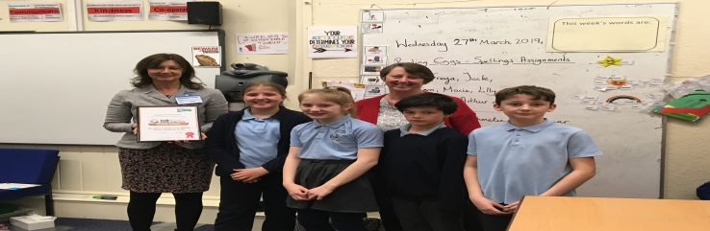

**Screveton Eco Farm – Mon 25th March**

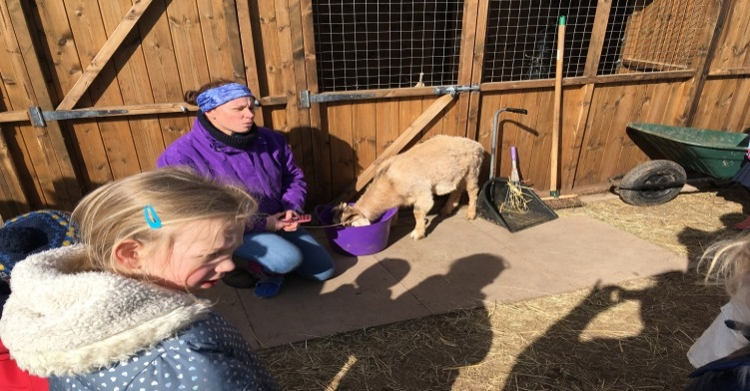

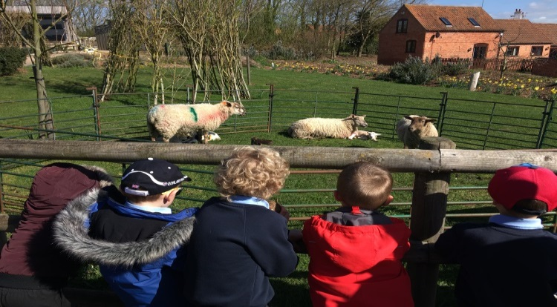

Governor Corner – Ken Bray

Somewhat to my own amazement, I have been a governor since 2006/7.  It doesn’t seem long ago at all.  I was chair of the Village Plan committee, which produced the first village plan in 2008, and prior to that had not been involved in local affairs.  I am now Vice-chair of the Parish Council and Vice-chair of governors at Stathern Primary School where I also serve as Chair of the Finance committee and Health & Safety. So see what getting involved can lead to.

Both roles are very fulfilling if occasionally challenging.  Fulfilling, because you can really make a difference, and challenging sometimes because both are subject to strict rules and constraints. Both involve juggling scarce resources for the benefit of the community.

As governors, we always keep an eye on how village development might affect pupil numbers and impact the school. As a small school, numbers can fluctuate heavily from year to year so it is really important that we work hard to meet the challenges of our 3 year financial plan. We will be consulting with parents on this next term.

Overall, I find it very interesting to be involved and it keeps me active in retirement. I am always in awe of those who manage to volunteer and work as well but it can be done. So get involved where you can.  A new Neighbourhood Plan is under way for Stathern and there are always opportunities in village groups.

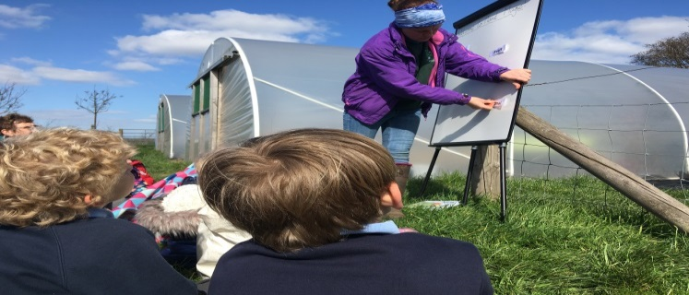

**Recruitment at Stathern**

* Vacancies for maternity cover in Class 1 and Before and After School Care have been advertised.
* We are looking to add another member of staff to our Before and After School Care team.
* We are still looking to recruit a new midday supervisor to work with us for any number of days up to 4 a week.

If you are interested in any of the above positions or know someone who is then please contact the school or pass on our details.