Year 1s Homework - 2nd half Autumn Term
English |  | Maths | Science - Seasons
Write your own acrostic poem using the word Autumn |  | Look around your house or the village and find lots of numbers up to 20. Write the number in your book and then write the word for it. i.e 6 - six | Go for a walk in the woods – be an Autumn detective and collect evidence of Autumn, turn your finds into a poster.
Choose an animal that hibernates and draw it in its home. Write some information about the animal i.e. where it lives, what it eats, describe what it looks like |  | Using pasta, buttons or lego make the number 10 or 20 and then partition the numbers into 2 groups and write an equation for them i..e  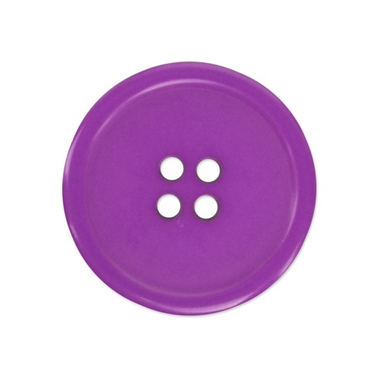 8 + 2 = 10 | Geography
 |  |  | Learn your address
Art and Craft |  | Draw a road with houses on both sides. Give the houses on one side an even number and the houses on the other side an odd numbers. | Science - Materials
Look at the art activity on the class page. Have fun completing it and send a picture on the class email.  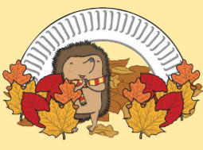 | Look at the cooking activity on the class page. Have fun completing it and send a picture on the class email.  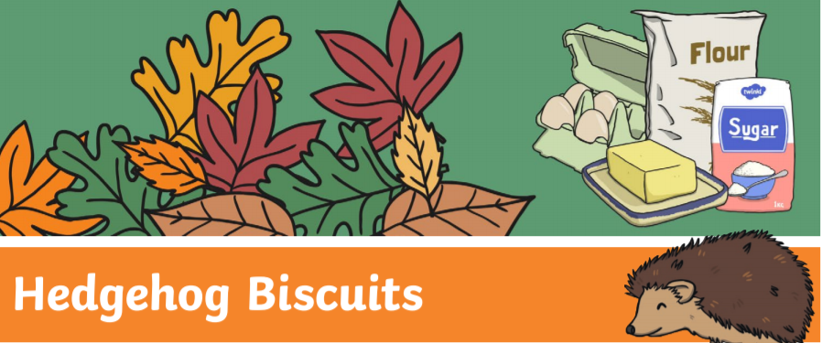 |  | Recycling  Make a poster of different objects you have recycled at home and state the material  (You might want to leave this one for a couple of weeks until we complete work in class)

