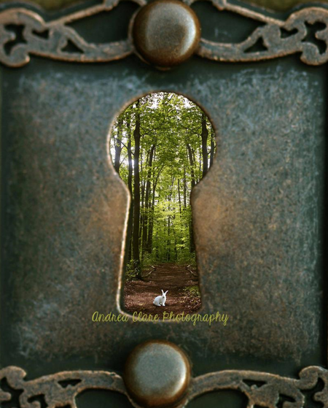
Setting Description
_____________________________
_____________________________
_____________________________
_____________________________
_____________________________
_____________________________
_____________________________
_____________________________
_____________________________
_____________________________
_____________________________
_____________________________
_____________________________
_____________________________

