**Hi there Class 3 – you’ve made it to week 4!**

Here’s to another amazing week of learning ahead Class 3. We are continually blown away by your focus and dedication to your learning. It has been impressive to see so many budding artists and shield designers last week so we hope that you enjoy the art activities that are planned for you this week. We are so proud of how you have adjusted to school at home so keep smiling those amazing smiles of yours – we miss you all so much! The weather has been hit and miss with Storm Christoph hitting our shores but we hope that you are managing to get out when you can to stretch those legs and get some valuable fresh air.

Please remember that the timetable below is just a suggested timetable so if you are needing to adjust the sessions then feel free to. This week however, the English sessions do need to be completed in the order that they are planned as they are part of a set sequence. For your Art this week, Monday’s session leads into Thursday’s activity but don’t worry if you can’t join the live Monday TEAMs session as the lesson will still be available to work through at your own pace.

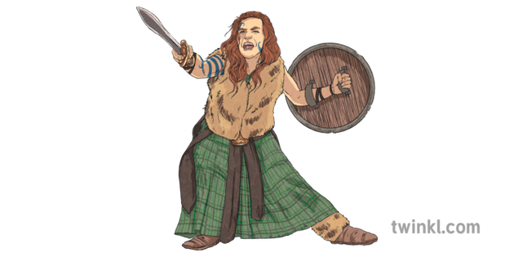

The main focus for our Roman topic this week is ‘Why did Boudicca lead a revolt against the Romans?’ You will discover who the Iceni tribe were, what happened when King Prasutagus died and how Boudicca fought back against the Romans. In Geography, you will further explore the United Kingdom and investigate the counties of England.

<https://stathern.eschools.co.uk/website/class_3_pupils_-_remote_learning/521528>

[class3@stathern.leics.sch.uk](mailto:class3@stathern.leics.sch.uk)

Mrs Hill, Mrs Maxwell and Mrs Green

**Class 3 Weekly Planner**

|  |  |  |  |  |  |
| --- | --- | --- | --- | --- | --- |
| Wk 4 | Monday | Tuesday | Wednesday | Thursday | Friday |
| English Activity  Please try to complete these activities in the sequence that they are planned. | Features of a Newspaper Report 1 and Conjunctions  [Oak National Academy Journalism Unit Lesson 1](https://classroom.thenational.academy/lessons/to-identify-the-features-of-a-newspaper-report-6rv30r)  See below for the actual web addresses for English this week | Speech Punctuation to use in a Newspaper Report  [Oak National Academy Journalism Unit Lesson 3](https://classroom.thenational.academy/lessons/to-revise-speech-punctuation-cngp8t) | Features of a Newspaper Report 2  [Oak National Academy Journalism Unit Lesson 4](https://classroom.thenational.academy/lessons/to-identify-the-features-of-a-newspaper-report-6dh3cr) | Using Rich Vocabulary Newspaper Report  [Oak National Academy Journalism Unit Lesson 5](https://classroom.thenational.academy/lessons/to-develop-a-rich-understanding-of-words-associated-with-feeling-surprised-c5j3jt) | Gathering Information for a Newspaper Report  [Oak National Academy Journalism Unit Lesson 6](https://classroom.thenational.academy/lessons/to-gather-information-and-evidence-for-a-newspaper-report-75h6ad) |
| Maths Activity | Length: m and cm  Extra Times table Assignment | Length: mm and cm  Extra Times Tables Assignment | Length: km  Extra Times Tables Assignment | Length: adding lengths  Extra Times Tables Assignment | Measuring Perimeter  Extra Times Tables Assignment |
| Topic  Afternoon Activity | **Live Session on TEAMS 1:30**  **Art**  Research famous portrait artists and report back | **Geography**  Counties in England | **History**  Why did Boudicca lead a revolt against the Romans?  [Oak Academy Lesson 5](https://classroom.thenational.academy/lessons/why-did-boudicca-lead-a-revolt-against-the-romans-60v3gc) | **Art**  Create a self-portrait  [Draw with Rob Tutorial](https://www.youtube.com/watch?v=oCDta3CQ9Ak)  Extra Challenge – create a portrait of Boudicca. | **PE**  The Plank and Burpees Challenge |
| TEAMS Drop In Session |  | Mrs Hill’s Drop  In English Session  1:30-2:00 | Mrs Maxwell’s Show and Tell Session 2:30 –3:00 | Assembly with Mrs Lambert  1:00-1:30 | Mrs Maxwell’s Maths Drop In Session  1:30-2:30 |
| Things you might need to prepare | Maths –a tape measure to measure at least 1m | Geography – a printed copy of the counties map.  Maths – a ruler (with mm) and tiddlywinks. |  | Art – blank A4 paper, drawing materials like pencil crayons, crayons or felt tips. | Maths – masking tape/chalk or large sheet of paper. A ruler. |

|  |  |
| --- | --- |
| English Lesson 1 | <https://classroom.thenational.academy/lessons/to-identify-the-features-of-a-newspaper-report-6rv30r> |
| English Lesson 2 | <https://classroom.thenational.academy/lessons/to-revise-speech-punctuation-cngp8t> |
| English Lesson 3 | <https://classroom.thenational.academy/lessons/to-identify-the-features-of-a-newspaper-report-6dh3cr> |
| English Lesson 4 | <https://classroom.thenational.academy/lessons/to-develop-a-rich-understanding-of-words-associated-with-feeling-surprised-c5j3jt> |
| English Lesson 5 | <https://classroom.thenational.academy/lessons/to-gather-information-and-evidence-for-a-newspaper-report-75h6ad> |

See you soon!

X