

**Year 6 Mayan Experience**

**Dear parents, pupils and members of the community, welcome to our November newsletter.**

As we head towards December, we have had lots to celebrate this term and also have lots to look forward to. Our brand new EYFS mud kitchen is the first of a range of improvements to arrive thanks to Miss Heafford and Mr Chivers-Blyth with his skill and generosity. Many children will benefit from this superb addition to our outdoor area – it is soon to be joined by a large painting and drawing board to allow the children to express their creativity! Looking forward, we are very excited about Enterprise week where children will experience everything from creating their own businesses, to advertising and marketing. Further details about our Nativity, Eastwell Concert and our Christmas Carol Afternoon are on the back of the newsletter, but safe to say we are looking forward to seeing the children’s creative talents come to life over the next month. Thank you to the vast majority of parents that have supported us with our healthy eating focus. Improvements in snacks and lunch boxes are making a real difference to the concentration and behaviour of pupils and the long term benefits are really important. We hope to see you at one or all of our many events before the end of term. ***Mr Lee***

*“Achievement for all in a stimulating and caring environment”*

[www.stathern.leics.sch.uk](http://www.stathern.leics.sch.uk)

01949 860316

Stathern Primary School

**Newsletter**

November 2017

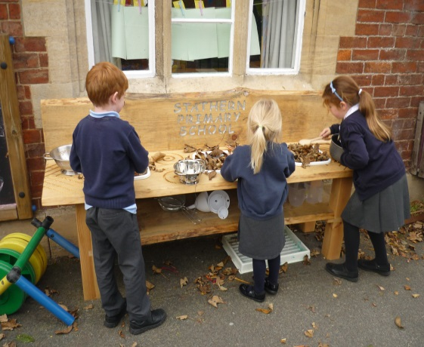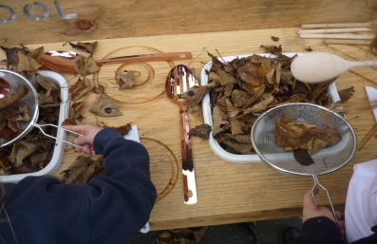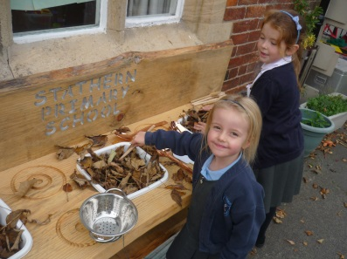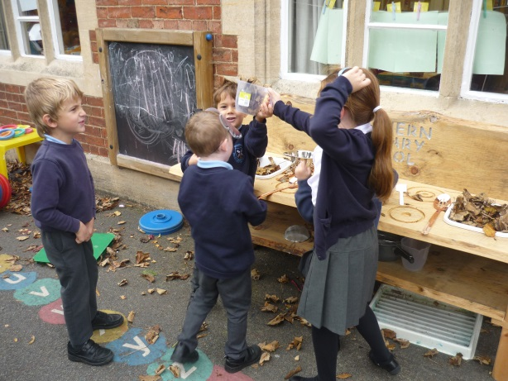.

**Stathern Primary School’s New Mud Kitchen**

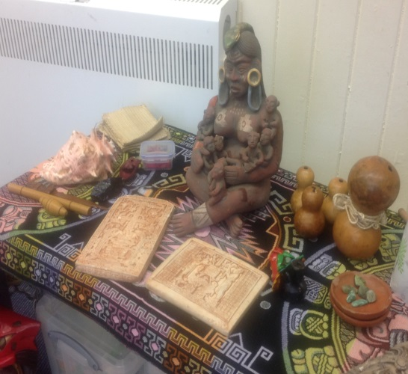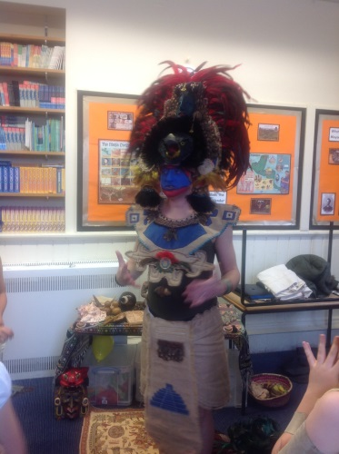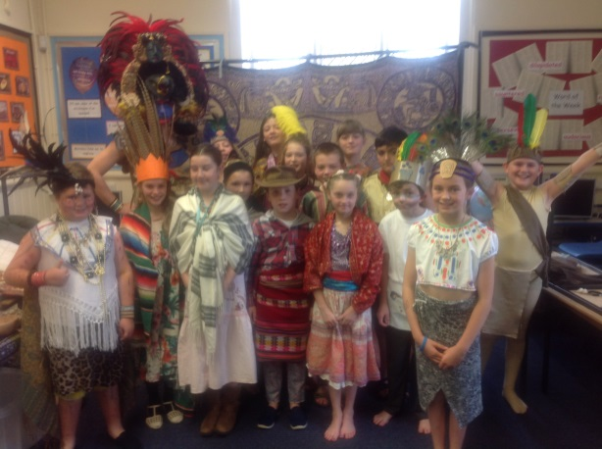

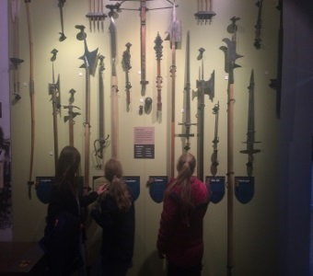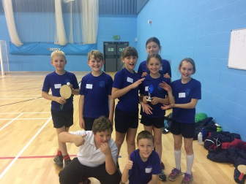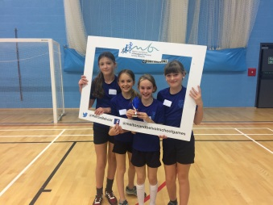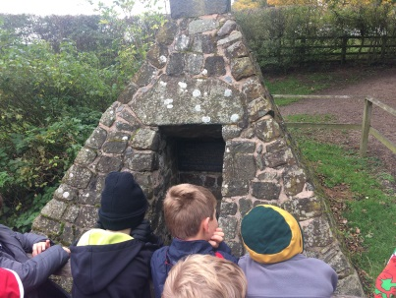

**Sports and Clubs Update**

Congratulations to our Table Tennis team on their excellent recent performance at the competition in Brooksby. The girls managed to finish second and the boys 4th. The girls were also the winners of the Spirit of the Games Award.

Well done to all our children who have been busy completing laps of the playground as part of Golden Mile project – they are all increasing their fitness brilliantly! A big thank you to Sports Crew and Mrs Rozentals who have been helping to lead the initiative.

Good luck to our Athletics and Dodgeball teams who will compete before Christmas. We look forward to updating you with the results.

**Class 3 Battle of Bosworth Trip**

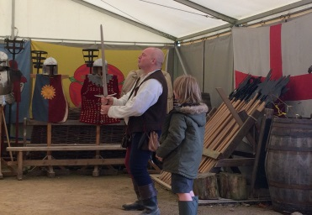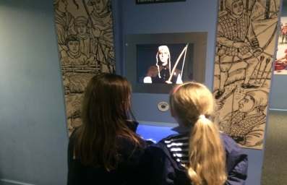

**Dates and Things to Remember:**

* Sportshall Athletics – 15th November
* Children In Need – Fri 17th Nov
* Choir @ Melton – Fri 1st Dec – 11:15am
* Christmas Fair – Sat 2nd - Dec 2pm-4pm
* Eastwell Concert – Fri 8th Dec 7pm
* School Council Bring and Buy – Fri 8th Dec
* Senior Citizens Lunch & Nativity – Tue 12th

Dec - 2pm @ St Guthlacs, 2:30pm @ School

* KS1 Nativity (with children from KS2 singing) Wed 13thDec 2pm & 5:30pm @ St Guthlacs
* Y5/6 Dodgeball - 13th December
* KS1 Theatre Trip – 14th December
* Y5/6 DARE Graduation– Fri 15th Dec – 9:30am @ St Guthlacs
* Christmas Jumper Day & Children’s Party Day – Fri 15th Dec
* Carol Concert & Celebration Assembly @ St Guthlacs – Mon 18th Dec 2pm
* Last day of term – Wed 20th Dec

**Nativity, Eastwell and Christmas Carols!**

Our Nativity (dates are listed to the left) will be performed by Classes 1 & 2, however this year, Classes 3 & 4 will support the singing of the songs and are encouraged to attend the evening performance to sing and support the younger children. They will also accompany the younger children during the daytime performances.

Eastwell Concert will be going ahead on Friday 8th Dec. If your child would like to perform then they will be asked to check in with Mr Lee and Mrs Minnaar just to make sure they are ready to perform. Finally, we hope you will be able to attend our Carol Concert and Celebration Assembly, where you will be able to sing with us and share in your child’s work whilst enjoying festive refreshments!

**School Nurse**

We are pleased to announce that Andrea Fiford our school nurse will be available for you to see on the 27th November between 3pm and 4pm. Please contact the school office if you would like to see her.

**FOSS**

Thank you to all those who attended the Halloween Disco to help raise funds for the school. FOSS are currently raising money to purchase new books for school and to support inspirational trips, visits and visitors such as the Mayan experience and Battle of Bosworth trip.

Christmas trees are available to pre-order after half term – order forms will go out in book bags or contact Mary Swain on 07966 082955.

**Vacancy - Midday Supervisor Role**

We continue to look for someone to come and join the team at lunchtimes. The role would be for an hour a day for up to 5 days (training provided).

If you are interested or know someone who might be interested then please contact the school office.