

**Dear parents, pupils and members of the community, welcome to our December newsletter.**

Thank you to all those who were able to come and support our Christmas Fair – it was a really enjoyable afternoon full of festive stalls, games and performances. There was a brilliant atmosphere and the children who performed were fantastic. Our choir also made us very proud in Melton last week where they sang beautifully in the market place to help turn on the Christmas lights; there were some really exceptional solo performances. Congratulations to Miss Heafford who has announced she will be getting married on New Year’s Eve; we wish her and partner Gray all the best for the day and the future! We hope you will be able to join us over the coming weeks at one or all of our events – we are looking forward to a really good Christmas period. Finally we are really pleased to announce our Happy Lunchtimes training on December 11th where Steve Harris will be supporting us with positive relationships and helping us put the finishing touches to our lunchtime plan. As always please do not hesitate to get in touch if there’s anything you wish to discuss. ***Mr Lee***

*“Achievement for all in a stimulating and caring environment”*

[www.stathern.leics.sch.uk](http://www.stathern.leics.sch.uk)

01949 860316

Stathern Primary School

**Newsletter**

December 2018

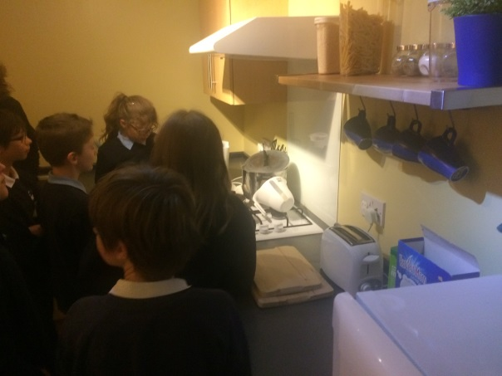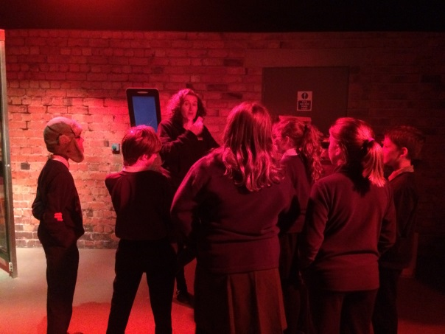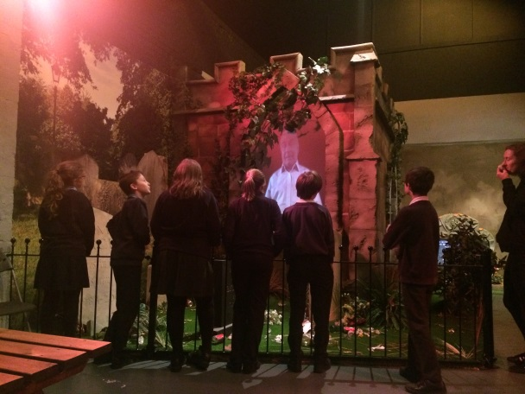..

**Warning Zone – Year 5 & 6 – Keeping Safe at Home, On-line and Out and About**

**Choir at Melton Christmas Lights – Thank you for all your hard work Mrs Waller!**

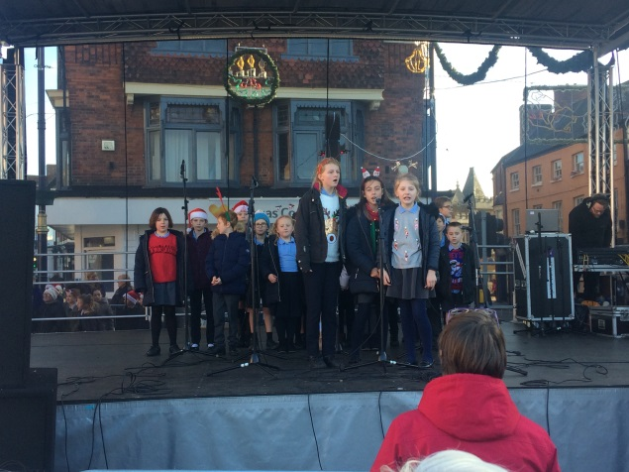.

**Clubs and Sports Update**

Congratulations to our Athletics Team who managed to finish 3rd at the recent Melton and Belvoir Tournament. They performed brilliantly throughout the competition and thoroughly deserved this great result.

Well done to all the children who competed in the individual cross-country event at Prestwold Hall. There were several top 100 finishes with one of our girls being invited to an elite event thanks to a top 50 finish.

The results are in from our second Packed Lunch Audit. This return visit saw an improvement in the kinds of drinks our children are having and a reduction in the number of unhealthy treats. The main area for further improvement was in the sandwich fillings where we should be aiming for more fillings that promoted growth.

Finally, thanks to Sports Crew who have been handing out certificates to promote examples of great character and reward physical challenges.

**Dates and Things to Remember:**

* Y5/6 Basketball – Fri 7th Dec
* Y1 Hearing Test – Fri 7th Dec
* Roman Experience – Mon 10th Dec – Class 3 (In school - children only)
* Flu Immunisation –Tues 11th Dec - YrR-6
* Christmas Dinner & Party – Thurs 13th Dec (non-uniform and sensible footwear)
* Eastwell – Fri 14th Dec -7pm (tickets available)
* Senior Citizens Tea Party and Nativity Dress Rehearsal – Mon 17th Dec – 2pm
* Classes 1 &2 Theatre Visit – Tue 18th Dec
* Nativity – Wed 19th Dec – 2pm & 5:30pm
* Celebration & Carol Assembly –Fri 21st Dec – 2pm
* First Day Back – Tue 8th Jan
* Y3/4 Pre-residential Meeting – Tues 29th Jan 3:15pm
* Y4 PGL Half-day Experience – Mon 4th Feb
* Film Night – Mon 11th Feb - TBC
* Ben Smith Assembly – Inspire + Ambassador – Mon 11th Feb
* Y3-6 Sky Dance Challenge – Wed 13th Feb

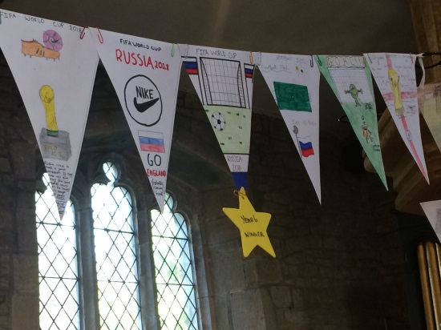

**Christmas!**

We hope you can join us for one of our festive events over the next few weeks. We have Eastwell Concert where children will be singing and performing on their instruments; our Nativity where Reception, Year 1 and 2 will take the lead roles with Years 3-6 supporting the singing; and our Christmas Sing-Along combined with a Celebration Assembly on the last day of term. Please contact the office if you require more information – Merry Christmas!

**Governor Corner** – by Clare Allen

The autumn term is always a busy one for governors as we set out our roles and responsibilities for the academic year to ensure that the School Development Plan is monitored properly.

We now have three committees who have a look, in depth, at school development, finance and health and safety. They all report back to the full group of governors so that we can ensure the best educational experience for our children.

You can see what our individual responsibilities are on our information leaflet - All About Us - which is coming out this week.

If you have any questions about governance at Stathern School, please do ask us. In the meantime, on behalf of all of the governors at school I wish you a Merry Christmas and a Happy New Year.

Best wishes  
Clare Allen   
Chair of Governors

**FOSS**

Christmas Trees are still available – contact Mary Swain on 07966 082955. Thanks to all who supported the fantastic Christmas Fair. Mulled wine and mince pies will be available at the Nativity and Celebration & Carol Assembly. Whole school tea towels - £4 each or 3 for £10 – please contact the office.

FOSS are looking to recruit new members to help run events and support the school in raising funds for new ICT resources – please contact us if you are interested.

**Midday Supervisor Position**

We are still looking to recruit a new midday supervisor to work with us for any number of days up to 5 a week. If you are interested in the position or know someone who is then please contact the school or pass on our details.