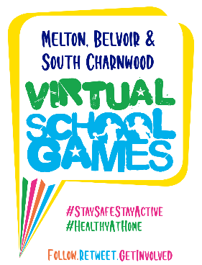

Are you up for the challenge?
Melton and Belvoir and South Charnwood School Sport & Physical Activity Networks would like to invite your child(ren) to take part in our Virtual School Games Competitions running up until Friday 26th June. The Virtual School Games Challenge is an exciting programme of sporting competition running through the Summer term, giving all children the opportunity to represent their school team.
VIRTUAL SCHOOL GAMES COMPETITION SCHEDULE
Week 1  Throwing Challenges | Monday 1st June – Friday 5th June
Week 2  Jumping Challenges | Monday 8th June – Friday 12th June
Week 3  Running Challenges | Monday 15th June – Friday 19th June
LRS School Games Summer Championships | Monday 22nd June - Friday 26th June

What do we you need to do?
Follow the Virtual School Games challenge cards each week. Once your child has completed both challenges, send your personal best results to your school teacher via xxxxxxxxxxxx by 4pm on Friday of each challenge week. This will allow schools to keep track of how many children have taken part. All participants will receive a certificate on competition of their challenges to recognise their involvement.
We’d love to see you in action so why not tweet us a clip of you taking part
@MeltonBelvoir @SouthCharnwood
Stay fit, stay healthy, have fun!

Disclaimer
Please make sure your exercise area is clear of obstacles and there isn’t anything nearby which could cause a trip or a fall. Suitable clothing and footwear is also advised whilst carrying out the challenges. All the challenges are designed to be suitable for each age group, however it is important to understand that if you choose to take part, you are doing so at your own risk.

