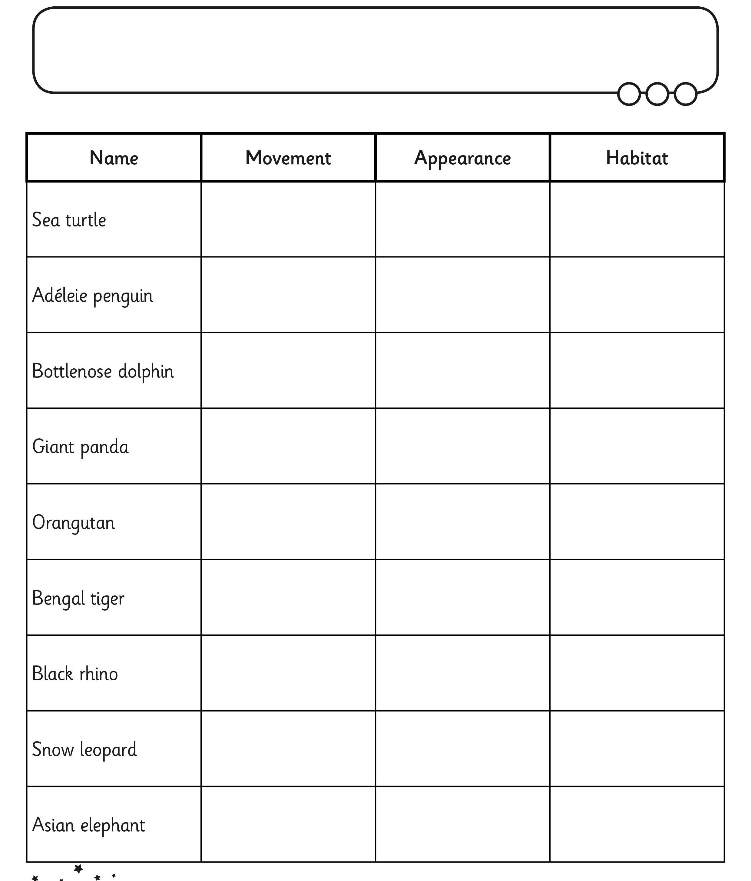

Aim: I can research ideas about different animals

