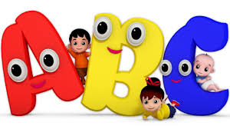
Lesson 1 – Shapes and movement
Warm up
- Oti’s Boogie Beebies dance – Shine like the Sun (BBC i-player – Cbeebies)
Activity 1 - Movement
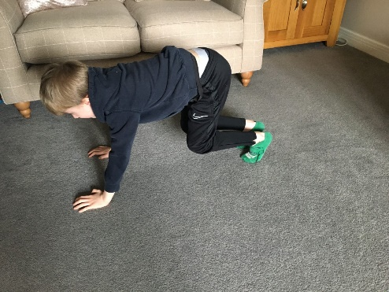
- Have a think about different ways you can move your body? What different body parts can you move/use to move around your space?
- Move around your space on the following parts of your body:
On your feet
On your hands and feet
On your tummies
On your tiptoes
On your hands and knees
- How many ways can you move on these body parts?? Example for moving on your feet – giant steps, skipping, jogging on the spot, jumping, side steps and hopping!
Activity 2 – Shapes
- Can you remember the four main shapes from our gymnastics lessons?
- They are Straight, Star, Tuck and Straddle shapes
- Have a go at performing these shapes in as many ways you can think of – see below for pictures to help.
- Make sure you have good body tension – squeeze your tummies, point your toes and hold the shapes still for at least 5 seconds!

Activity 3 – Alphabet shapes
- Have a go at getting your bodies into the shape of different letters in the alphabet – you can try the letters in your name, or you could even try and work through the whole alphabet! See below for an example for T.

Straight Shape Star Shape Tuck Shape
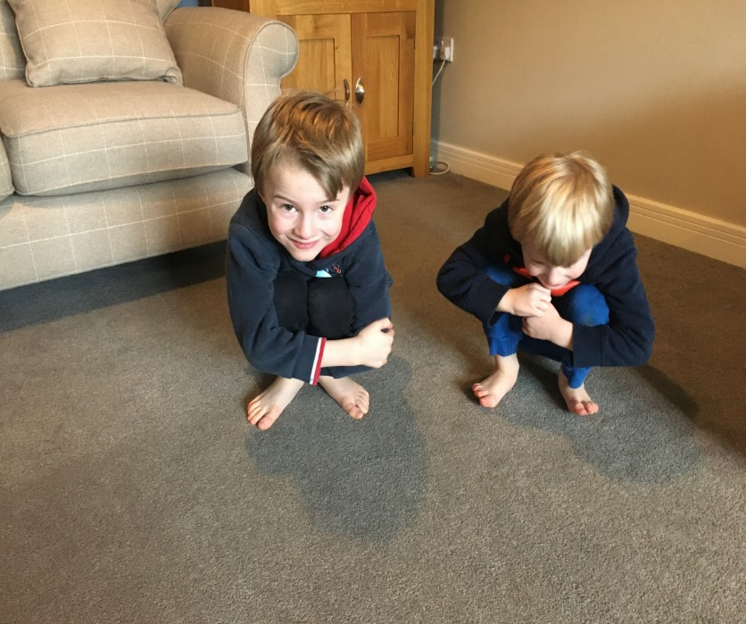
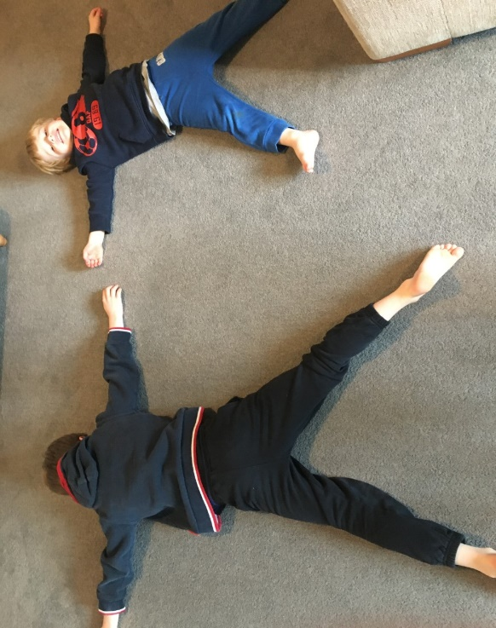
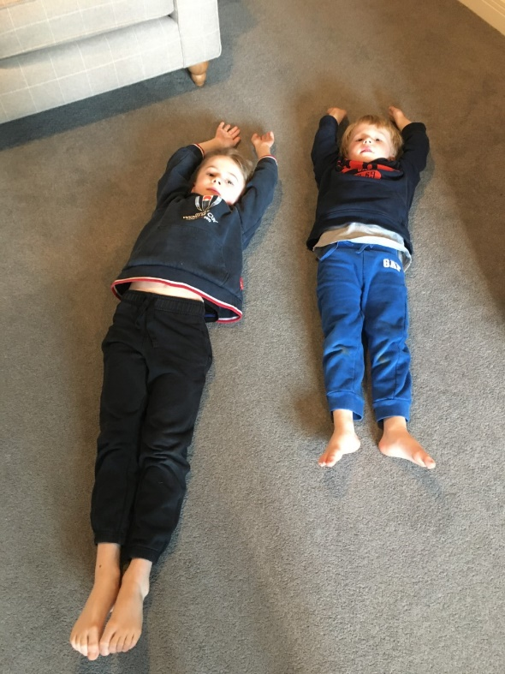

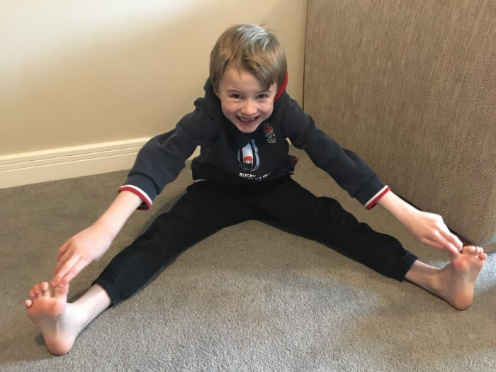
Straddle Shape T letter shapes
