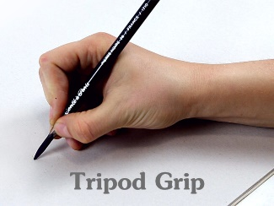
These handwriting name cards are to support your child in recognising and writing their full name. We encourage the children to hold their pen/pencil properly in the pincer grip, carefully following the lines. Please practise this with your child, trying to start each letter in the correct place. If you are unsure on the letter formation we teach, please use this website link to help 😊 https://www.youtube.com/watch?v=wduPhJLeBhA (please be mindful that our letter formation for an f goes below the line)
Thank you,
The Class 1 team

These handwriting name cards are to support your child in recognising and writing their full name. We encourage the children to hold their pen/pencil properly in the pincer grip, carefully following the lines. Please practise this with your child, trying to start each letter in the correct place. If you are unsure on the letter formation we teach, please use this website link to help 😊 https://www.youtube.com/watch?v=wduPhJLeBhA (please be mindful that our letter formation for an f goes below the line)
Thank you,
The Class 1 team

