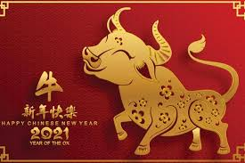
Chinese New Year Yoga Poses
- Chinese New Year yoga poses to act out the animals of the Chinese Zodiac.
- I have included poses for six of the twelve animals for you to perform with your family and you can create poses for the other six animals if you like!
- Hold the poses for as long as you can and repeat them as many times as you want!
Ox - On your hands and knees with a flat back. Lift your head upwards and arch your back (cow pose).

Rabbit – Sit on your knees with your heels tucked in under your bottom. Sit up with a straight back and hands on your knees (hero pose). You can make rabbit ears with your hands on the top of your head if you want!
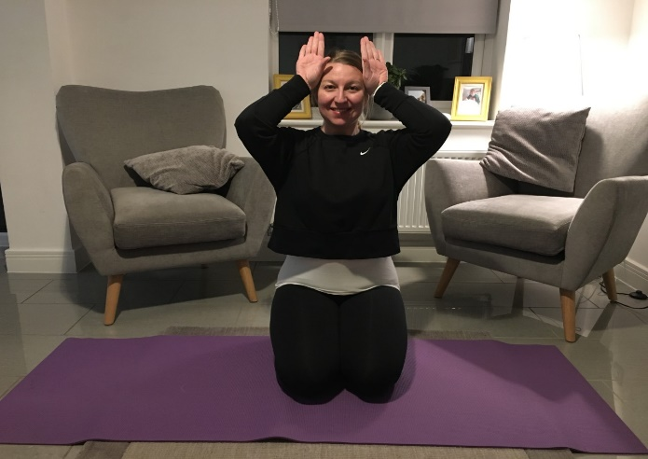

Snake – Lie on your tummy and place the palms of your hands flat next to your shoulders. Pressing into your hands, lift your head and shoulder off the ground and hiss like a snake. Make sure you squeeze your tummy muscles and keep your arms straight.
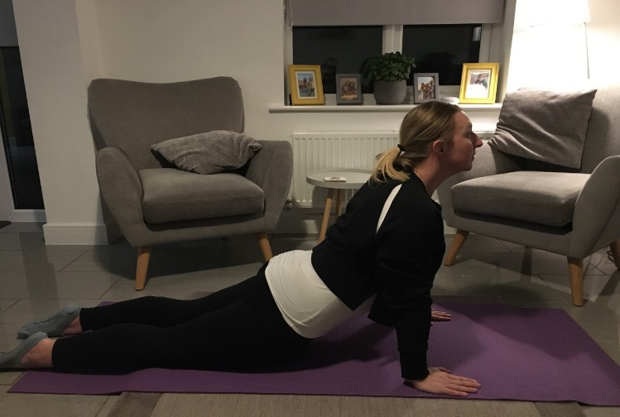

Monkey – Lower yourself into a squat position with your feet pointing outwards at a diagonal and place your hands on the floor between your knees (a bit like a frog!) Extension - lift your arms into the air and move them like a monkey!

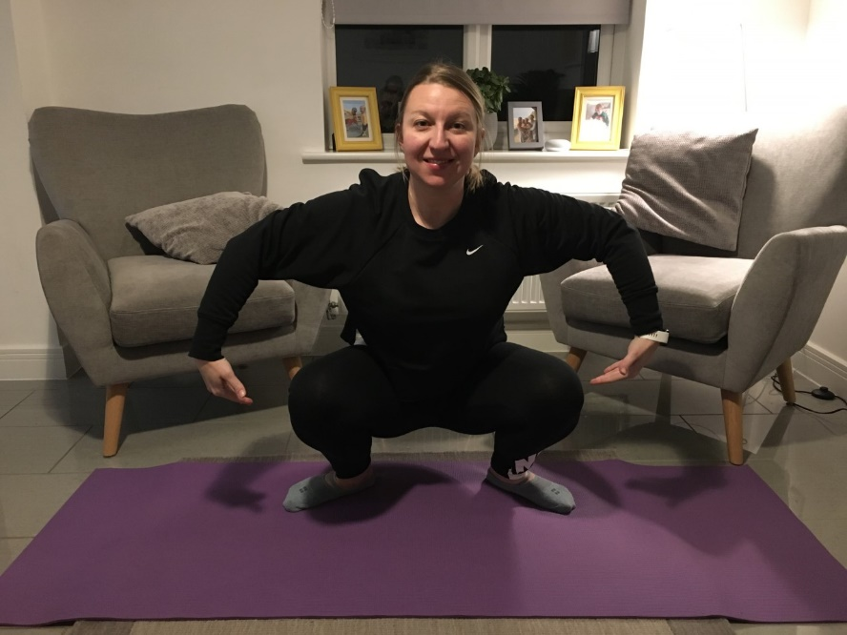

Dog – Place your hands and feet on the floor and step your feet back into an upside-down V shape. Lift your bottom into the air and stretch like a dog (downward dog pose).
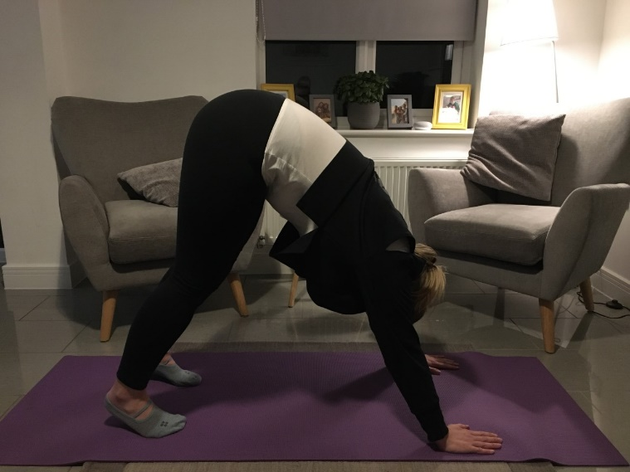

Rat – Sit on your heels and slowly bring your forehead down to the floor in front of your knees. Rest your arms down by the side of your body and take a few deep breaths (child pose).
