Year 2s Homework – 2nd half Autumn Term
English |  | Maths | Science - Autumn
Write your own acrostic poem using the word Autumn |  | Look around the house or village and find 2 digit numbers. Write them in your book and write the words for them. i.e 52 – fifty two | Go for a walk in the woods – be an Autumn detective and collect evidence of Autumn.  Write a report- explaining all your findings and observations.
Choose an animal that hibernates. Write a report about the animal i.e. where it lives, what it eats, describe what it looks like |  | Choose a 2digit number and draw the Base 10 equipment for your number.  Partition your number in more than one way and show the whole-part-part model. | Geography
Find the definition of the following words:
Continent, country, county, city, town and village
Art and Craft |  | Choose a 2digit number and then find 10 more and 10 Less  24---- 34 ----44 | Science - Materials – Plastic pollution
Look at the art activity on the class page. Have fun completing it and send a picture on the class email.  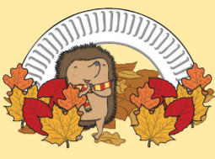 | Look at the cooking activity on the class page. Have fun completing it and send a picture on the class email.  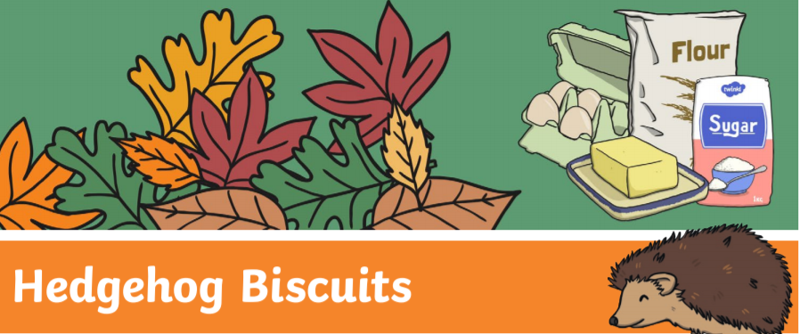 |  | - Find out how plastic pollution is affecting the planet  - Can you think of different ways to solve the problem of plastic pollution.  (You might want to leave this one for a couple of weeks until we complete some work in class)

