

**Dear parents, pupils and members of the community, welcome to our July newsletter.**

What a busy but enjoyable last term it’s been! I think one of our Year 6 children best summed up the feeling, saying “There’s something for everyone here at Stathern and all those opportunities make it brilliant!”. I really enjoyed seeing the children from Key Stage 2 performing ‘Dream On’ outside, I felt they really rose to the challenge of performing Shakespeare. It was great to see our girls win at the recent Asfordby Amateurs tournament – they’ve worked together so well for so long that they really deserved the success. We enjoyed a wonderful Summer Fair and would like to thank FOSS, staff and all who supported the event for making it so good. Class 3 enjoyed performing with their brass instruments at Demontfort Hall – it was a very special evening, showcasing musical talent from all across Leicestershire and we were very proud of the children. Class 4 shared 2 days at PGL and were a real joy to be with. The trip reminded Mrs Jackson, Mrs Jones and I, just how much we’ll miss them! With one day left to go we are looking forward to our Leavers Service at St Guthlacs at 9:15am. This is where we will say a fond farewell to all our Year 6 pupils and of course Mrs Jackson. This will be the perfect opportunity to thank her for all she has done at Stathern Primary School and wish her well in the future. Can I also take this opportunity to thank you all for your continued support and of course to the staff and pupils of the school who have worked so hard to make it such a fabulous place to be . ***Mr Lee***

*“Achievement for all in a stimulating and caring environment”*

[www.stathern.leics.sch.uk](http://www.stathern.leics.sch.uk)

01949 860316

Stathern Primary School

**Newsletter**

July 2018

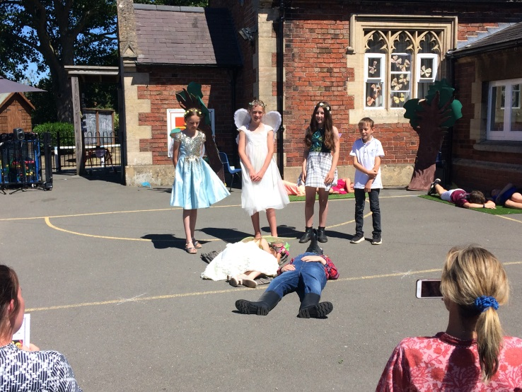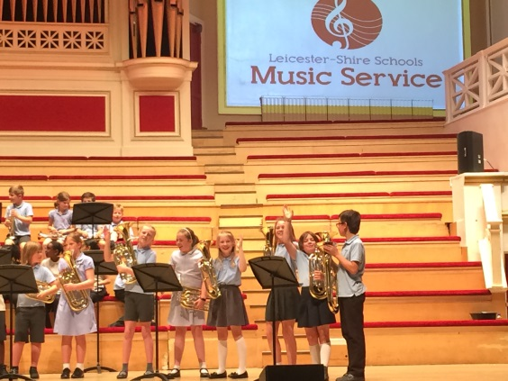.

**KS2 Production, Demontfort, Girls Football, School Summer Games – *see website for more details & photos***

.

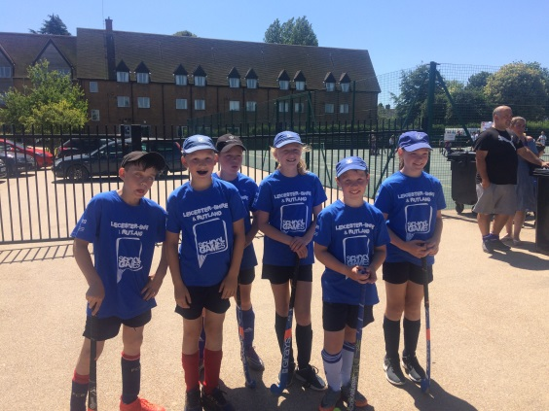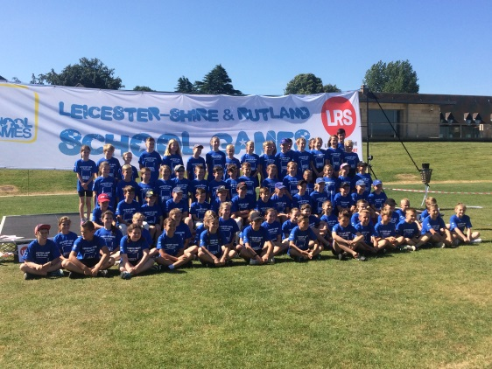

**Sports and Clubs Update**

Well done to the Hockey Team who represented Melton and Belvoir in the School Games Finals on Friday 29th June. They won 4, lost 3 and drew 1 to finish mid table.

Well done to our girls who won the recent tournament at Asfordby Amateurs July 1st. After a close penalty shoot-out in the semi-final, the girls went on to win 1-0 in the final against Brownlow. Well done on this much deserved win after all your hard work and outstanding attitudes.

**Dates and Things to Remember:**

* Leavers Service (Last Day) – Fri 13th July – 9:15am
* First day back – Thurs 30th August

**Governor Corner – July, 2018**

Well, it has been a busy and exciting term for everyone at school. As governors we have continued to visit and support the school with areas for development and it has been fantastic to share this journey with such a dedicated team of staff.

The school council sent us a video presentation of their work for our recent meeting. It was a real privilege to see all that they do to represent children’s voice at our school. We are delighted to be able to be involved in securing funds to ensure that the playground project is to go ahead. This really is a testament to the strength of the whole school community, as parent contribution and support via FOSS has also been instrumental in the success of this project, which has ultimately been driven by the children. What a team!

On behalf of all of the governors at school, I wish you a fantastic summer and we look forward to continuing our work in the new academic year.

Best wishes

Clare Allen

Chair of Governors

*Write* Now!

Creative writing after school club

**Fun new club for Y3 to Y6 children coming in Sept 18.**

Do you love books, films or plays? Love poems or songs? Ever dreamt of writing your

own? Come and join our club and be inspired to write.

**Watch out for the FREE taster session on the first week of term.**

We’ll read amazing books, act out plays, play games, make story boards, write stories,

poems, reviews, scripts, lyrics for songs, perform our work, enter writing competitions,

author visits… Oh, and there’ll be biscuits! What are you waiting for?

*Write* Now!

**FOSS**

Foss would like to thank everyone for their continued support. Look out for a full calendar of events next year.

**Gardening**

Thank you to all who have supported our gardening projects down at the WMI. Please feel free to help water the plants over the summer and help yourself to any produce that is ready and not marked for the Horticultural Show.

**WMI BBQ**



**Before and After School Club**

We would like to thank Helen Jones for all her help and support in our club. She will remain with us as a Learning Support Assistant but will be reducing her hours in club to just one a week. Mary Swain will continue to manage and lead the club with our new appointment Miss Hannah Rowe joining us from September.

Governor Corner – July, 2018

Well, it has been a busy and exciting term for everyone at school. As governors we have continued to visit and support the school with areas for development and it has been fantastic to share this journey with such a dedicated team of staff.

The school council sent us a video presentation of their work for our recent meeting. It was a real privilege to see all that they do to represent children’s voice at our school. We are delighted to be able to be involved in securing funds to ensure that the playground project is to go ahead. This really is a testament to the strength of the whole school community, as parent contribution and support via FOSS has also been instrumental in the success of this project, which has ultimately been driven by the children. What a team!

On behalf of all of the governors at school, I wish you a fantastic summer and we look forward to continuing our work in the new academic year.

Best wishes

Clare Allen

Chair of Governors