

**Dear parents, pupils and members of the community, welcome to our March newsletter.**

As it turns colder again, we seem to still be searching for Spring! Thank you for your patience during the challenging weather of late, we’ve tried not to let the snow and ice slow us down. Our Science and Enterprise visit was a huge success and the children gained valuable insight into how a small business runs and deals with customers effectively in readiness for their Sport Relief Challenge next week. Our Enterprise Video will be available on the website next week. It was great to see lots of parents at our Maths Calculation Evening, working alongside children to gain a better understanding of how our Calculation Policy is used in school. We hope the children have found the new system of children coming straight in from 8:50am useful – it is an important part of maximising the impact of marking and feedback, allowing children to respond to comments from their teachers. Thank you for your support with Stathern Duathlon but unfortunately this event has had to be postponed due to the weather. Finally we hope you can join us for one or both of our Easter events next week. On Monday we will have our Celebration Assembly and Easter Service at 9:15am and on Friday we will have our Wear Your Hat for Brain Tumour Awareness parade along with egg rolling at 2:30pm. There will also be a special dance performance from Year 3; we hope you enjoy the last week at school and the Easter holidays. ***Mr Lee***

*“Achievement for all in a stimulating and caring environment”*

[www.stathern.leics.sch.uk](http://www.stathern.leics.sch.uk)

01949 860316

Stathern Primary School

**Newsletter**

March 2018

.

**Twin Lakes Science and Enterprise Visit – 8th March**

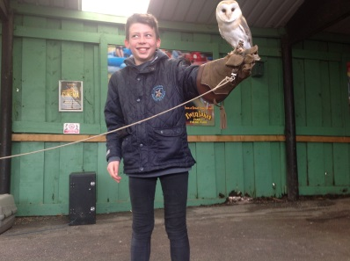

.

**Maths Calculation Evening – 7th March - Presentation Available on the Website**

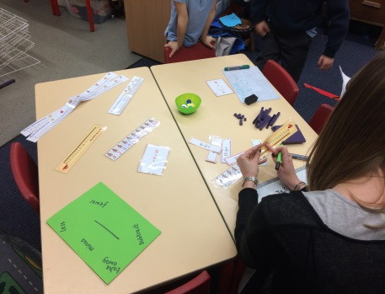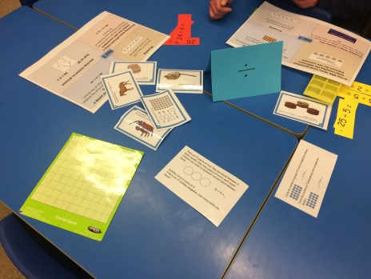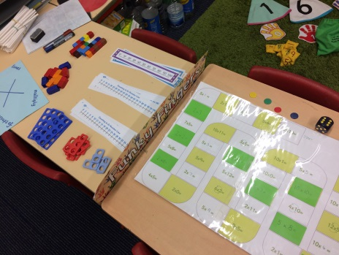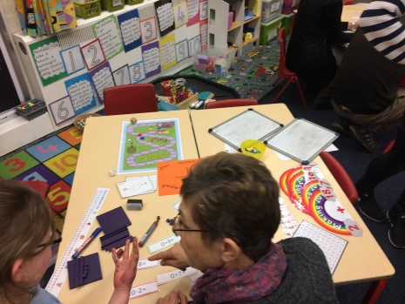

**Sports and Clubs Update**

Well done to our girl’s football team who took on the best teams from Leicestershire, managing to finish 3rd in their group. They have also been chosen to represent Melton & Belvoir in the upcoming Level 3 Tournament.

Congratulations to our cross country runners for their superb performances at Longfield. 5 children qualified for the National event at Prestwold on the 24th March. Good luck!

**Dates and Things to Remember:**

* Easter Service and Celebration Assembly – All children and parents – Mon 19th March 9:15am
* Year 2 Beaumanor Residential – Tue 20th March & Wed 21st March
* Last Day, Enterprise Sport Relief Day and Wear Your Hat and Easter Fun Day – All children & parents from 2:30pm – Fri 23rd March
* Return to school – Mon 9th April
* Class 2 Re-arranged Parents Evenings – bookings to become available next week for the first fortnight back. Dates TBC next week.
* Tag Rugby - Tuesday 17th April
* Class 1 Screveton Eco Farm Visit – Tue 8th May
* Year 4 @Dove Cottage – Sunday 13th May
* Year 6 SATs Week – Wk Beg 14th May

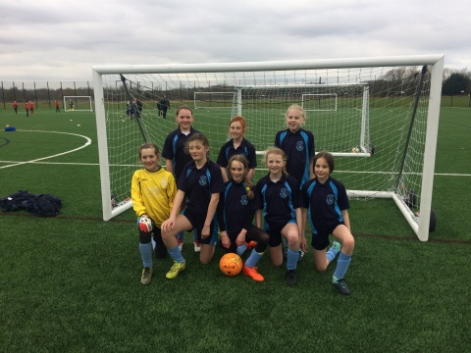

**FOSS**

Thank you to all those who supported the recent school disco. Look out for the next FOSS event which will be the Curry and Quiz. We hope you can make it.

Just a reminder that FOSS is currently fundraising for inspiring trips and visits, reading books and Forest Schools Training for staff.

**Vale Choral – 14th March**

Well done to our talented Year 4’s who performed brilliantly alongside children from the Vale schools.

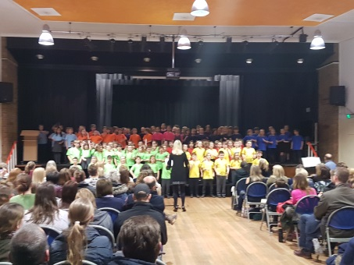

**Adventurer Sarah Outen Visit – 14th March**

The children were treated to a fabulous presentation by Sarah where she shared her 4 year round the world adventure. Her tale was one of resilience, character building and a connection with nature. I hope the children were as inspired as the adults in the room as she left them with the question – “What will your next adventure be?”. See more online.

**Wear Your Hat Day – 23rd March 2:30pm**

We would like to invite you to our Wear Your Hat Day where pupils will parade their hats in a competition and go head to head in an egg rolling battle. Children have been busy making hats in school but taking these home and improving them or even making them again from scratch is all within the rules! We hope you will be able to join us in support of Brain Tumour Research through the £1 entry fee and through donations for refreshments.

**Y6 PGL Day Visit & Y3/4 Internet Safety Pantomime**

Our Year 6 children had a brilliant (if a little cold) day taking part in orienteering activities and experiencing the Giant Swing. It was a great way to experience outdoor and adventurous activities beyond the school site. Our Year 3 & 4 children were thoroughly entertained by the high quality actors who performed at Belvoir High in a specially commissioned Internet Safety Pantomime. The clear messages were superbly delivered by the team.

**Celebration Assembly and Easter Service – 19th March 9:15am**

We hope you can join us for our Celebration Assembly this Monday where children will show case some of their learning and the exciting curriculum. Rev. Jamie will also join us for our Easter Service.

