

**Dear parents, pupils and members of the community, welcome to our January newsletter.**

Happy New Year to you all and congratulations to the teacher formerly known as Miss Heafford! I am pleased to report that Mrs Bailey is now happily married and she was delighted with how the big day went. We hope your child has settled in well after the Christmas period, please come and see us should there be any concerns or anything you wish to discuss. We have already begun to implement the changes suggested to us by health and well-being expert Steve Harris and I hope your child will enjoy the benefits of the improvements we have made. We are really looking forward to all the residential visits that we have coming up in the Spring Term. These trips are a great opportunity for children to experience learning beyond the classroom, challenge themselves and form stronger bonds with their peers. They also form some of the best memories for years to come. We are also looking forward to embedding our Life/Character Skills work and communicating with you our curriculum changes that form a key part of our new vision for the future. Look out for an exciting pupil/parent/carer event in March to celebrate these changes. ***Mr Lee***

*“Achievement for all in a stimulating and caring environment”*

[www.stathern.leics.sch.uk](http://www.stathern.leics.sch.uk)

01949 860316

Stathern Primary School

**Newsletter**

January 2019

..

**Happy Lunchtimes :)**

**Residential Visits: Y3/4 @ Hathersage Y6 @ PGL Y2 @ Beaumanor**

**Pre-residential Meeting: 29th January 3:15pm 4th March 3:15pm 11th March 3:15pm**

**Dates of Residential: 25th – 27th February 18th – 20th March 9 &10th April**

.

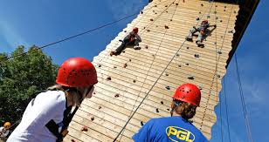

**Dates and Things to Remember:**

* Y3/4 Pre-residential Meeting – Tues 29th Jan 3:15pm
* Futsal – Wed 30th Jan
* Y4 PGL Half-day Experience – Mon 4th Feb
* Ben Smith Assembly – Inspire + Ambassador – Mon 11th Feb
* Y3-6 Sky Dance Challenge – Wed 13th Feb
* Y3/4 Hathersage Residential – 25th-27th Feb
* Y6 Pre-residential Meeting – 4th March 3:15pm
* Y2 Pre-residential Meeting – 11th March 3:15pm
* Y4 Vale Choir – Wed 13th March – 2pm rehearsal + evening performance
* Y6 PGL Residential – 18th – 20th March
* Parents Evening – 2nd & 3rd April
* Y2 Beaumanor Residential – 9th & 10th April
* Last Day -12th April

**Clubs and Sports Update**

Clubs have started this week with a good range of sports for both Key Stages along with opportunities/clubs for writing, art, mindfulness, computers, French, drumming, guitar and brass. Thank you to staff, parents and children for their support.

Our Young Ambassadors are currently receiving training before the role out of the exciting Legacy Challenge, designed to support healthy eating and physical activity – watch out for a report on this next time.

Good luck to our children who will be representing us in Basketball, Swimming, Handball, Futsal, Tag-Rugby and Dance this term!

Preparations for the Sky Dance Challenge are well underway with two very different dances being prepared by staff. Thank you to local dance teacher Clare Calder for her support with choreography and coaching – we look forward to seeing the end results!

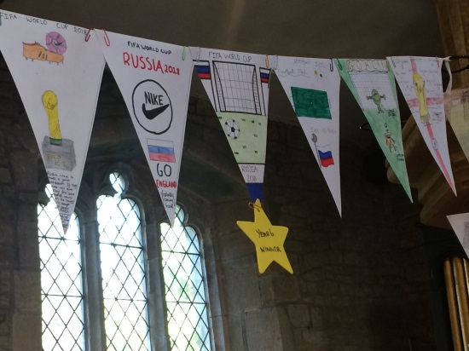

**Film Night**

We have moved our Film Night to the Summer Term and will be making some modifications to the event to further improve it. All the films made so far will still be used in the event and the extra time will allow us to make the film content even better!

**Governor Corner** – by Clare Allen

Happy New Year Everyone!

There is no better time than a new year to review your resolutions for the future, and that is just what the staff and children have been doing in their work to update the values and vision statement for our school.

It has been exciting to see this project develop over the last term and we are delighted that parents, children, the whole staff team and governor input has been included to begin to form a shared aspiration for our children's education. It will be forward thinking, as we look to the future, but will also hold dear the nurturing ethos that you have all told us is such a strength already.

As governors, we oversee the strategic direction of the school and it will be a privilege to see all of this work become embedded within the school ethos over the coming months.

Thank you all for your feedback and support.

Clare Allen

Chair of Governors

**FOSS & Stathern Duathlon**

A huge thank you to all those who supported the school by purchasing their Christmas tree from FOSS. It raised significant funds which are being put towards refreshing ICT equipment.

We hope you will be able to join us for our fabulous Burns Night celebrations on Saturday 26th at 7 for a 7.30pm start.

Tickets are now available by contacting Mary Swain, FOSS members or the school office.

**Job Opportunities at Stathern**

We are looking to add another member of staff to our Before and After School Care team – please contact the school office if you would like further information or know of someone who may be interested.

We are still looking to recruit a new midday supervisor to work with us for any number of days up to 5 a week. If you are interested in the position or know someone who is then please contact the school or pass on our details.