Class 3 Spelling Homework 30th October
Focus on Phonics  /-er/ sound with different graphemes | Year 3 Spelling Focus | Year 4 Spelling Focus | Lower Key Stage 2  Core Spellings to also practise
farmer  boxer  finger  flower  burp  slurp  turn  shirt  dirt  skirt | 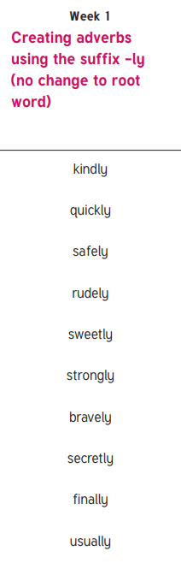 | 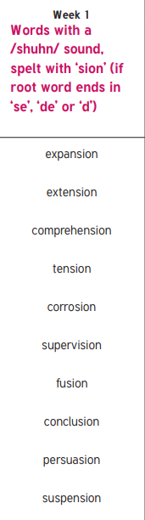 | calendar  caught  centre  century  certain

