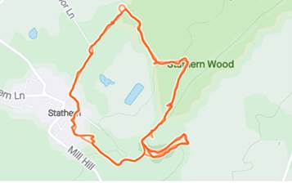
Hi all, hope you are doing well. If your adults have anything like Strava, then my challenge is to draw a picture. This is mine.

It is an elephant. You can do anything e.g. Run, cycle, walk and skip and, last but not least, jog.
This is my mum’s coat hanger that she does on a bike ride.
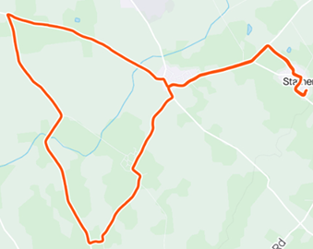

321 go and start drawing AKA sporty :)

From Danny

