So here we are in **Week 2** Class 3!

It has been so amazing seeing your faces on Friday for those of you that could join us and we are very much looking forward to developing using TEAMS with you during this lockdown. We hope that you are all managing to settle into a new routine at home and are managing to

This week, we will continue to upload activities on to the website but will also be using TEAMS with a view to solely use that in the near future – as always, please bear with us…we are

learning too!

<https://stathern.eschools.co.uk/website/class_3_pupils_-_remote_learning/521528>

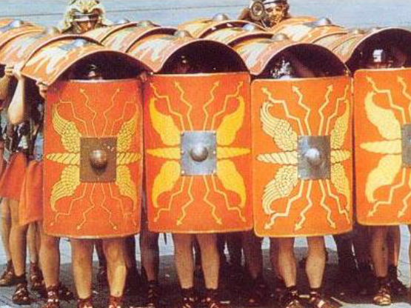This week, we are starting our weekly English and Maths TEAMS Drop Ins which you will see timetabled below. This is an opportunity for you to literally ‘drop in’ to the session to discuss any questions that you have about your learning or if you just want to say Hi and have a little catch up.

The main focus for your activities this week is the Roman Invasion of Britain, the sequence of key events and Roman Soldiers. You will also explore the UK through some map work similar to what we have already done in school when we studied Sheffield last half term as well as creating a painting inspired by music!

Have a great week everyone and remember to contact us through the Class 3 email address or through TEAMS if you need any advice or have any further questions.

[class3@stathern.leics.sch.uk](mailto:class3@stathern.leics.sch.uk)

Mrs Hill, Mrs Maxwell and Mrs Green

**Class 3 Weekly Planner**

|  |  |  |  |  |  |
| --- | --- | --- | --- | --- | --- |
|  | Monday | Tuesday | Wednesday | Thursday | Friday |
| English Activity | Spellings of the Week | SPaG  Year 3 Word Classes  Year 4 Apostrophes for Singular Possession | Reading  The Romans | Writing  Note making  Roman Soldiers | Writing  Roman Soldier Diary |
| Maths Activity | 7 times table: counting up | 7 times table:  Fluent recall | 7 times table: division too! | Times table challenge | Times table challenge |
| Topic Activity  Afternoon Activity | **Mindfulness**  Rainbow Flow Breathing  Go Noodle  **Additional activity** – Rainbow Mosaics | **History**  The Roman Invasions  [National Oak Academy Lesson](https://classroom.thenational.academy/lessons/how-did-the-romans-conquer-britain-6gwk6d) | Roman Beliefs  Gods and Goddesses  Paint to Music | **PE**  Joe Wicks session on You Tube,  go on a bike ride or take a family walk | **Geography**  Labelling countries and cities in the UK |
| TEAMS Drop In Session | English Drop In Session  1:30-2:30 |  | Assembly with Mrs Lambert  1:00-1:30 |  | Maths Drop In Session  1:30-2:30 |

Assemblies with Mrs Lambert are starting this week and will be on Thursdays at 1:00 on TEAMS. Don’t forget ‘News Day Tuesday’ where we would watch Newsround together in school after lunch. Why not try to fit that in to your weekly schedule or you could even watch Newsround each day. Keep checking your assignments for more challenges being set throughout lockdown!

See you soon!

x