

**Dear parents, pupils and members of the community, welcome to our May newsletter.**

I am pleased to open this month’s newsletter by welcoming Miss Helen Widdowson to the team. Helen will be joining us from September 2018 as a senior teacher with leadership responsibilities following a very successful recruitment process that took place last week. She is an experienced teacher with outstanding references and I’m positive she will be a superb addition to the team. We are also really pleased to welcome Mrs Rebecca Box to the midday supervisor team from next week. It has been great to have both Mrs Ombler and Miss Pearce back with us this term as well. In terms of school structure and who will be teaching which class next year, please look for an announcement shortly after half-term. There’s a definite sporting feel to the newsletter below but we have lots of other exciting events and developments going on in school. We are working closely with the WMI on several projects around nature and growing produce, including a gardening club, plug plants, plant sharing, bug hotels, food for school events and even prize winning vegetables! Let us know if you’d like to get involved. Following our packed lunch audit we will be working with children and parents to improve healthy eating in school. This is just part of a whole range of approaches we will be using to support the health and well-being of the pupils, including the Routes to Resilience and Mentally Healthy School’s programme next year. It’s all about building happy, confident, resilient learners that will be successful and enjoy life. ***Mr Lee***

*“Achievement for all in a stimulating and caring environment”*

[www.stathern.leics.sch.uk](http://www.stathern.leics.sch.uk)

01949 860316

Stathern Primary School

**Newsletter**

May 2018

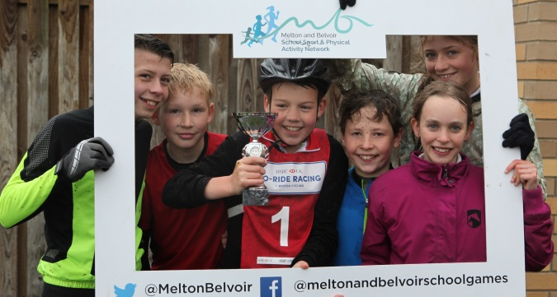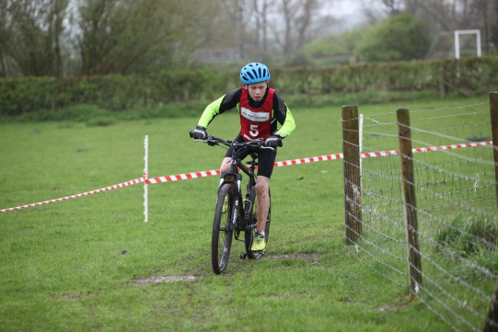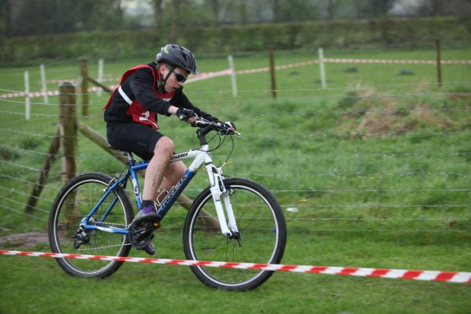.

**Cycling at Brooksby – *see website for more details and photos***

.

**Girls Football County Finals - *see website for more details and photos***

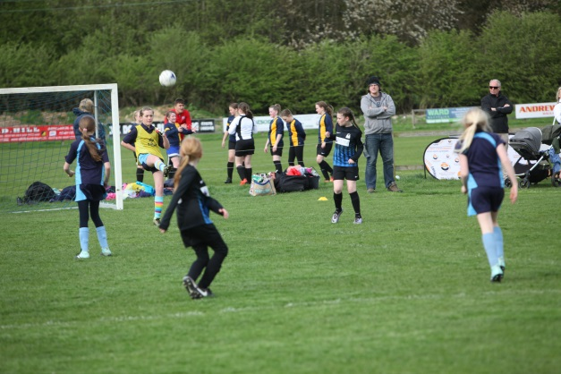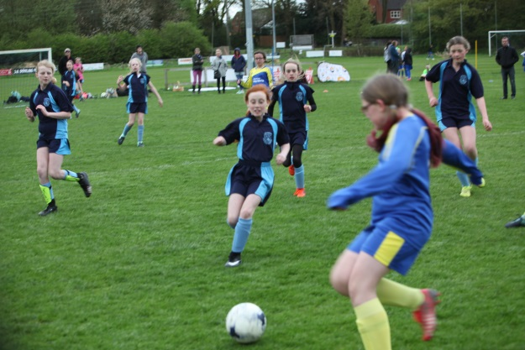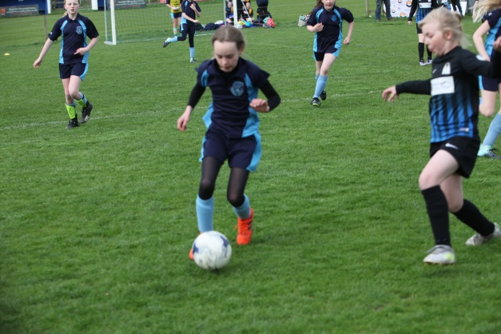

**Dates and Things to Remember:**

* May Bank Holiday – school closed – Mon 7th May
* Class 1 Screveton Eco Farm Visit – Tue 8th May
* Para-Olympic Experience – Thur 10th May
* Year 4 @Dove Cottage – Sun 13th May
* Year 6 SATs Week – Wk Beg 14th May
* Sponsored Walk – Sun 20th May – 10am
* Year 5&6 Netball – TBC
* Year 5&6 Mixed Cricket – Thur 25th May
* Last Day - Fri 25th May
* Back to School - Mon 4th June
* Group Photos – Wed 6th June
* Girls Cricket – Fri 8th June
* Year 6 PGL Visit 12th & 13th June
* Tri-Golf – Fri 15th June
* Girls Football League – 19th, 26th June & 3rd July
* Sports Day – Wed 20th June (TBC) (27th Reserve)
* Summer Fair – Fri 22nd June
* Cricket & Countryside Day – Whole School – Tue 26th June
* Class 3 - Demontford Hall Brass performance – Thurs 28th June
* School Games Finals (Hockey) –Fri 29th Jun
* Girls Football Tournament – Sun 1st July
* KS2 Production – Mon 2nd July – (6pm TBC)
* Leavers Service (Last Day) – Fri 13th July – 9:15am

**Sports and Clubs Update**

Well done to our cyclists who won the recent competition at Brooksby (see Governor Corner below) and also to our Rugby team who finished second and remained undefeated in the tournament despite narrowly losing out to Swallowdale on points in the league table. Well done to our girl’s football team who represented Melton and Belvoir in the County Finals. It was a tough tournament but they showed great team spirit and scored several times. A huge apology from Mr Lee for not being able to make it to the tournament due to interviews held on the same day as the rearranged fixtures

**Governor Corner – Amy Alison (Parent Governor)**

Having had the great pleasure of witnessing the recent win of our cycling team at Brooksby securing them a well-deserved place in the finals, I would like to take a few moments to tell you about something which, as a governor, made me even more proud.

After a great win in the first event, the Italian pursuit, the team went on to win the relay by well over a lap. Rather than standing around celebrating their win while the rest of the competitors battled it out for the remaining places, they cheered on the other teams and then ran the entire lap with the last competitor who would otherwise have been alone on the course. They did not know this girl or her team mates but in the true spirit of the game they supported her regardless.

As a governor, this was easily one of my proudest moments. In addition to the academics and the social life our school gives our children, the sporting opportunities on offer are fantastic. More importantly than all of that though, is the ethos and values our school instils in our children, those displayed by our team supporting the last cyclist on the track that day, values which make our children stand out from others.

**Non - Uniform Day – Fri 25th May**

School council would like to organise a non-uniform day for 25th May. They are currently raising money for the new outdoor area we are planning.

**Singing Opportunities @ Dove Cottage & Party in the Park**

We would like to invite all children from Years 3-6 to sing at Dove Cottage on Sunday 13th March at 11am (parking is free if your children are performing)

Should anyone from Years R-2 want to join us they are welcome although they might not know the songs quite as well.

There will be another opportunity for the children to perform the same songs at Party in the Park on Saturday 23rd June at 1pm.

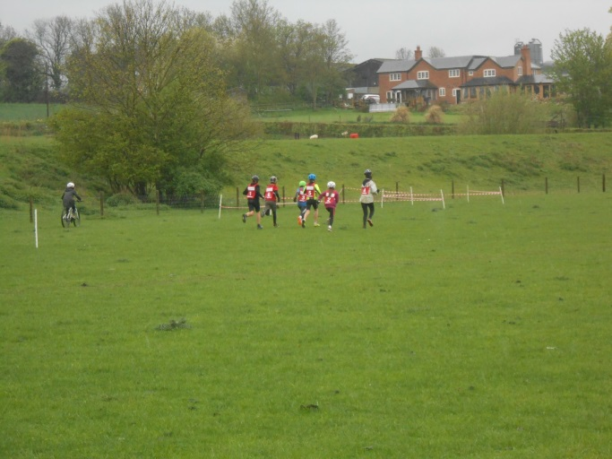

**FOSS – Now Sold Out! Thank you for your support**

The next FOSS event will be the Curry and Quiz @ WMI on the 12th of May – 7pm for a 7:30pm start. Up to teams of 8 are welcome.