

**Dear parents, pupils and members of the community, welcome to our November newsletter.**

Thank you for your contributions towards the shaping of our schools ethos, vison and values – it has been really valuable to hear from all stake holders as we look to establish a clear shared direction to ensure the best possible future for the school. We will be announcing a new event between now and February half-term where staff parents and children will come together to better understand these ideas whilst having fun! We hope you enjoyed the Harvest Festival – along with the children’s excellent performances at St Guthlac’s, one of the highlights this year was the children taking the donations to Grantham Foodbank. They were given a superb tour of the facility and it gave real insight into how important the donations were and how much effort and organisation goes into getting it to the people who need it. This has sparked off a whole range of new ideas around learning that ‘makes a difference ’in the world – it seems to really enthuse pupils and staff. As always if you wish to discuss any aspect of school please do not hesitate to contact me. ***Mr Lee***

*“Achievement for all in a stimulating and caring environment”*

[www.stathern.leics.sch.uk](http://www.stathern.leics.sch.uk)

01949 860316

Stathern Primary School

**Newsletter**

November 2018

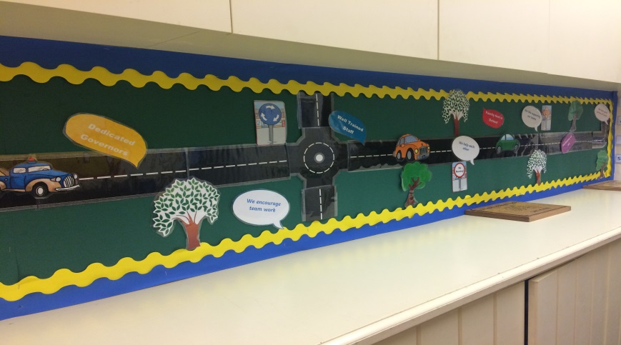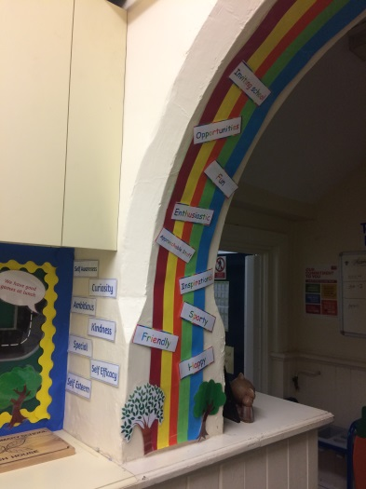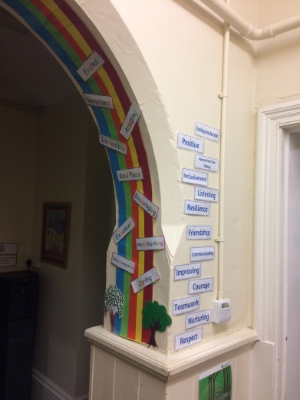.

**Ethos and Vision – Responses and Character Vocab**

**Harvest Festival and Grantham Foodbank**

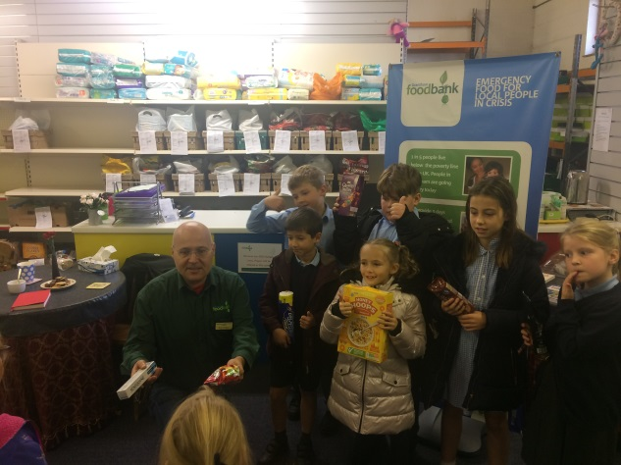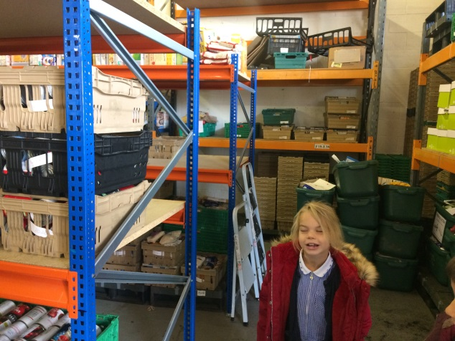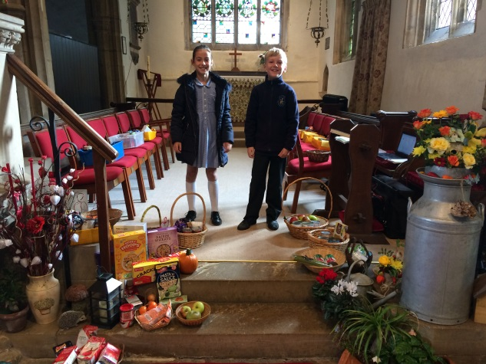.

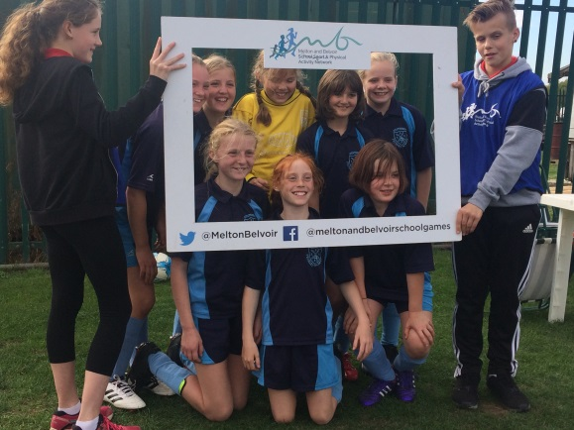

**Dates and Things to Remember:**

* Warning Zone – Mon 12th Nov – Yr5&6
* Great Fire of London Experience – Fri 16th Nov - Class 2 (In school - children only)
* Sports-hall Athletics – Thurs 22nd Nov – Y5&6
* Non-Uniform Day – Fri 23rd Nov (children to bring tombola prize)
* Choir @ Melton Christmas Lights Switch On – Fri 30th Nov – 11:15am
* Christmas Fair – Sat 1st Dec - 2-4pm
* Sarah Outen Adventurer Assembly – Mon 3rd Dec
* Y5/6 Basketball – Fri 7th Dec
* Roman Experience – Mon 10th Dec – Class 3 (In school - children only)
* Flu Immunisation –Tues 11th Dec - YrR-6
* Christmas Dinner – Thurs 13th Dec
* Eastwell – Fri 14th Dec (time TBC)
* Senior Citizens Tea Party and Nativity Dress Rehearsal – Mon 17th Dec – 2pm
* Classes 1 &2 Theatre Visit – Tue 18th Dec
* Nativity – Wed 19th Dec – 2pm & 5:30pm
* Celebration and Carol Assembly – Fri 21st Dec
* First Day Back – Tue 8th Jan

**Clubs and Sports Update**

Well done to both our football teams for their excellent performances at the recent tournament held at Asfordby. Our boys finished second in their group, narrowly missing out on a place in the final, whilst our girls won every game to reach the final where they were beaten 2-0. Well done to both teams who played some excellent football!

We look forward to updating you on how our Athletics and Table-tennis teams got on next time.

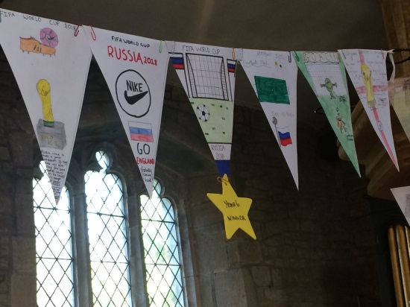

WW1 Centenary Procession and Performance

A huge thank you to Mrs Fryer and Mrs Waller for their joint efforts in supporting the children to walk through the village collecting for the Royal British Legion followed by performances of ‘It’s a Long Way to Tipperary’ and ‘Pack Up Your Troubles’. By the end – everybody in the hall had joined the choir in singing! There will be a service for the children in school on the 7th November led by Judith Wells and members of the British Legion.

**Governor Corner** – by Felicity King

Last night the staff hosted the first Vision and Ethos meeting in school. It was a wonderful evening and reflected an exciting time in the school’s history. In addition to the considerable work the team have already explored in terms of the strengths and magnetic atmosphere that make our school what it is, we were also given the chance to hear more about the way the existing creative curriculum is going to be employed as the foundation for learning for the future. How amazing that our children will have access to local and regional initiatives as the vehicle to establish a skills-based education that will form the very foundation of their experience.

In a world that can scream targets and performance I feel reassured and excited to be part of this bigger picture approach to preparing our children for the future. More than ever I felt in touch with the values underpinning these development plans and that they are aligned with the hopes and dreams we have for our children, whatever their skills and talents. A big thank you to the staff team and all the parents and carers for your contributions so far.

Best wishes  
Clare Allen   
Chair of Governors

**FOSS**

Thank you to all those who joined us for our Halloween Disco we hope you enjoyed it. Please look out for the separate FOSS Newsletter with lots of exciting events already planned in.

FOSS are looking to recruit new members to help run events and support the school in raising funds for new ICT resources – please contact us if you are interested.

**New Staff and Midday Supervisor Position**

We are still looking to recruit a new midday supervisor to work with us for any number of days up to 5 a week. If you are interested in the position or know someone who is then please contact the school or pass on our details.