

**Dear parents, pupils and members of the community, welcome to our June newsletter.**

I would like to start by announcing the class structure and teachers for next year. Class 1, taught by Miss Heafford, will have Reception only. Class 2, taught by Mrs Waller, will include Year 1 and Year 2. Class 3, taught by Miss Howlett, will include Year 3 and Year 4 (this teaching structure will change following the return of Mrs Minnaar from maternity leave which is expected to be in December). Class 4, taught by Miss Widdowson, will include Year 5 and Year 6. Should you have any questions or concerns then please either arrange to come in and see me or voice them at our Communications Evening, scheduled for Thursday 21st June. At this event there will also be an opportunity for parents to meet Miss Widdowson, our new Class 4 Teacher. All the children will get to experience their new class and teacher on Friday 6th July during a half-day move up experience. Our Year 6 will be starting to experience their next school soon through transition days; I’m sure they will enjoy the experience and I must commend them all for the way they handled the pressure of the SATs. I can honestly say that they approached the experience with positivity, maturity and determination. I would like to thank them for all their hard work and I hope they enjoy the PGL experience this week we have organised for them. There are lots of events planned for our last term before the summer break; please check the dates list as we’ve had to change a couple. We hope to see you at one or all of the events listed overleaf. ***Mr Lee***

*“Achievement for all in a stimulating and caring environment”*

[www.stathern.leics.sch.uk](http://www.stathern.leics.sch.uk)

01949 860316

Stathern Primary School

**Newsletter**

June 2018

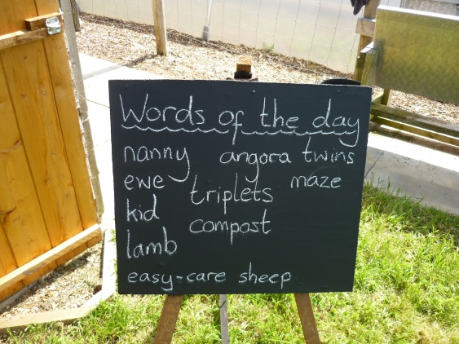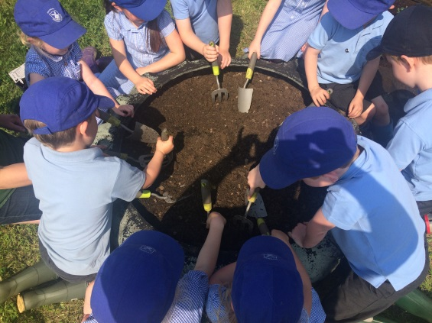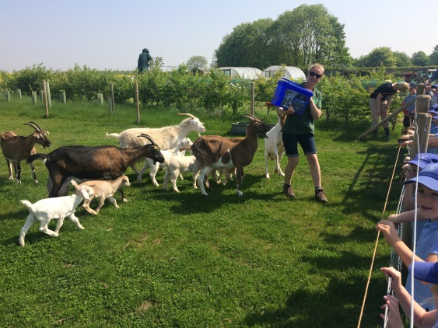.

**Class 1 Eco-Farm Visit – *see website for more details and photos***

.

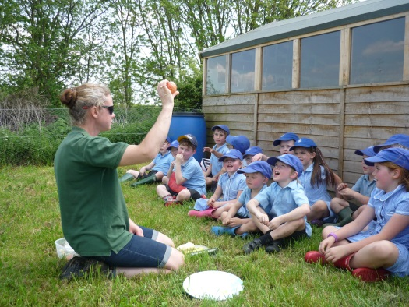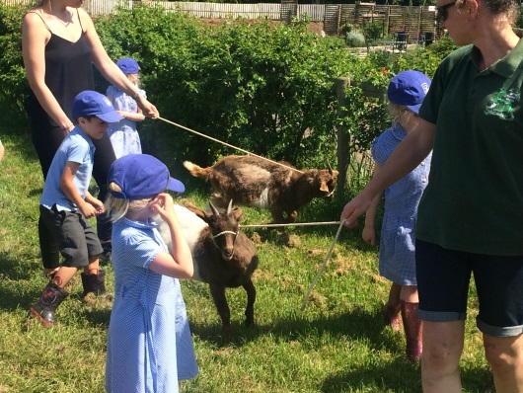

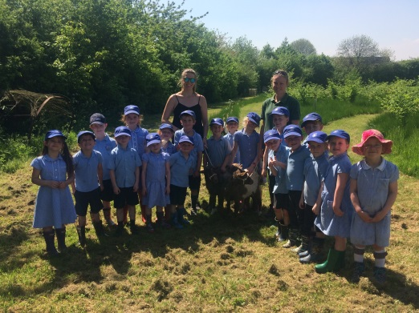

**Sports and Clubs Update**

We are all excited for the Hockey Team who qualified for the School Games Finals on Friday 29th June to represent Melton and Belvoir against the best from Leicestershire. Good luck – more details to follow.

Good luck to our girls who take on Swallowdale, Bottesford and Scalford in the upcoming Girls League. They’ll battle out over 3 nights and several fixtures to see who can top the table!

Well done to our Mixed Cricket Team. With players from Year 3 to Year 6 they put in a valiant effort to finish 8th against opposition from larger schools.

KS1 Athletics – Well done to all our young competitors for their superb efforts on the day!

**Dates and Things to Remember:**

* Year 6 PGL Visit 12th & 13th June
* Girls Football League – 19th, 26th June & 10th July
* Sports Day – Wed 20th June – 1:15pm
* Communications Evening – Thursday 21st June – 6pm
* Summer Fair – Fri 22nd June - 3:30pm- 5.30pm
* Party in the Park – Sat 23rd June
* Cricket & Countryside Day – Whole School – Tue 26th June
* KS2 Production ‘Dream On’ – Wed 27th June - 1:45pm and 6pm
* Class 3 @ DeMontfort Hall Brass Performance – Thurs 28th June
* School Games Finals (Hockey) –Fri 29th Jun
* KS1 Mini Olympics ( in school ) - Monday 2nd July - 2.15 – 3.15pm
* Girls Football Tournament – Sun 1st July
* Stathern Move Up Morning – Fri 6th July
* Class 3 Tag Rugby Tournament – Fri 6th July (pm)
* New Starters Transition Meeting – Mon 9th July – 6pm
* Leavers Service (Last Day of Term) – Fri 13th July -

St Guthlac’s Church - 9:15am

**Sports Day – Wednesday 20th June @1:15pm**

Our annual Sports Day will be taking place on the play-park and will include a selection of individual sprint, novelty and mixed age house relays for you to enjoy. We hope the sun comes out and you are able to join us in support of the children on the afternoon.

**Summer Fair – Friday 22nd June @3:30pm-5.30pm**

We hope you’ve received our flyer about the school Summer Fair organised by FOSS.

There will be enterprise competition winning games designed by the children, stalls, refreshments and entertainment provided by each class!

If you are able to help at the Summer Fair then please sign up on the sheet outside of school that will go up soon (they’ll be a text alert when it’s out) or just let the school office know.

**Communications Evening – Thursday 21st June @ 6pm**

We hope you will be able to join us for our next Communications Evening where there will be the opportunity to meet our new teacher Miss Widdowson and we will have the following items on the agenda:

* School and Class Structure
* Message from the Chair of Governors
* School Ethos and Vision Development
* School Development Plan
* Our Outdoor Playground Project
* Mental Health and Well Being
* Attendance
* Meet Miss Widdowson
* Questions

As always please feel free to ask questions as part of the group sessions or on an individual basis after the presentation. If you feel your question may require us to look into something more deeply then please feel free to e-mail it or phone it through prior to the meeting.

It would be great to see as many people join us as possible. Teas, coffees, cakes and biscuits will be available free of charge on the night.

**KS2 Production – Wednesday 27th June**

Children in Years 3-6 have been working hard on their adaptation of Shakespeare’s – A Mid-Summer Night’s Dream, called ‘Dream On’.

We will be trying something new and showcasing the performance in our own ‘open-air’ theatre. Let’s hope it doesn’t rain!! Tickets are now available to reserve from the school office at a cost of £2. You can book for the 1:45pm or 6pm performances.

It is our hope that children will be available to perform at both shows, should they not be available for any reason then please let us know as soon as possible.