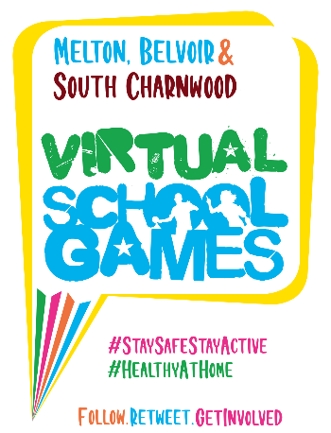

**Challenge 1 Target Throw**

***How many times can you throw a bean bag into your target in 60 seconds?***

**What you’ll need:** - Stop watch or something to time 60 seconds

- A bean bag or pair of rolled up socks

- A hoop or washing basket (your target)

**How to play:** - Place your target on the ground and take 3 large steps backwards

- Where you are stood is now your throwing line (put a marker on the floor)

- Throw your bean bag/socks into your target area as many times as you can in **60 seconds**

- Keep a count of every successful attempt and record your results below

- After each attempt, collect your bean bag and return to the throwing line

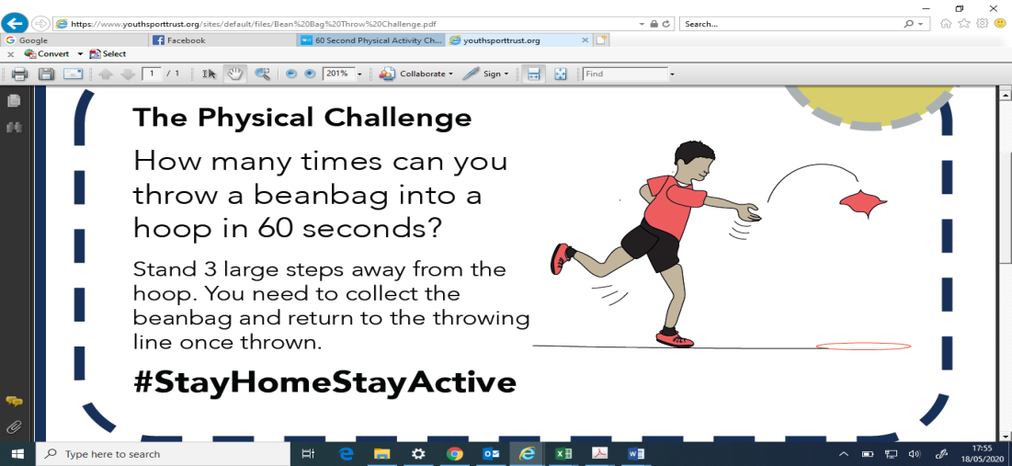



Keep going…Once you’ve had a few practices, set yourself a target and keep going until you achieve your personal best!

**Challenge 2 Distance Throw**

***How far can you throw?***

**What you’ll need:** - A vortex howler or a tennis ball

- Measuring Tape

- Something to mark your throwing line like a jumper

**How to play:** - Place your marker on the floor

- Stand with your foot behind the line and try to throw your howler/ball, as far as you can

- Record your results in the table below

- After each attempt, collect your bean bag and return to the throwing line

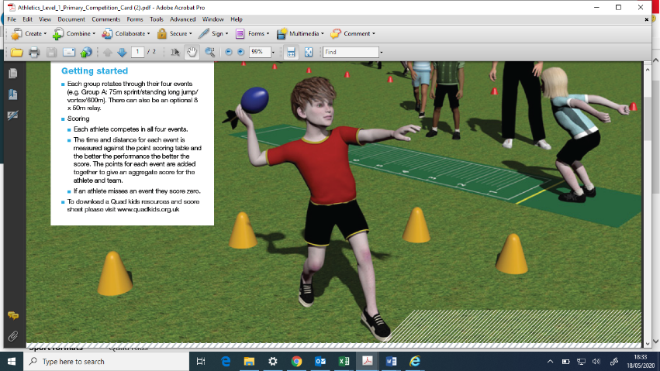



You've got to believe to achieve. Have the self-belief and confidence to succeed and reach your personal best.

**Personal best score card  
Submit results by 4pm on Friday 5th June**

**Name: Arthur**

|  |  |  |
| --- | --- | --- |
|  | **Your best score/distance** | **How many attempts did you have throughout the week?** |
| **Challenge 1** | **12** | **3** |
| **Challenge 2** | **24 steps** | **6 (with different sized and weighted balls)** |

**We’d love to see you in action so why not tweet us a clip of you taking part** [**@MeltonBelvoir**](https://twitter.com/meltonbelvoir?lang=en)[**@SouthCharnwood**](https://twitter.com/SouthCharnwood?ref_src=twsrc%5Egoogle%7Ctwcamp%5Eserp%7Ctwgr%5Eauthor)

**Get Creative - Can you think of your own throwing challenge that could be a part of your school’s own Virtual Sports Day?**