Welcome back Class 3!
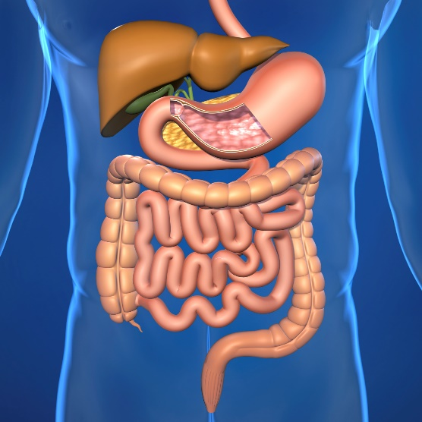
Well done to each and every one of you for your continued hard work last week. We are so proud of your attitude towards home learning and the effort that you have already shown in this new unit of work. It was wonderful seeing some of your marshmallow towers and your art pieces which you created were spectacular! We are extremely excited about seeing you all back in school next Monday when we are all reunited as a school family and we bet that there are a few excited grownups too!

In our final week of home learning, we move on to focus on the digestive system where you will learn about the parts of the digestive system as well as their functions. Your maths this week will continue focusing on statistics and data where you will learn about more about discrete data building on from last week as well as continuous data in the form of line graphs. We continue to read George’s Marvellous Medicine in our English lessons and celebrate the wonders of books on Thursday for World Book Day. Don’t forget to check out your Mindfulness Monday, Well-Being Wednesday and Family Friday activities too.

We hope that you enjoy your activities this week and fingers crossed that the sunshine remains as it is certainly good for the soul! During the beginning of next week, please share any ideas you have about some little games or ways you might like to celebrate the end of this lockdown at our little scheduled TEAMS party – let's leave this lockdown on a high! We are immensely proud of all that you have achieved and can’t wait to see you all soon!

https://stathern.eschools.co.uk/website/class_3_pupils_-_remote_learning/521528
class3@stathern.leics.sch.uk Mrs Hill, Mrs Maxwell and Mrs Green

Weekly Theme: Our Digestive System
Week 2 | Monday | Tuesday | Wednesday | Thursday | Friday
English Activity | Conjunctions  Chapter 6  Rewriting the chapter using subordinating conjunctions | Direct Speech  Chapter 7  Complete Who Said...Activity Sheet | Pronouns  Chapter 8  Complete Pronouns worksheet | World Book Day Activities  Book Quiz  Make your favourite book character  Draw with Rob  Make your own gruesome medicine | Reading Activity  Chapter 9  Complete Scanning Skills Activity Sheet
Maths Activity | Discrete Data: combining bar charts, tables and pictograms. | Comparison, sum and difference questions: discrete data | Continuous data: Creating a line graph | Reading a line graph: estimating between intervals  Optional world book day maths quiz | Reading a line graph:  comparison questions
Topic Activity  Afternoon Activity | Mindfulness Monday  Mindfulness helps us to digest food  Kids Body Scan Meditation | Science:  Parts of our digestive system | Well-being Wednesday | Science:  The digestive system:  A poo factory | Family Friday
TEAMS Drop In Session | The week ahead drop in session  1:30-2:00 | Friendly Catch Up Time  12:30 -1:00 | Class 3 talent show  12:30 -1:00 | Assembly with Mrs Lambert  1:00-1:30 | End of lockdown learning party!  1:30-2:00
Things to prepare | Maths: You may want some squared paper today to help you copy out tables neatly.  English: Lined paper. | Maths: You will need access to edshed for your quiz and you may want a printed copy of the optional challenge sheet.  Science: Not necessarily to prepare in advance, but you will need access to junk modelling materials to represent the digestive system. You may also want a printed copy of the digestion dominoes activity.  English: Direct Speech ‘Who Said...’Worksheet | Maths: You will need squared paper or access to the linked online graph creator and someone to time you for the 60 second challenges!  English: Pronouns Worksheet | Maths: You will need a piece of plain paper and coloured pens and a sheet of squared paper to work on. You will also need to access edshed for your quiz today.  Science: For the making poo activity: scissors, masher, large bowl, baking tray, old tights, 2 or 3 biscuits, banana and bread. | Maths: You will need squared paper and a printed copy of today’s worksheet.  English: Scanning Skills worksheet

