Cyclocross

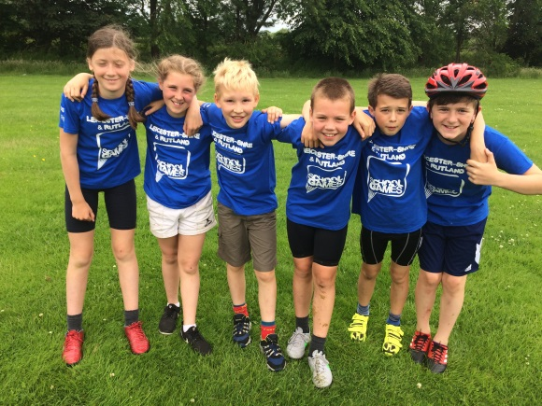
  - On the day, Cyclocross was a big deal because last year we came home victorious. First, we started off on the big hill where our team did a relay called the team relay when we won only by a couple of seconds though. Next, we did the Italian Pursuit which we had been perfecting after school, it had paid off, we did come second but by less than a second!

After the Italian Pursuit.

