

**Dear parents, pupils and members of the community, welcome to our September newsletter.**

Welcome back and I hope you have had an excellent summer break. A special welcome to our new starters who have settled in really well and have been quickly coming to terms with the long days! We also welcome Miss Heafford, our new Class 1 teacher, who I’m sure will be a superb addition to the team. Please visit our website where you will find calendar dates, information about your child’s work in class (from the 8th Sept or sooner) and photos from exciting events. This year will see the arrival of several new projects, including Healthy Eating, Love to Read, Forest Schools and Developing Character and Resilience. We hope you will be able to get involved with the school in lots of ways including trips, visits, sharing days in your child’s class, Celebration Assemblies, performances and parents evening. You may even fancy a job as a Mid-day Supervisor – this is a role which we need to fill as soon as possible. As always, if there is anything you need to discuss then please do not hesitate to contact us and we will do our best to support you. ***Mr Lee***

*“Achievement for all in a stimulating and caring environment”*

[www.stathern.leics.sch.uk](http://www.stathern.leics.sch.uk)

01949 860316

Stathern Primary School

**Newsletter**

September 2017



**Welcome Back!**



**Sports and Clubs Update**

As you will already have seen, we have offered a range of clubs for this half-term. We hope to continue to increase the amount of clubs for Reception and KS1 and also expand the diversity of clubs to include more options beyond sport.

That said, the school continues to go from strength to strength in sport and PE as we are pleased to announce further coaching and support from our qualified PE specialist teacher Mrs Rozentals.

Our PE lessons and clubs will feed into the following competitions:

Y5/6 Football – 22nd September

Y3/4 Football – 6th October

Y3/4 & 5/6 Hockey - 12th October

Y5/6 Table Tennis - Wed 1st November

Sportshall Athletics – 15th November

Y5/6 Dodgeball - 13th December

**Bushcraft Residential – Tue 5th – Fri 8th September**

Leaving school at 7:30am on Tuesday 5th September, our intrepid explorers will experience a brand new residential. Years 4 and 5 will spend 4 days in the forest as they develop ‘bushcraft’ and survival skills whilst improving their teamwork, co-operation and listening skills. They will return on Friday at 5:15pm!

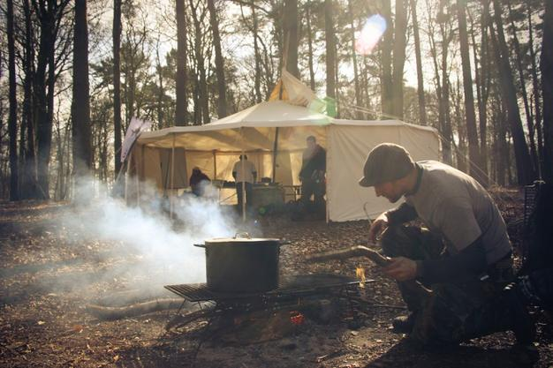

**Dates and Things to Remember:**

* Stathern Show – Sat 2nd Sept – 1pm-4pm
* Y4/5 - Bushcraft Residential – 5th-8th Sept
* Party in the Park – Sat 9th Sept – 1pm (unfortunately we are unable to perform as a school this year)
* School Photos – Individual and Sibling Groups – Tue 19th Sept – from 8:15am
* Black History Experience – Fri 22nd September (Whole School)
* Harvest Festival @St Guthlacs –Fri 29th September – 9:15am (donations that week please)
* Parents Evening – Wed 11th Oct - 4-6pm, Thurs 12th Oct - 3:30-5:30pm
* Last day of term – Fri 13th Oct
* Year 6 Mayan Experience – Fri 3rd Nov
* Enterprise Week – wk beg 13th Nov
* Children In Need – Fri 17th Nov
* Last day of term – Wed 20th Dec

Dates to be confirmed asap – Nativity, Christmas Fair, Eastwell Concert, Celebration Assembly. More detailed letters for the above events will follow where appropriate.

**Before and After School Club**

Our before and after school club runs from 7:30am until school starts and after school until 6pm. Places can be booked as a block or on an ad-hoc basis. Please contact Mary Swain on 07966 082955. Places are limited and must be booked prior to arrival.

**School Holiday Club (Half-term) 8am – 5:30pm**

Please book as soon as possible for the dates below:

**WMI Funding Fitness Holiday Camps – 9am – 3pm (no school holiday club options on these dates)**

Mon 16th October – Friday 20th October (Half-term)

See letter in book bags for more information.

**FOSS – Karaoke and Party Night (Adults Only!)**

**Sat 23rd September 8pm – late!**

If you are interested in joining FOSS to support your school then look out for a text invite to the next meeting – all help appreciated however small!

**Tea towels are still available – please contact the school office or Mary Swain on 07966 082955**

**Vacancy - Midday Supervisor Role**

We are still looking for someone to come and join the team at lunchtimes. The role would be an hour a day for up to 5 days.

If you are interested then please contact the school office. If you know someone who might be in touch then please put them in touch with the school.