Schools sabotaged by head teacher!
Volume 1

The crime scene

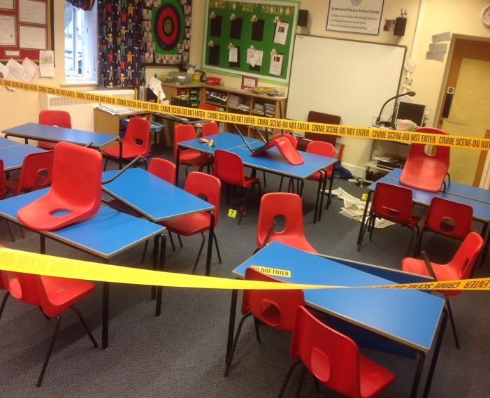
Last Wednesday, the poor children of Class 3 came into their classroom to find it had been ransacked. Over the next few days, the Class have been finding clues and linking them to find out who did the crime. They found out that the robber liked custard creams, flakes and coke. The children also interviewed some witnesses of the event. One of the key witnesses was Class 3’s teacher, Mrs Minnaar when asked she said, “I walked in and it was upside down and ransacked,’’ another said “I’m devastated, I was supposed to be using the iPads this afternoon. Who could have done this?’’ All of their suspicions pointed to their head teacher Mr Lee. On Friday’s lesson they measured Mr Lee’s feet that were exactly the same width as the robber so they proved that he stole the iPads!

