

**Dear parents, pupils and members of the community, welcome to our February newsletter.**

Thank you to all those who completed the recent parent questionnaire we really appreciate you taking the time to let us know your thoughts. We will be looking to build on the positives and consider your suggestions for improving all aspects of our school. I will be responding to all of the issues raised in the questionnaires via letter after half term and through Parents Evening in March. For a more detailed look at the development going in at the school and further responses to suggestions please visit our website where you will find our Communications Powerpoint which will be available on the front screen (for a limited time) and via the ‘Key Information’ tab, under the Communications and Questionnaires tab, from Monday 19th Feb. We will also be providing a data analysis of the questionnaires after half-term. Can I please encourage any parent with a specific concern about any issue to please contact me to discuss this. We always welcome conversations that help resolve issues and make our school an even better place. With that in mind we hope your child has enjoyed the sessions and assemblies we have put on for Children’s Mental Health this week. These were designed to support children’s emotional well-being and resilience and we have really enjoyed celebrating the children’s strengths but also their differences. Finally, we hope you will be able to support the school through entering or helping out at Stathern Duathlon. Please visit the website or contact the school office for more information. ***Mr Lee***

*“Achievement for all in a stimulating and caring environment”*

[www.stathern.leics.sch.uk](http://www.stathern.leics.sch.uk)

01949 860316

Stathern Primary School

**Newsletter**

February 2018

.

**Sky Dance Competition –** Well done to all the children for competingand a big thanks to Clare Calder for her superb choreography and work with the pupils. Winners of: 2nd Overall, Best Acting, Best Props, Best Hair

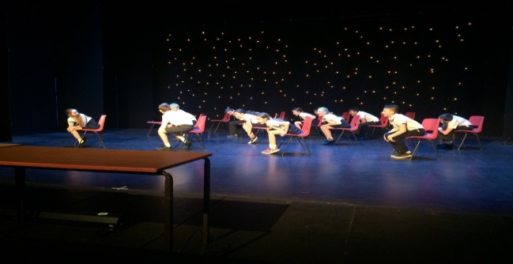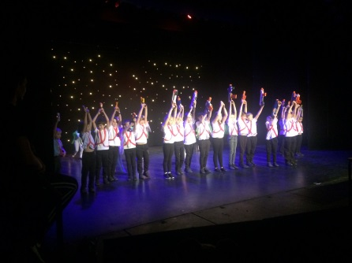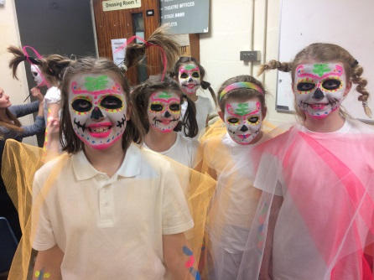

**Class 3&4 Space Centre Visit –** Thanks to FOSS for supporting this inspiring trip which supports our curriculum.

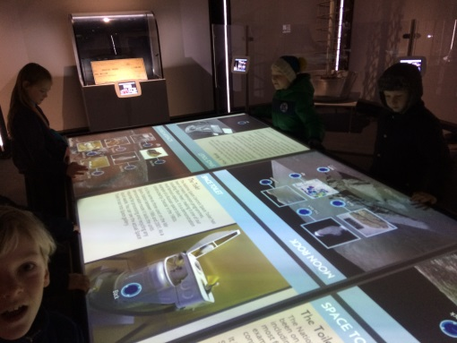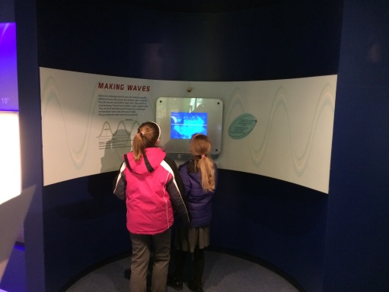

**Sports and Clubs Update**

Well done to all our swimmers who took part in the annual Swimming Gala. There were some superb individual wins along with a 5th place finish overall.

Congratulations to all the children who competed in the Vale Cross Country. We had several top three finishes and overall the school came 2nd.

**Dates and Things to Remember:**

* Film Night @ WMI – Mon 19th Feb – Classes 1 & 2 5:30-6:15pm, Classes 3 & 4 6:30-7:15pm
* Girl’s Football Tournament – Primary Stars – Wed 21st Feb 1pm-3pm (re-scheduled)
* In the Net E-Safety Performance to Children @ Belvoir High – 22nd Feb 1:30pm
* Longfield Cross Country – Sat 24th Feb
* PGL Caythorpe Daytrip – Year 6 – Mon 26th Feb 2pm-5pm
* Maths Calculation Evening – all parents and children – Wed 28th Feb 6pm
* World Book Day – All Children invited to dress up as a book character – Fri 1st March
* Parents Evening – Mon 12th March & Tues 13th March (Note: Class 3 12th& 19th March)
* Sarah Outen – Adventurer Visit to school – all children – Wed 14th March
* Vale Choral –Year 4 – Belvoir High - Wed 14th March
* Stathern Duathlon – Sun 18th March
* Easter Service and Celebration Assembly – All children and parents – Mon 19th March
* Year 2 Beaumanor Residential – Tue 20th March & Wed 21st March
* Last Day, Enterprise Sport Relief Day and Wear Your Hat and Easter Fun Day – All children, parents from 2:30pm – Fri 23rd March



**FOSS**

Thank you to all those who supported the recent Burns Night. Tickets are now available for our next School Disco where there will be a red, white and blue theme. Please contact FOSS members or the school office to buy tickets.

Just a reminder that FOSS is currently fundraising for inspiring trips and visits, reading books and Forest Schools Training for staff.

**Governor Corner – By Felicity King - So what exactly have we been up to?**

Each governor sits on sub committees and is linked to subject areas or initiatives in school. You can see a full list of these in the “Meet the Governors” section on the school website. We liaise with the staff involved and visit to talk through annual plans as well as meeting with children and seeing their work. We look at the priorities for development over the next few years and match our own governor action plan to fit these key areas. The plans are reviewed constantly to ensure the school is moving forward where it needs to, celebrating the successes as they happen and adapting to the changing needs of the pupils.

A key part of the review process is the parent and pupil questionnaires. We can’t thank you enough for completing these, without which we would be far less able to challenge and support the school effectively. Science week will be coming up shortly and I can’t wait to see what exciting experiments and research projects will be launched for the children to take part in. I’ve visited Mr. Lee to talk about school trips and am looking forward to talking to children about their residential visits. It certainly was a treat to read their stories about Bosworth Hall!

I love the fact that Stathern is a small school with a family atmosphere. But being a Governor has shown me the challenges this little community can face. I have enormous admiration for all the staff, both teaching and the support team. Their adaptability and support for each other, just doesn’t come up in bigger schools. To my mind that has to be a great example to set to the pupils and goes a long way towards developing a learning culture in the context of real life and the inevitable challenges ahead. For me it’s where the special comes from. Please look out for us at school events, it would be great to talk. In the meantime, we wish you a very happy half term.

**Olympian Sophie Allen 200m Swimmer Visit**

A big thank you to 200m swimmer Sophie Allen for inspiring our children with her story this term.

Dear Parents & Children

I would like to run a Family Confirmation Course for parents & children sometime after Easter.  This would be be a 4-6 week programme which would take you through the basics of the Christian Faith allowing you to ask questions as we go along.  By the end of the course you will be able to decide for yourself whether you would like to be confirmed or not.

I plan to run this course either one evening after school or on a Saturday morning.  If you would like to register an interest with me please contact me on 01664 823 475 or by email [revjamiemackay@btinternet.com](mailto:revjamiemackay@btinternet.com)  Also let me know when the best time is for you , after school or Saturday morning?

Kind regards - Rev Jamie Mackay