

**Dear parents, pupils and members of the community, welcome to our April newsletter.**

Welcome back – I hope you had a good Easter break and thank you to all those who supported our Wear Your Hat and Easter Egg Rolling event. As you’ll see from the list of dates overleaf we have an exciting and busy term ahead which we are all looking forward to. I’m sure you’ll join me in offering congratulations to Mrs Minnaar who has had a baby boy called Kobus Rihan Minnaar. Both mother and baby are doing well and are now at home. We hope children in Class 3 have settled in well with Miss Howlett and I will be informing you of who will be replacing Mrs Jackson next year as soon as I can. Accompanying this month’s newsletter you will find an Internet Access Agreement that we would appreciate you signing as part of our continuing efforts to ensure the safety of pupils in school. We’ve also included a data collection sheet for you to complete to ensure our records are fully up to date. Finally, I’d like to announce our intention to redesign and improve our Millennium Garden area! Following consultation with pupils, we are hoping to provide an all-weather surface and a range of equipment to support the children’s physical development. We are aiming to fund this through school, FOSS and school council events. As always please contact me should you wish to discuss any issues or ideas you may have and please visit our website for dates, news of events and exciting class pages. ***Mr Lee***

*“Achievement for all in a stimulating and caring environment”*

[www.stathern.leics.sch.uk](http://www.stathern.leics.sch.uk)

01949 860316

Stathern Primary School

**Newsletter**

April 2018

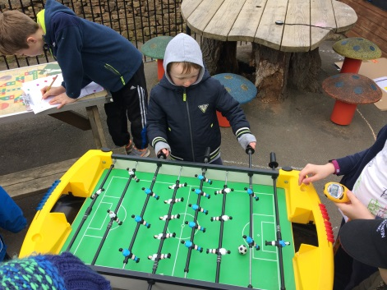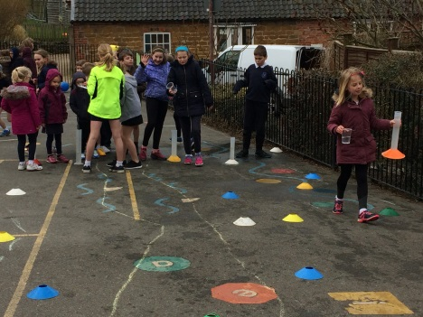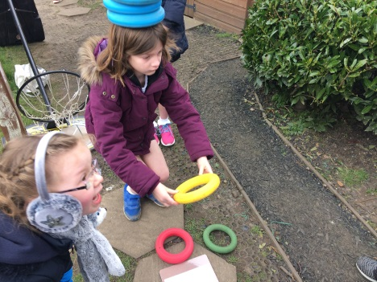.

**Sport Relief Enterprise – 23rd March – *see website for more details and photos***

.

**Year 2 Beaumanor Residential – 20th & 21st March - *see website for more details and photos***

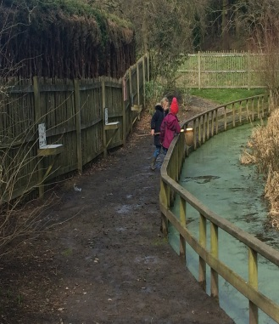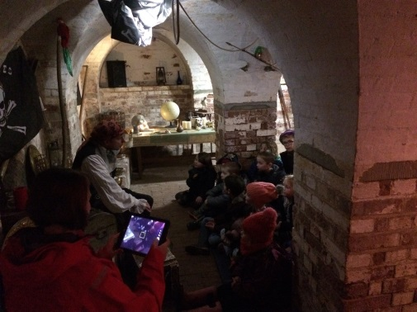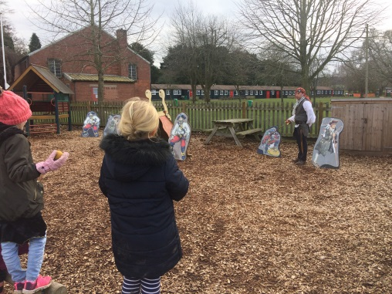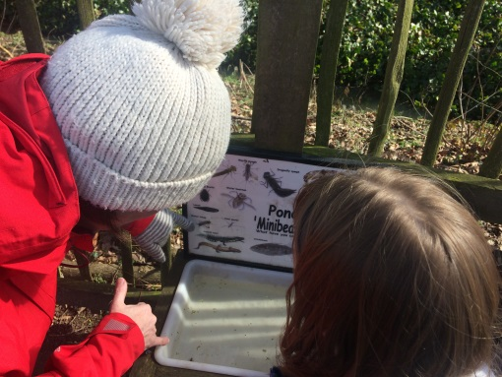

**Dates and Things to Remember:**

* Class 2 Re-arranged Parents Evenings – Mon 16th & Thurs 19th April
* Year 5&6 Tag Rugby - Tues 17th April
* Girls Football L3 – Mon 23rd April
* Y6 Cycling @ Brooksby – Fri 27th April 12:30-3pm
* Year 3&4 Tag Rugby – Tues 1st May
* May Bank Holiday – school closed – Mon 7th May
* Class 1 Screveton Eco Farm Visit – Tue 8th May
* Para-Olympic Experience – Thur 10th May
* Year 4 @Dove Cottage – Sun 13th May
* Year 6 SATs Week – Wk Beg 14th May
* Sponsored Walk – Sun 20th May – 10am
* Year 5&6 Netball – Tues 22nd May
* Year 5&6 Mixed Cricket – Fri 25th May
* Last Day - Fri 25th May
* Back to School - Mon 4th June
* Group Photos – Wed 6th June
* Girls Cricket – Fri 8th June
* Year 6 PGL Visit 12th & 13th June
* Tri-Golf – Fri 15th June
* Girls Football League – 19th, 26th June & 3rd July
* Sports Day – Wed 20th June (TBC) (27th Reserve)
* Summer Fair – Fri 22nd June
* Cricket & Countryside Day – Whole School – Tue 26th June
* Class 3 - Demontford Hall Brass performance – Thurs 28th June
* School Games Finals (Hockey) –Fri 29th Jun
* Girls Football Tournament – Sun 1st July
* Belvoir Transition Days – Thurs 5th & 6th
* Leavers Service (Last Day) – Fri 13th July – 9:15am *Dates for the KS2 production TBC*

**Sports and Clubs Update**

Well done to our cross country runners who represented Melton & Belvoir in the Level 3 Event at Prestwold Hall on the 23rd of March. The children ran brilliantly and the Year 4 Girls Team won Gold!

We are looking forward to upcoming tournaments in Cycling, Football, Rugby and Netball this term.



**Planting at the WMI**

As part of the work that goes into our Enhanced Healthy Schools status, we are working with the WMI and the Soil Association on some exciting new food and gardening projects. A huge thankyou to the WMI for building 4 large raised beds for the children and members of the community to come together and grow lots of exciting produce. If you would be interested in getting involved in the project then we would be excited to hear from you. A letter will follow in about a fortnight’s time giving further information.

**Governor Corner**

The Beast from the East II brought its wintry weather and resulted in the postponement of the Stathern Duathlon which means a reprieve for 'The Guvners', our three woman team representing the Governing Body.  Clare, Fliss and I will continue to train hard ready for the new date of 23 September; we hope to see as many of you there as possible for this key fundraising event for the school.

In the meantime we are delighted to welcome two new governors, Sarah Cross and Marcus Help, who bring their skills and experience to help in the work of the governing body and we look forward to working with them in the coming months.  I am still learning the ropes of being a governor but am finding it incredibly rewarding and inspiring to be more involved with our fantastic school and be a part of shaping its future.  I am looking forward to coming into school this term for my first visit and am really pleased that it will be with Mrs Jackson so she will be able to steer me through it with her wealth of experience before she retires!

Lisa Leathborough

**Year 2 & 6 SATS – Wk Commencing 14th May**

During the month of May both our Year 2 and Year 6 children will undertake important tests in school. Please help us by ensuring your child is in school and well rested\fed to give the children the best chance of achieving their full potential during this time.

**Sponsored Walk – Sun 20th May**

You will find a letter with this newsletter about our sponsored walk next month. School Council would like to encourage you to join in this great event and sponsor generously towards funds they are raising for our new playground project.

**FOSS**

The next FOSS event will be the Curry and Quiz @ WMI on the 12th of May – 7pm for a 7:30pm start. Up to teams of 8 are welcome. Tickets are available from FOSS members or the school office.