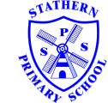

**Nativity & Town Mouse Country Mouse Theatre Trip – 13th &14th December**

**Dear parents, pupils and members of the community, welcome to our November newsletter.**

I hope you are all looking forward to final week of the Christmas period and have enjoyed the successes, performances and achievements of the children over this term. I really hope you will be able to join us for our Celebration Assembly and Carol Sing-along at St Guthlac’s this Monday at 2pm where the children will share some of their learning with you. In this month’s newsletter we have photos from our Enterprise week where the children really rose to the challenge, competing in teams to get the most customers to play their innovative games whilst raising money for Children In Need. The top nine games were invited to our Christmas Fair where they went head to head, earning real money! The winning game raised over £40 for the school! We hope to repeat the event in March to allow children to build on their skills. I’d like to take this opportunity to thank the staff for all their hard work this term – the opportunities they are providing for the children are fantastic and really inspiring. We look forward to seeing you in the New Year and hope you have a brilliant Christmas. ***Mr Lee***

*“Achievement for all in a stimulating and caring environment”*

[www.stathern.leics.sch.uk](http://www.stathern.leics.sch.uk)

01949 860316

Stathern Primary School

**Newsletter**

December 2017

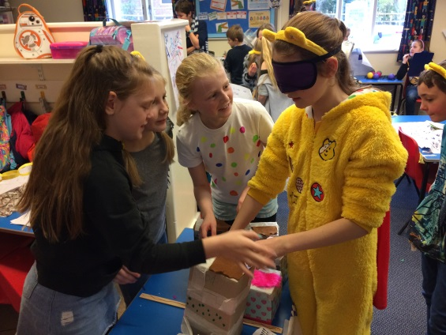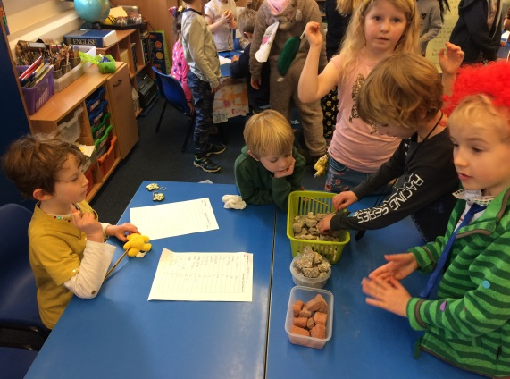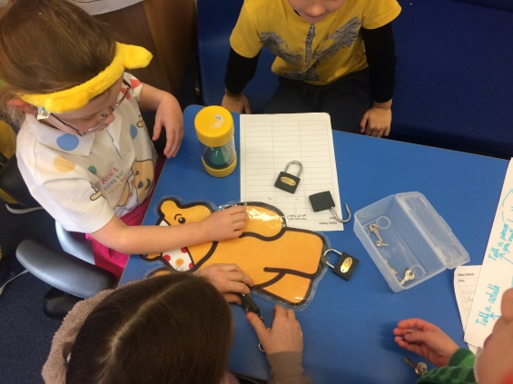.

**Enterprise Week for Children in Need – 17th November**

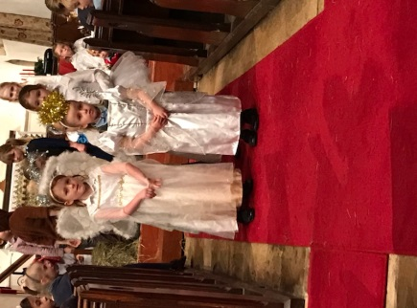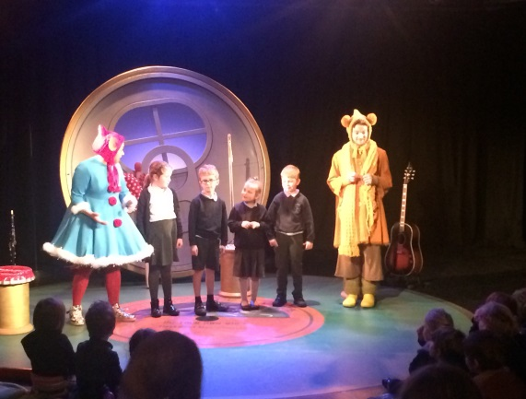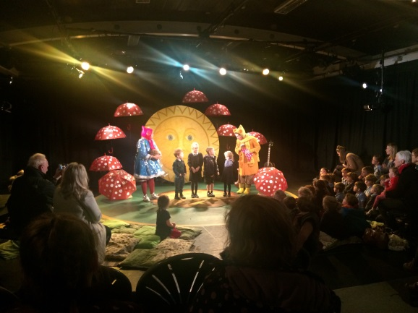

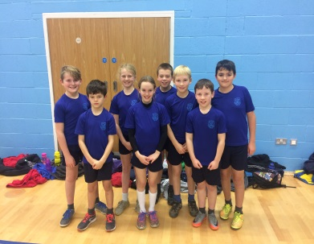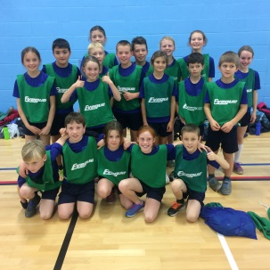

**Sports and Clubs Update**

Well done to our Sports-hall Athletics team who won their event at Brooksby College on the 15th of November – a superb effort!

Well done to our Dodgeball team for their 2nd place finish at the tournament on Wednesday 13th December – you were fantastic.

Healthy Lunch Boxes – Look out for our information leaflets and children’s lessons on what makes a healthy lunch box. Parents have been really supportive in helping us improve our healthy snacks. Please help us keep our children healthy by limiting unhealthy treats in their lunch box whilst striving for a balanced diet.

**School Council Bring and Buy and Christmas Fair**

Thank you to FOSS, staff, children and parents for supporting this year’s Christmas Fair. It was a superb event which raised over £500 and we really hope you enjoyed it. School Council’s Bring and Buy Sale raised £180 for outdoor improvements – thank you to all who supported the event.

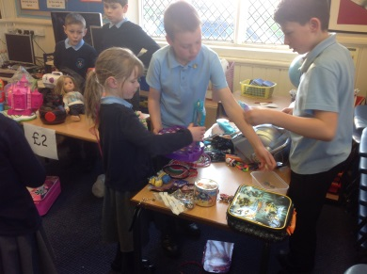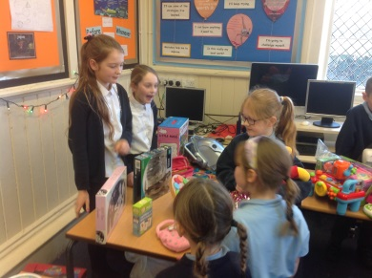

**Dates and Things to Remember:**

* Y5/6 DARE Graduation– Fri 15th Dec – 9:30am @ St Guthlacs (All children and Y5/6 parents)
* Christmas Jumper Day & Children’s Party Day – Fri 15th Dec (All children)
* Carol Concert & Celebration Assembly @ St Guthlacs – Mon 18th Dec 2pm (All children & parents)
* Last day of term – Wed 20th Dec
* Teacher INSET day – Mon 8th Jan
* First day back – Tue 9th Jan
* Sophie Allen 200m Swimmer Visit – Wed 17th Jan 1:15pm (All children in school time)
* Communications Evening – Wed 31st Jan 6pm (All parents)
* Film Night @ WMI – Mon 19th Feb TBC (All children and parents)

**Choir at Melton Christmas Lights & Eastwell Concert**

Well done to our singers and musicians for their superb performances at these two recent events.

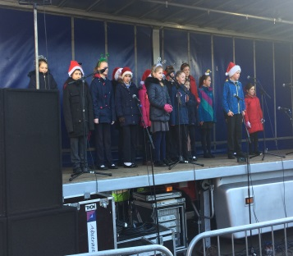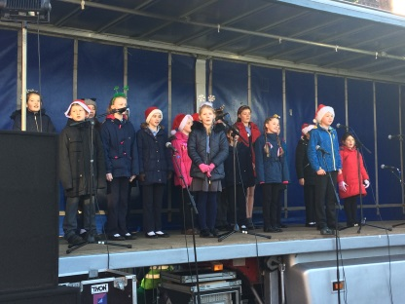

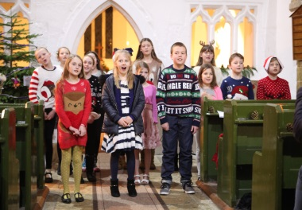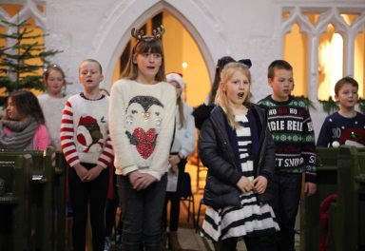

**School Nurse**

Andrea Fiford our school nurse will be available for you to see on the 29th of January between 3pm and 4pm. Please contact the school office if you would like to see her.

**FOSS Thank you & Burns Night Sat 27th January**

Thank you to all those who have purchased Christmas Trees, there are still a few left if anyone would like one. Thank you also for your continued support at all FOSS events. We have already raised over £2000 pounds to support the school.

Burns Night will be on Saturday 27th January (adults only) at the WMI - £10 a ticket to include a traditional ‘Burns Night Supper’ and music. Tickets are available from FOSS members or the school.

**Vacancy - Midday Supervisor Role**

We continue to look for someone to come and join the team at lunchtimes. The role would be for an hour a day for up to 5 days (training provided).

If you are interested or know someone who might be interested then please contact the school office.