

**Flag Fen Visit**

**Dear parents, pupils and members of the community, welcome to our October newsletter.**

It’s been a great first half term with lots of exciting things happening. We hope you enjoy the pictures below but please visit our website to see more – especially the News, Calendar and Children’s work sections. We are excited to move forward with projects such as Nurture and Healthy Eating. We hope to support children in developing an improved sense of resilience and well-being in order for them to be happier more confident individuals. This of course will impact on their capacity to learn. With this in mind, please only send in healthy snacks for break times rather than chocolate bars, sweets, cakes and crisps. If you have any queries please come and see us. We are also very excited about our Enterprise Week, where children will go head to head with their small businesses to see who can make the most money for Children in Need. It is also with great pleasure I can announce we will be overhauling our reading books to coincide with our developments in reading, reading comprehension and the love of reading. With several new children joining us, we continue to grow and now have 86 children who are looking forward to a fantastic second half to the Autumn Term ***Mr Lee***

*“Achievement for all in a stimulating and caring environment”*

[www.stathern.leics.sch.uk](http://www.stathern.leics.sch.uk)

01949 860316

Stathern Primary School

**Newsletter**

October 2017

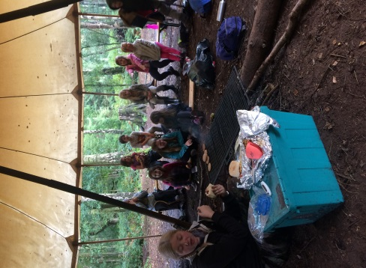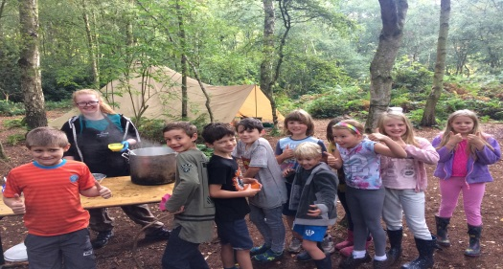

**Bushcraft Residential**

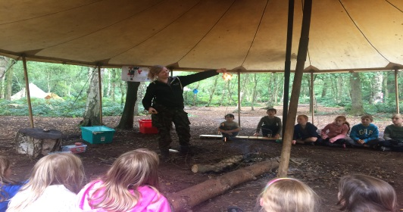

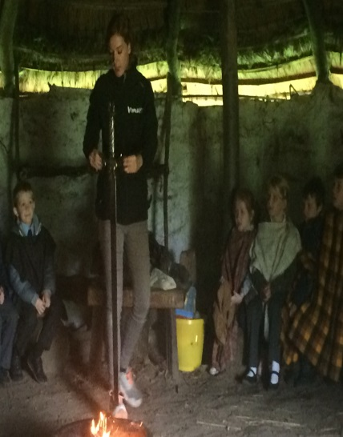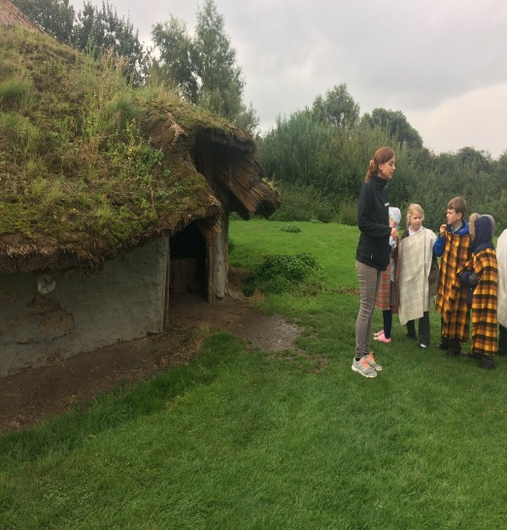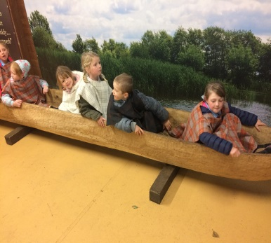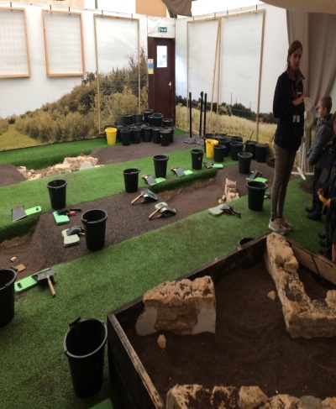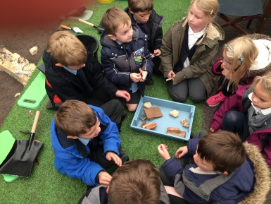

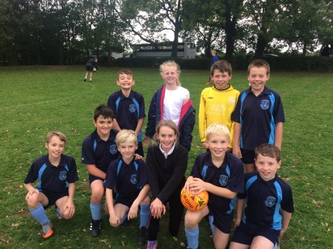

**Sports and Clubs Update**

Well done to our Y5/6 football teams. Our mixed team finished 3rd overall and our girls a fantastic 2nd, narrowly losing out in the 10th round of a thrilling penalty competition with Bottesford.

Both our Y3/4 Girl’s Football and 5/6 Hockey Teams won their competitions against teams from the Melton and Belvoir area! Our Y3/4 Hockey team managed an excellent 5th place.

**Black History Day**

The children welcomed Bemma to our school as we celebrated black history and culture.

Children took part in a range of dance and art activities before coming together for a Caribbean story. It was a fantastic day and a brilliant opportunity for the children to experience different cultures through art and dance.

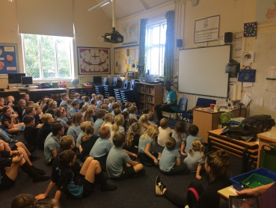

**Dates and Things to Remember:**

* Battle of Bosworth Trip Class 3 – Mon 23rd Oct
* Year 3/4 Tag Rugby – Tue 24th Oct
* Year 5/6 Table Tennis – Wed 1st Nov
* Year 6 Mayan Experience – Fri 3rd Nov
* Sportshall Athletics – 15th November
* KS1 Nativity (with children from KS2 singing) – Wed 13th Dec – 5:30pm @ St Guthlacs
* Enterprise Week – wk beg 13th Nov
* Children In Need – Fri 17th Nov
* Choir @ Melton – Fri 1st Dec
* Christmas Fair – Sat 2nd - Dec 2pm-4pm
* Senior Citizens Lunch & Nativity – Tue 12th

Dec - 2pm @ St Guthlacs/School

* Y5/6 Dodgeball - 13th December
* Y5/6 DARE Graduation– Fri 15th Dec – 9:30am @ St Guthlacs
* Carol Concert & Celebration Assembly @ St Guthlacs – Fri 18th Dec 2pm
* Last day of term – Wed 20th Dec

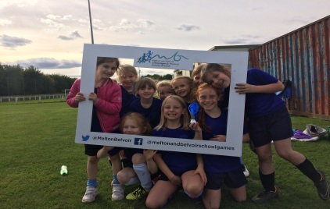

**Harvest Festival**

Many thanks to all those who attended this year’s Harvest Festival at St Guthlacs. With over 60 parents attending it was fantastic to see the event so well supported. Well done to all the children for their singing and performances and thank you for all your kind donations which supported Grantham Food Bank and Water Aid.

**School Nurse**

We are pleased to announce that Andrea Fiford our school nurse will be available for you to see on the 4th Monday of every month between 3pm and 4pm. Her first visit will be on Monday 23rd October 2pm – 3pm, please contact the school office if you would like to see her.

**FOSS Halloween Disco – Friday 27th Oct 6pm– 8pm**

Thank you to all those who attended Karaoke Night to help raise funds for the school.

Christmas trees are available to pre-order after half term – order forms will go out in book bags or contact Mary Swain on 07966 082955.

Tickets for the Halloween Disco are now available – please contact any of the FOSS members, the school office or Mary Swain chair of FOSS on 07966 082955.

**Vacancy - Midday Supervisor Role**

We continue to look for someone to come and join the team at lunchtimes. The role would be for an hour a day for up to 5 days (training provided).

If you are interested then please contact the school office. If you know someone who might be in touch then please put them in touch with the school.